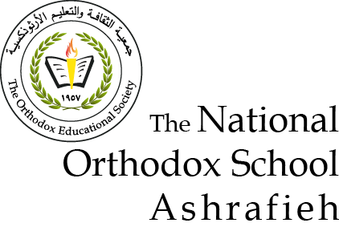

Grade Eight ( A + B )

Name: Energy in our life 13/ 9 /2022

Energy: is the ability to do work .

*Types (kinds) of energy :

1- solar( sun) 2- stored 3- sound 4-water (hydro )

5- chemical 6- light .

Energy resources: a) renewable energy resources.

b) non-renewable energy resources.(fossil fuel )

Renewable resources: are energy resources that can be reformed ( replenished) in a short period of time . like : (solar , water , geothermal , biomass & wind).

\*\***Solar energy** : ( energy of the sun)

- Sun rays reach the earth in the form of **light & heat** .

-The uses of solar energy :

a) Heat water in buildings. b) can be converted to electrical and mechanical energy .

-The **advantages** of solar energy :

a) It is free . b) It causes no pollution to land, air or water .

- The **disadvantage** of solar energy :

That we can’t get it at night or on cloudy days .

\*\***Biomass energy** : is organic wastes from plants and animals .

??? The sun is considered to be the origin of biomass energy ??**Explain**

**Because** plants need the solar energy to make their own food by photosynthesis ,and so the solar energy is converted to chemical energy and then stored in plants, and passes to animals (when they are eaten by animals).

???Biomass energy is considered as renewable resource**; Explain**??

**Because** if we grow plants and crops ,then we get more wastes ( biomass) .

-**Examples** of biomass :

1- wood 2- crops 3- manure 4- garbage

The **advantages** of biomass energy :

a) It is less pollutant than fossil fuels .

b) It releases (CO2) for photosynthesis .

\*\***Water energy** ( hydro-power )

-It is the oldest energy source .

- We use hydro energy to generate electricity .

-The **advantages** of hydro-power energy :

a) It is free . b) There is no waste products . c)It doesn’t pollute air or land.

**\*\*Geothermal energy** : Is the heat from inside the earth .

- We use geothermal energy to :

a) Generate electricity b) Heat buildings .

????Why do we consider geothermal energy as a renewable source??

**Because** water is reformed by water cycle and heat is always produced inside the earth .

** **Wind energy** : :

Wind : is air in motion ( moving air ).

???How is wind formed??

Wind is formed by the uneven heating of earth surface ( land & water ) by the sun .

- The **advantages** of wind energy :

a) Clean fuel ( no pollution ).

b) We use it to generate electricity .

- The **disadvantage** of wind energy :

It is not always found ( there is no wind on calm days ).

\*\*\***Non –renewable energy** : is a source of energy that can’t be formed in a short period of time .

Like : a) fossil fuel ( oil , gas & coal ) b) nuclear energy

**Sahar Silkawi+ Amal Juha**