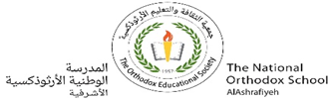Grade Eight (A+B)

Name: Water Cycle /11/2023

______________________________________________

**Evaporation:** is the process, in which a liquid changes into a gas by heating.

* Factors that increase evaporation:

1.Dry air 2.Air motion 3.Large surface of water

**Condensation**: is the process, in which a gas changes into a liquid by cooling.

Q) Evaporation and condensation are reversible; **Explain**?

Because:

1. Evaporation needs heating while condensation needs cooling.
2. In condensation , water vapor changes into liquid while in evaporation liquid water changes into vapor (gas)

**Water drops resulting from condensation on cool surface is called dew.

**Water cycle:** The continuous movement of water.

**Water is found in three states of matter at normal earth’s temperature:

1. Liquid water in oceans, lakes, rivers...

2. Solid water (ice) glaciers.

3.Gaseous water water vapor.

Q) The total amount of water on earth is nearly constant;**Explain?**

Because water is always moving from place to place and changing from state to state.

Water falls on earth as precipitation in three forms:

1. Rain 2.Snow 3.Hail

**Amal Juha & Sahar Silkawi**