|  |  |  |
| --- | --- | --- |
| **Grammar: The Passive Voice** **|** Lower Secondary  **1st Semester | 2023-2024** Stage (6-8) | | |
| **Name:** | __________________________ **Grade:** _____________ | |
| **Date:** | __________________________ | |
| **Subject:** **English Language** | |  |
| **Objectives:**   * to differentiate between the active and passive voices * to understand uses of the passive voice * to be able to transfer active voice sentences to passive in different tenses and vice versa | | |

**The Passive Voice**

**What is voice?**

Voice refers to the form of a verb that indicates when a grammatical **subject performs the action or is the receiver of the action**. When a sentence is written in the **active voice**, the **subject performs the action**; in the **passive voice**, the **subject receives the action**.

**Sentences can be active or passive.** Therefore, **tenses also** have "active forms" and "passive forms." You must learn to recognize the difference.

### **Active Form**

In active sentences, the thing **doing the action is the subject** of the sentence and the thing **receiving the action is the object**. Most sentences are active.

[Thing doing action] + [verb] + [thing receiving action]

Examples:

The professor teaches the students.

SUBJECT VERB OBJECT

DOING ACTION RECEIVING ACTION

John washes the dishes.

SUBJECT VERB OBJECT

DOING ACTION RECEIVING ACTION

### **Passive Form**

In passive sentences, the thing **receiving the action is the subject** of the sentence and the thing **doing the action is optionally included near the end of the sentence**.

[Thing receiving action] + [be] + [past participle of verb] + [by] + [thing doing action]

Examples

The students are taught by the professor.

SUBJECT PASSIVE VERB AGENT

RECEIVING ACTION DOING ACTION

The dishes are washed by John.

SUBJECT PASSIVE VERB AGENT

RECEIVING ACTION DOING ACTION

## **When do we use the passive voice?**

In English, you can use the passive form if you think that **[1]** the thing receiving the action is more important or should be emphasized. You can also use the passive form if you **[2]** do not know who is doing the action or if you **[3]** do not want to mention who is doing the action. **[4]** It can also be used if the one doing the action is obvious.

Check the following examples.

* A bank***was robbed*** yesterday. (=We don’t know who robbed the bank.)
* He ***was arrested*** last night. (=It’s obvious that the police arrested him.)
* I ***have been told*** that you insulted my brother. (=I don’t want to say who told me.)
* Jurassic Park ***was filmed*** by Spielberg in 1993. (= My focus is on Jurassic Park and not on Spielberg.)

**Reasons to Avoid Passive Voice**

Sometimes the use of passive voice **can create awkward sentences**, as in the example below:

**PASSIVE:** I am reminded of watching a movie or TV by **watching a framed, mobile world** through a car’s windshield.

**ACTIVE: Watching a framed, mobile world** through a car’s windshield reminds me of watching a movie or TV.

Also, **overuse of passive voice** throughout an essay can cause your writing to seem flat and uninteresting, and the flow of information will not be smooth.

In **scientific and informative writing**, however, **passive voice is more readily accepted** since using it allows one to write without using personal pronouns or the names of particular researchers as the subjects of sentences. (see example below). This practice helps to create the appearance of an **objective, fact-based discourse** because writers can present research and conclusions without attributing them to particular agents. Instead, the writing appears to **convey information that is not limited or biased by individual perspectives or personal interests.**

**PASSIVE: Research** will be presented by Smith at the conference.

**Research** will be presented at the conference.

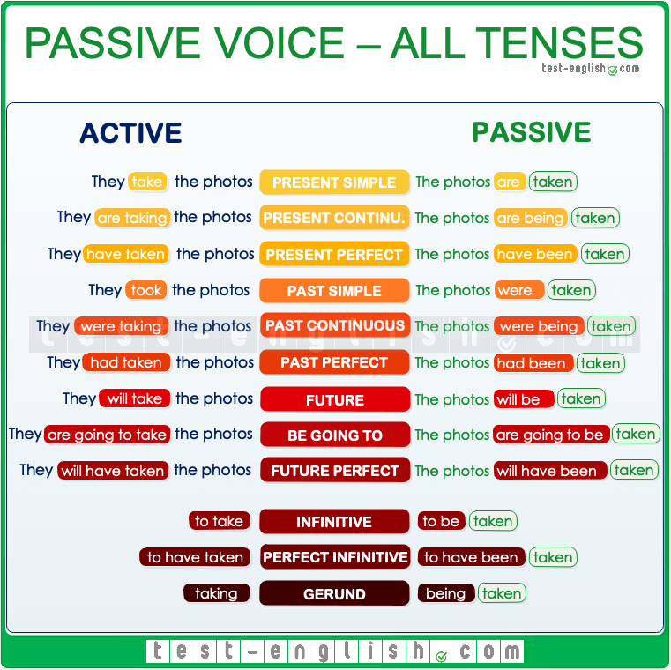

We make the passive using forms of the verb ***to* be + past participle**.

We **start** the sentence **with the object**.

It is not always necessary to add who or what did the action. (the agent)

Only the form of ***to* be changes to make the tense**. The **past participle stays the same**.

Here are examples of the passive in its most common tenses.

|  |  |  |
| --- | --- | --- |
| **Tense** | **Active** | **Passive** |
| **SIMPLE** | | |
| **Simple** Present | Once a week, Tom **cleans** the house.  subject + **verb** + object | Once a week, the house **is cleaned** by Tom.  object + **is/are + past participle** + by agent |
| **Simple** Past | Sam **repaired** the car.  subject + **verb** + object | The car **was repaired** by Sam.  object + **was/were + past participle** + by agent |
| **Simple** Future ***will*** | Someone **will finish** the work by 5:00 PM.  subject + **verb** + object | The work **will be finished** by 5:00 PM.  object + **will be + past participle** + by agent |
| Simple Future ***be going to*** | Sally **is going to make** a beautiful dinner tonight.  subject + **verb** + object | A beautiful dinner **is going to be made** by Sally tonight.  object + ***am/is/are + going to + be + past participle*** + by agent |
| **CONTINUOUS** | | |
| Present **Continuous** | Right now, Sarah **is writing** the letter. | Right now, the letter **is being written** by Sarah.  object + **is/are + being + past participle** + by agent |
| Past **Continuous** | The salesman **was helping** the customer when the thief came into the store. | The customer **was being helped** by the salesman when the thief came into the store.  object + **was/were + being + past participle** + by agent |
| Future **Continuous** ***will*** | At 8:00 PM tonight, John **will be washing** the dishes. | At 8:00 PM tonight, the dishes **will be being washed** by John.  object + ***will be + being + past participle*** + by agent |
| Future **Continuous** ***be going to*** | At 8:00 PM tonight, John **is going to be washing** the dishes. | At 8:00 PM tonight, the dishes **are going to be being washed** by John.  object + ***is/are going to be + past participle*** + by agent |

|  |  |  |
| --- | --- | --- |
| **PERFECT** | | |
| Present **Perfect** | Many tourists **have visited** that castle. | That castle **has been visited** by many tourists.  object + **has/have + been + past participle** + by agent |
| Past **Perfect** | George **had repaired** many cars before he received his mechanic's license. | Many cars **had been repaired** by George before he received his mechanic's license.  object + **had + been + past participle** + by agent |
| Future **Perfect** ***will*** | They **will have completed** the project before the deadline. | The project **will have been completed** before the deadline.  object + ***will have + been + past participle*** + by agent |
| Future **Perfect** ***be going to*** | They **are going to have completed** the project before the deadline. | The project **is going to have been completed** before the deadline.  object + ***is going to have + been + past participle*** + by agent |
| **other passive forms:** | | |
| used to | Jerry **used to pay** the bills. | The bills **used to be paid** by Jerry. |
| would always | My mother **would always make**the pies. | The pies **would always be made**by my mother. |
| yes/no passive questions |  | **Was** the project **completed** by him?  ***was/were*** + object + ***past participle*** + by + agent? |
| wh- passive questions |  | ***When was*** the report ***written*** by Jim?  ***wh-word + was/were*** + object + ***past participle*** + by + agent? |
| tag passive questions |  | The work has been finished by you, hasn't it?  the object + ***have/has + been + past participle*** +by + agent**,** hasn't/haven’t it? |
| modal verbs | You ***must*** **pay** the bills to the council. | The bills ***must be paid*** to the council.  any ***modal + be + past participle*** |

**The passive voice in negative sentences**

The passive voice can also be used in **negative sentences**. All you have to do is **change the verb to be to a negative**. Let’s take a look at the first examples from the table.

You can do this with **any passive tense**.

|  |  |
| --- | --- |
| **passive - affirmative** | **passive - negative** |
| The house **is cleaned** by Tom. | The house **is not cleaned** by Tom. |
| The car **was repaired** by Sam. | The car **was not repaired** by Sam. |
| The work **will be finished** by 5:00 PM. | The work **will not be finished** by 5:00 PM. |

**Modal Verbs – Passive**

**What are model verbs?**

They are verbs like can, could, or should that we often use to talk about ability, possibility, permission, or obligation.

**Here's a list of the modal verbs in English:**

|  |  |  |  |  |
| --- | --- | --- | --- | --- |
| can | could | may | might | will |
| would | must | shall | should | ought to |

**Modals are different from normal verbs:**

1. They don't use an 's' for the **third person** singular.  
2. They make **questions** by inversion ('she can go' becomes 'can she go?').  
3. They are followed directly by the **infinitive** of another verb (without 'to').

|  |  |  |
| --- | --- | --- |
| **Usage** | **Modal Verb** | **Example** |
| Ability | Can, could (past ability) | *She****can****hold her breath for two minutes.* |
| Possibility | Might, may, can, could | *They****might****be late.* |
| Permission | Can, could (more polite), may (most polite) | ***Could****my son use your bathroom?* |
| Obligation | Must, have to, need to | *They****need to****check in by seven.* |
| No obligation | Don’t have to, don’t need to | *You****don't have to****take your shoes off.* |
| Advice | Should, ought to | *You****should****try online gaming.* |
| Habits | Will, would (past habits) + an adverb of frequency | *They****would****sometimes take the train.* |
| Preferences | Would rather | *She****would rather****walk.* |

## **Why do we use modal verbs in the passive voice?**

We use modal verbs in the passive voice because it sounds more **objective and less personal**, especially in situations when we’re **asking people to do something or offering criticism or advice**.

For example, if your boss wants everyone to finish a project by a certain deadline, they want to sound firm, but not too rude or direct. So, they might say:

* This project **has to be finished** by the end of this week.

Instead of saying:

* You all **have to finish this project** by the end of this week.

And when we’re criticizing someone for something they didn’t do, we often prefer to use modal verbs in the past passive voice because it doesn’t sound like we’re putting the blame or fault directly on someone.

* I **should have been told** that yesterday.

Instead of...

* You **should have told** me that yesterday.

We can also use it to take the blame or the attention off of ourselves, as in this example:

* The wrong package **may have been sent.**

Instead of...

* I **may have sent** the wrong package.

Let’s look at the table below to see how we use **modal verbs in the passive voice**:

|  |  |  |
| --- | --- | --- |
| **Modals in the Active Voice** | **Modals in the Passive Voice**  *modal verb + be + past participle* | **Modals in the Past Passive** Modal + have been + past participle |
| They can do it. | It can be done. | It **could have been** done. |
| You could sell your car. | Your car could be sold. | Your car **could have been** sold. |
| He might fix the refrigerator. | The refrigerator might be fixed. | The refrigerator **might have been** fixed. |
| They may make a donation. | A donation may be made. | A donation **may have been** made. |
| You must finish this today. | This must be finished today. | This must have been finished today. |
| He has to send that email. | That email has to be sent. | That email had to have been sent. |
| They should find that document. | That document should be found. | That document should have been found. |
| She should fix her writing. | Her writing should be fixed. | Her writing **should have been** fixed. |

**Practice**

1. ***Decide* whether each of the following sentences is written in active or passive voice. *Write* Active or Passive on the line provided.**

|  |  |
| --- | --- |
| 1. Boys like to play football. |  |
| 1. The room has been painted blue. |  |
| 1. Cricket is played in Australia. |  |
| 1. I am given a book. |  |
| 1. We have lost our keys. |  |
| 1. You might see dolphins here. |  |
| 1. The report must be completed by next Friday. |  |
| 1. We were singing a song in music class yesterday. |  |
| 1. A letter was written to her a few days ago. |  |
| 1. The black bike is being repaired at the moment. |  |

|  |  |  |
| --- | --- | --- |
| 1. **Make correct passive phrases. Pay attention to the tenses in brackets. The first one has been done for you.** | | |
| Posters / to make (simple present) | posters are made |
| books / to write (simple present) |  |
| songs / to sing (simple past) |  |
| English /to speak (simple present) |  |
| computer games / to buy (simple present) |  |
| the table / to lay (will – future) |  |
| children / to see in the park (simple past) |  |
| the computers / to replace (past continuous) |  |
| the penguins / to feed (future perfect) |  |
|  | | |

1. **Write the correct passive tense to the given verb form. The first one has been done for you.**

|  |  |
| --- | --- |
| 1. is written | simple present |
| 1. were sold |  |
| 1. have been played |  |
| 1. are recorded |  |
| 1. will be shown |  |
| 1. had been built |  |
| 1. was made | |  |
| 1. are being discussed | |  |
| 1. has been done | |  |
| 1. was being given | |  |

1. **What tenses are the following sentences?**

|  |  |
| --- | --- |
| 1. A song is going to be sung 2. going to – future 3. past continuous 4. present continuous 5. will-future | 1. The dog is being taken to the vet 2. present perfect 3. present perfect continuous 4. present continuous 5. simple present |
| 1. I’m being watched. 2. going to future 3. past continuous 4. present continuous 5. will-future | 1. The president will be elected 2. present perfect continuous 3. present continuous 4. simple present 5. will-future |
|  | |
| 1. **Rewrite the sentences in active voice** | |
| The club was founded by Ron and Peggy. | |
|  | |
| Football is played by the children. | |
|  | |
| The president was elected by the people. | |
|  | |
| The exercise is completed by the teacher. | |
|  | |
| The telephone was invented by Alexander Graham Bell. | |
|  | |
| The book is read by her. | |
|  | |
| The car was repaired by the mechanic. | |
|  | |
| The cake will be baked by Jane. | |
|  | |
| The document can be signed by anyone. | |
|  | |
| The work had been completed by the team. | |
|  | |
| The report has been written by him. | |
|  | |
| The meal is being prepared by the chef. | |
|  | |
| The class was being taught by her. | |
|  | |
| The fence will be being painted by them. | |
|  | |

|  |
| --- |
| 1. **Rewrite the sentences in the passive voice.** |
| The dog did not bite the cat. |
|  |
| Levi Strauss invented the blue jeans. |
|  |
| The girls can play handball. |
|  |
| The teacher closes the window. |
|  |
| John cleaned the kitchen. |
|  |
| They developed an environmentally friendly type of washing powder. |
|  |
| The professor is going to show the students an old bone. |
|  |
| We must write to her. |
|  |
| Snow covered the mountains. |
|  |
| The lady gave me the keys. |
|  |
| She writes a letter. |
|  |
| He repaired the car |
|  |
| They will finish the project. |
|  |
| They can solve the problem. |
|  |
| She had completed the assignment. |
|  |
| They have built the house. |
|  |
| The chef is preparing the meal. |
|  |
| She was teaching the class. |
|  |
| They will be painting the fence. |
|  |

**Change the following sentences as indicated on the lines provided: active, passive, and question forms as indicated:**

Active: She was teaching the class.

Passive: ___________________________________________________________________

Wh-question**:** ______________________________________________________________

Active: ___________________________________________________________________

Passive: The room was being painted by them.

Yes/No question: _________________________________________________________

Active: He was fixing the car.

Passive: ___________________________________________________________________

Tag question: _____________________________________________________________