

Grammar worksheet(1)

Prediction with Will

Grade (4)

Name: Date: / /2023

|  |
| --- |
| **Objectives:**  1. To identify the future simple .  2. To practice using will to describe the future. |

**Key Words :**

Tomorrow, today, later , in five minutes , on Saturday afternoon, Next year-day-month….etc

**Future Will Form:**

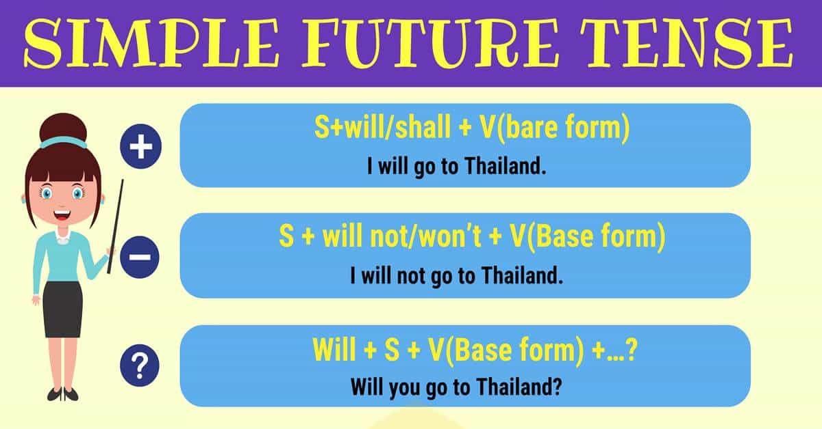

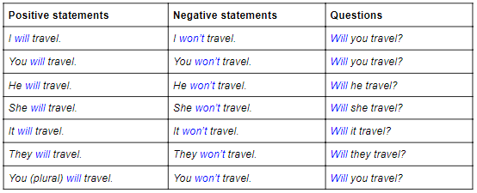

**We use simple future to (Usage):**

1. **Say something will happen in the future .**

I will go to the market tomorrow.

1. **To make promises.**

I will be there at 7 p.m. I promise .

I will do it for you I promise.

1. **To request help or to offer help .**

Will you …..?

Will you help me please to do my homework?

1. **To predict future events.**

I think it will rain tomorrow .

____________________________________

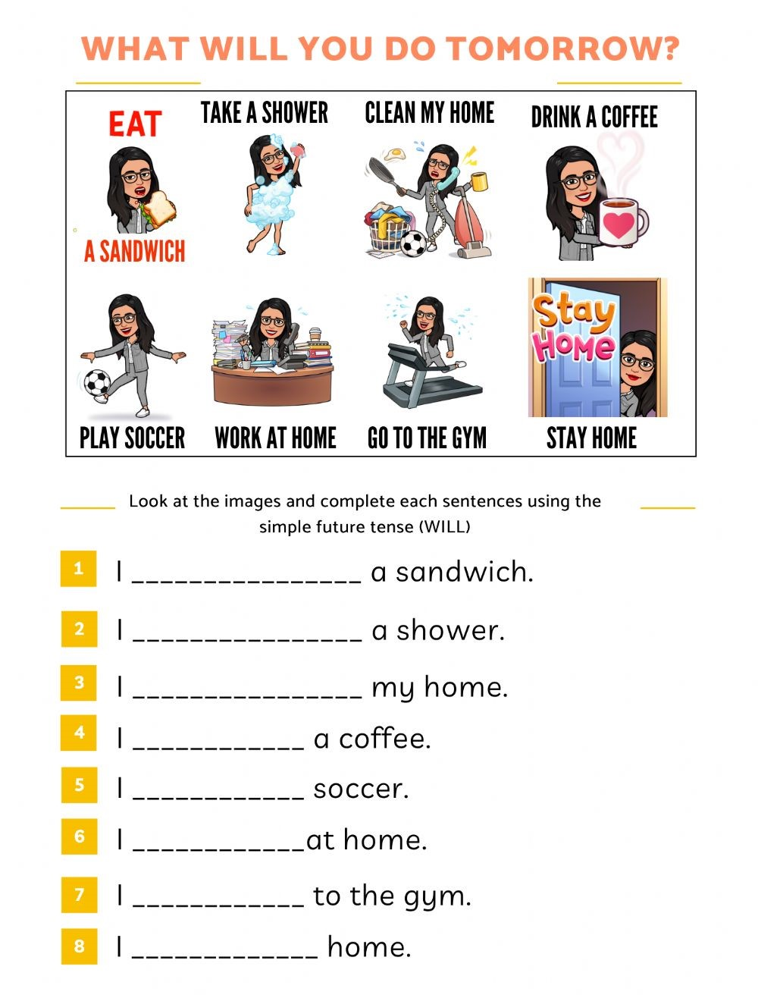

**Q2 ) Write the correct form of the verb** .

1. Wait, I ----------------------- you **.( help)**
2. He ----------- probably ------------------ back tomorrow.

**( not-come)**

1. I ----------------------------- TV tonight . **(watch)**
2. It ------------------------ tomorrow. **(rain)**
3. -------------------- you----------------- him ?**(ask)**

**Q3) Rewrite these sentences in the simple future tense.**

1. I buy a new car next month .

-----------------------------------------------------------

1. We learn English this month .

-----------------------------------------------------------

1. They watch TV tonight .

-----------------------------------------------------------

1. I travel to Turkey next summer.

-----------------------------------------------------------

**Q4) Change these sentences into question and negative sentence .**

**Ex**: They will visit my friend today.

**Negative** : They won’t visit my friend today .

**Question** :Will they visit my friend today ?

1. She will go to the mall tonight .

Negative :---------------------------------------------

Question:---------------------------------------------

1. We will come to Jordan next year.

Negative:---------------------------------------------

Question:---------------------------------------------

1. The robot will win the race .

Negative:---------------------------------------------

Question:---------------------------------------------

1. I will read a new book next week .

Negative:---------------------------------------------

Question:---------------------------------------------

**Q5) Write the usage for each sentence .**

1. I think it will rain later so, take an umbrella with you

----------------------------

2.I promise you , I will do my best to help you .

--------------------------.

3.Will you carry the bag for me ,please ?

-----------------------

4.He will turn to Jordan next year on December.

-----------------------------

5.Will you pass me the pen, please ?

------------------------------

**Q6) Write a sentence using will to describe something will happen in the future.**

**______________________________________________**

Teacher : Raneem Haddad

Coordinator’s Signature : _________________.