

Worksheet Unit Five

Simple Past

Grade (3)

Name: Date: / /2023

|  |
| --- |
| **Objectives:**  1. To identify how to form the verb in the past tense in sentence.  2. To practice using the simple past. |

•A verb in the past tense tells about an action that happened and finished in the past.

**• The key words for simple past tense :**

Yesterday, last (week, night, month, year) -in 2003,at 6 o’clock yesterday …

* **Spelling rules of regular verbs:**

|  |  |  |  |
| --- | --- | --- | --- |
| -e + -ed | Consonant+ vowel + consonant  double consonant + -ed | Consonant + y  -y + -ied | Vowel + y  + -ed |
| lik**e** -like**d** | Pref**er** – prefe**rred** | Car**ry** - carr**ied** | Pl**ay** - pla**yed** |
| Hat**e** –Hate**d** | St**op** – sto**pped** | Stu**dy**-stud**ied** | Enj**oy** - enjo**yed** |

*There is no spelling rule for irregular verbs.

The form of the simple past :

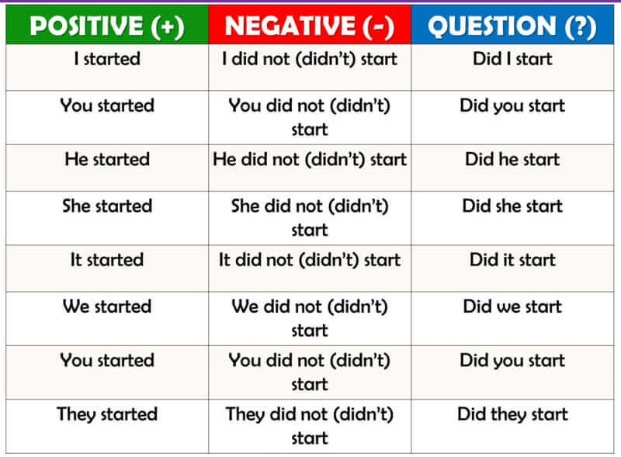

Irregular verbs:

|  |  |  |  |
| --- | --- | --- | --- |
| Base verb | Past verb | Base verb | Past verb |
| Eat | ate | sleep | slept |
| drink | drank | Wake | Woke |
| Swim | swam | Take | Took |
| Run | ran | write | Wrote |
| Sing | sang | buy | bought |
| Go | went | See | Saw |

**Example:**

I **woke** up at 6 o’clock yesterday.

I **drank** a glass of milk an hour ago.

**Q1) Write the past simple of the following verbs.**

1. Cry:-------------------- 7. Eat:-------------------
2. Stay :----------------- 8. Go:---------------------
3. Travel: ---------------- 9.Sleep:------------------
4. Live:--------------------- 10.Write:--------------------
5. Watch :------------------
6. Close :---------------------

**Q2) Write the past tense form of each action verb in brackets.**

1. The baby__________________ **(cry)** too much last night.
2. The father______________ **(wash)** the car .
3. Seagulls _______________ **(carry)** away bits of food.
4. Jack and Sam______________**(go)** to the zoo. It was fun.
5. The frog _______________ **(jump)** across the water.
6. Talia ________________**(buy)** some sweets.
7. The boy _______________**(swim)** happily in the river.
8. We __________________(**travel)** to China last year.

**Q3) Order these words to make meaningful sentences.**

1. I / my /ate /meal/ favorite.

----------------------------------------------------------------

1. watched / in the/ He/ living room / TV.

----------------------------------------------------------------

Teacher : Raneem Haddad Coordinator’s Signature : ------------------