
Worksheet ( 8 )
Grade 2
Name: ------------ Date: / /2023
Objectives: 1-To identify verb to be in the present.
2- To practice using verb to be in the present.
pronouns | Long form | Short form | Example
I | am | ’m | -I am a boy.  -I’m a boy.
He | is | ’s | -He is six years old.  - He’s six years old.
She | is | ’s | -She is Emma.  - She’s Emma.
You | are | You’re | -You are my friend.
They | are | They’re | -They are my sisters.
We | are | We’re | -We are good students.

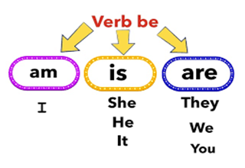
1)Write “ is, am or are “ next to each pronoun below:
They __________
He __________
You __________
She __________
I __________
Adam and I:_________

2) Circle the correct answer.
1-He is /are my father.
2-They is/are flowers.
3- I am /is a girl.
4- She are /is my friend.
5- You is/are a good student.
T.Raneem Haddad  Coordinator’s Signature:

