
Comprehension Worksheet (7)
Grade Two
Name: Date: / /2023 __________________________________________________
Objective: To read and understand the text and be able to answer the questions.
Read the following text and answer the questions below.
What is our world made of?
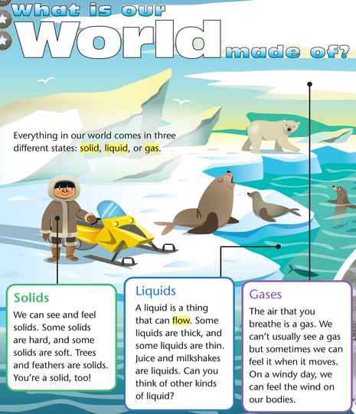

1)What is the title of the text?
________________________________________________

2)How many states of matter are there?
_________________________________________________

3)What is the state of matter that can flow?
_________________________________________________
4) Write two solid objects.
________________________________________________

4) Write(T) beside the true sentence and ( F) beside the false one.
A- We can breathe gas. _______
B- Solids can flow. __________
C- We can see gas. __________
D-We can always feel gas. ______
5) Find out:
A noun: ________
A verb: ________
An adverb of frequency: _________
A subject pronoun: _____________
The opposite of thin: __________

T. Raneem Haddad Coordinator’s Signature:

