
Meaning Worksheet ( 3 )
Grade 2
Name: Date: / /2023
Objectives: To identify the meaning of new words.
To practice using the new words in sentences.
- Study the words below:
word | meaning
flow | 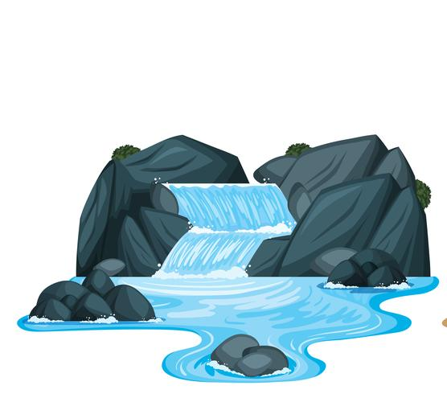
solid | 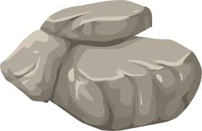
liquid | 
gas | 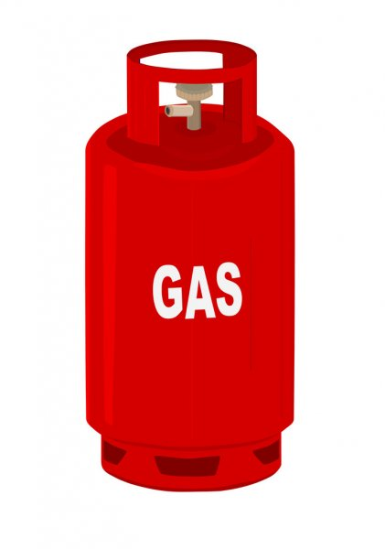
heat | 
steam | 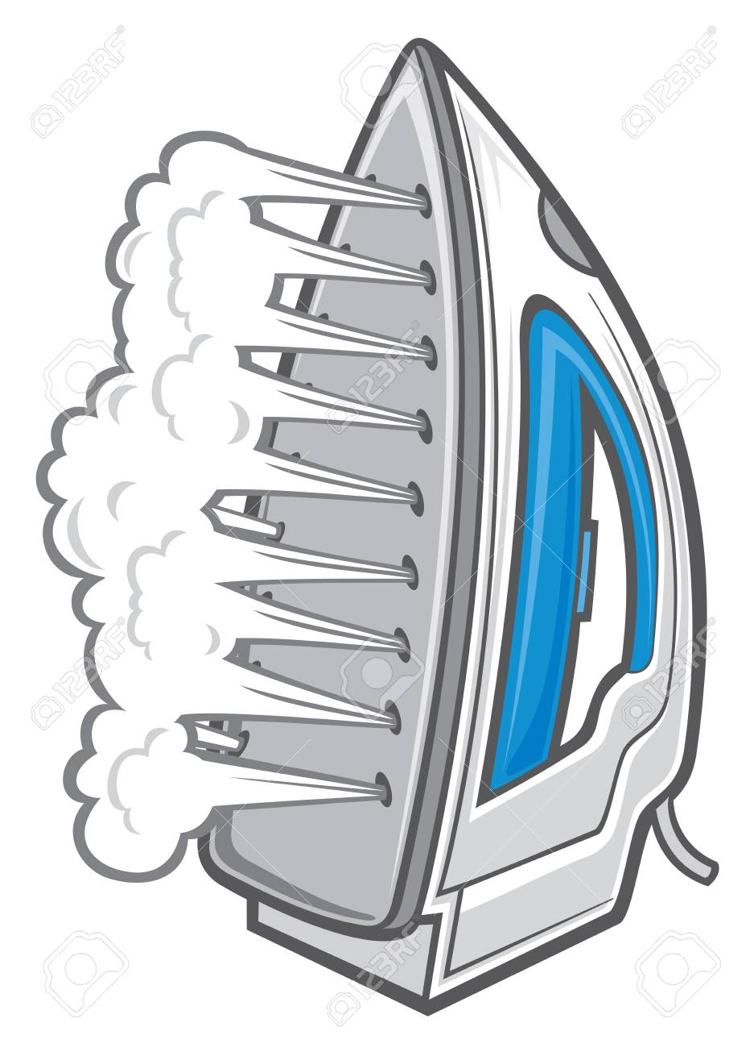
ice | 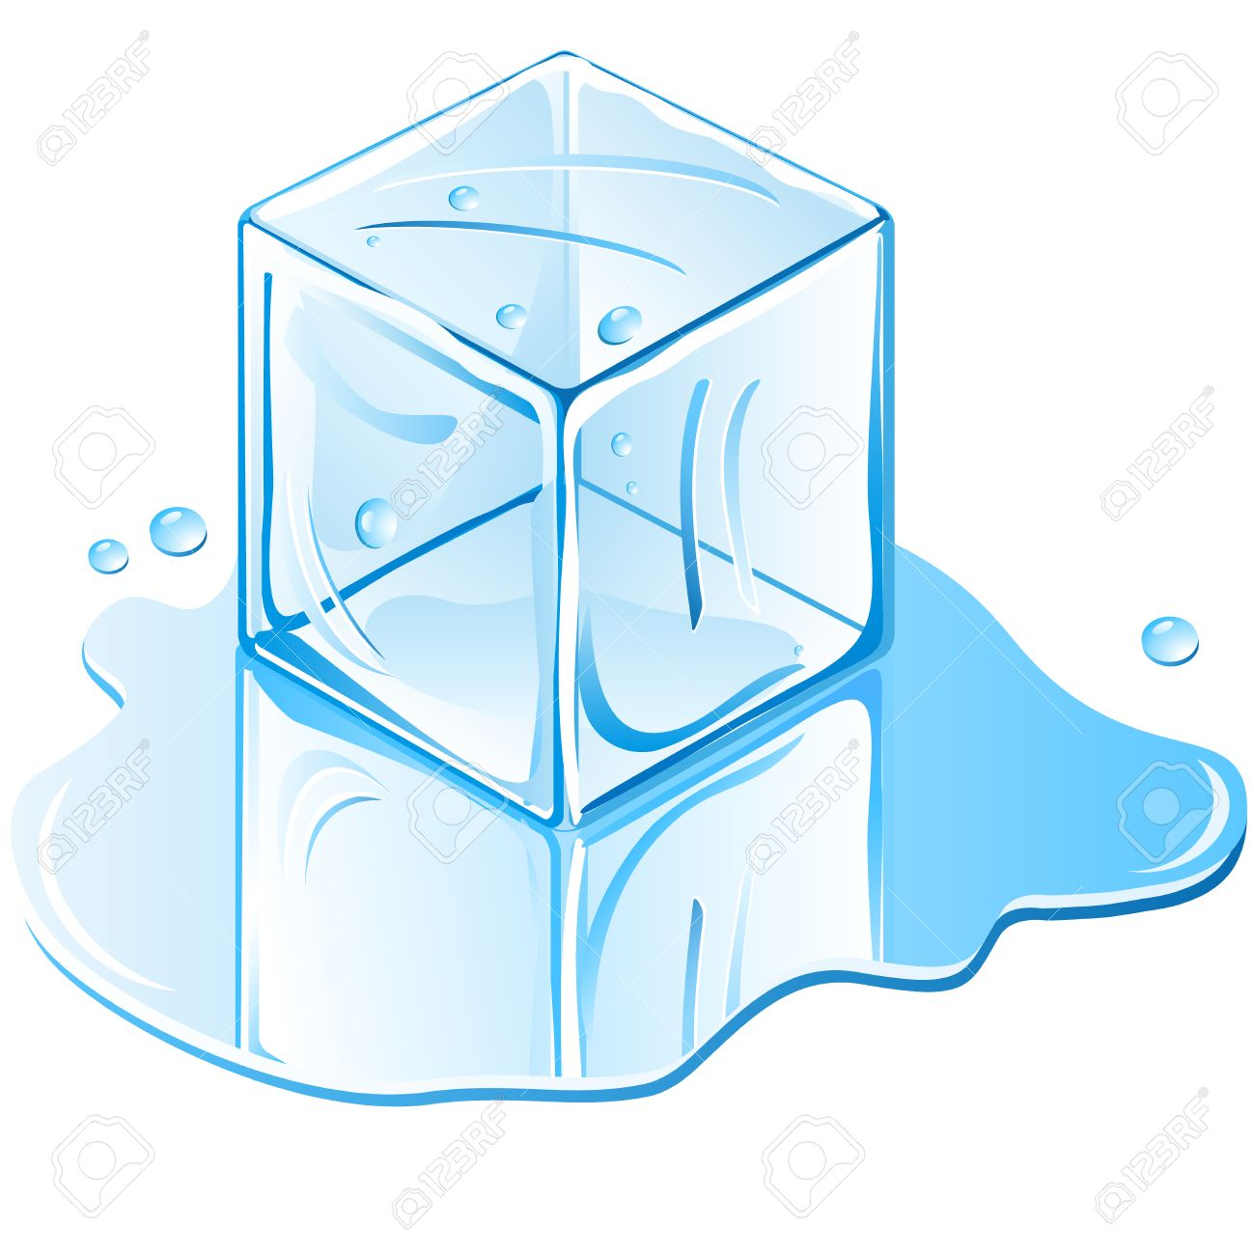
freeze | 
melt | 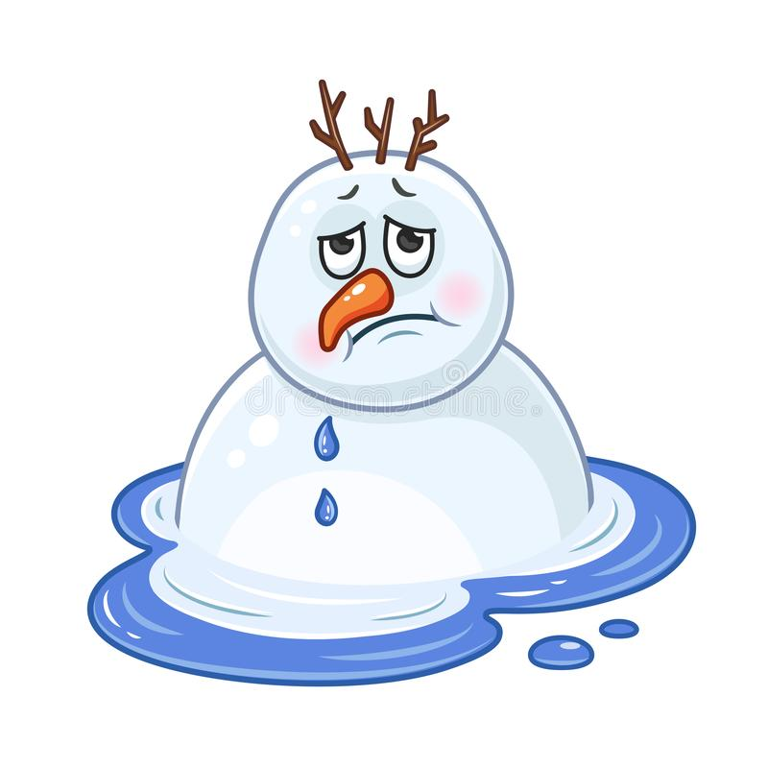
2) Circle the correct word:
steam - liquid - ice
heat - freeze - melt
gas - liquid - solid
3)Fill in the blanks with the correct word:
flows liquid steam freeze solid
- Milk is a ____________.
- When I want to make something very cold, I _______ it.
- Water changes into _________ when it is boiled.
- The river _________ into the lake.
- ________can be hard and soft.

T. Raneem Haddad Coordinator’s Signature: _______

