
Grammar worksheet (6)
Grade 2
Name: ------------ Date: / 11 /2023
Objective: To practice using subject and object pronouns.
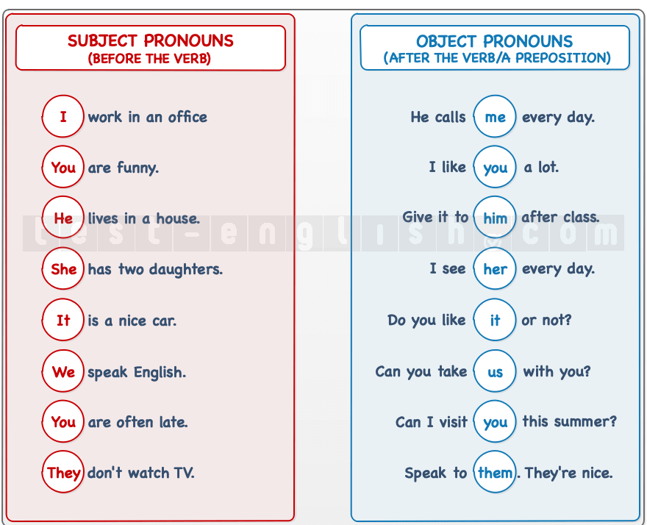

- Fill in the blanks with ( She, He, It, They, We or You)
1-Miriam is a good doctor. She is my sister.
2- Ward likes apples . He eats apples a lot.
3-Zaid and Jiovanni are twins. They are lovely kids.
4- My ball is big . It is black and white.
5- I am Elias.
6- She is my mother.
7- Saed, Raed, Yazeed and I are family. We are a happy family.
_______________________________________
- Look at the picture and choose the correct pronoun.
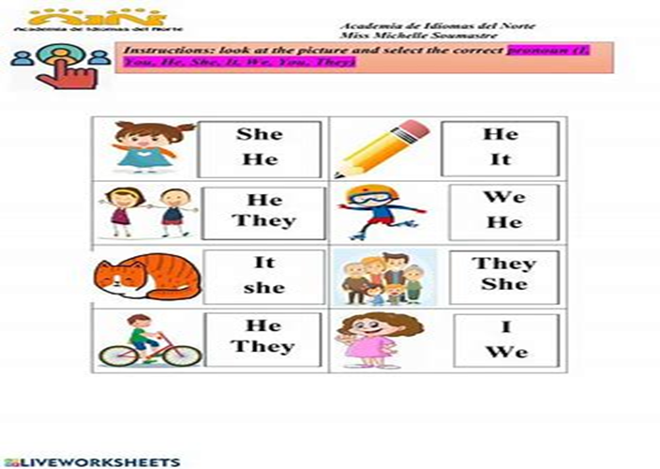
3) Circle the correct answer.
1-Angelina is my best friend. I met ------ yesterday.
him her me
2-Tia and George are friends. I love ---------very much.
us it them
3- My dad gives me a car. -------is red.
She It You
4- My dad is kind. I asked------- to give me a present.
him her them
5- Fish have gills. Gills help -------- to breathe.
they them you
T.Raneem Haddad Coordinator’s Signature:

