

**Worksheet |** The Primary Stage of Grades (4-5)

2023-2024

|  |  |
| --- | --- |
| **Name:** ……………………………………… | **Subject:** English Language  **Revision Sheet #2** |
| **Date:** / / | **Class:** Grade 4 (All Sections) |

**­­­**

**Objective/s: :** To read a text and answer comprehension questions.

To practise some grammatical concepts covered.

**Read the text then answer the questions that follow:**

**Jakarta**

Do you live in a city and have nothing to do? Just step outside! A city has fascinating things to see and interesting places to explore. No one could see everything in one day. This brief look at Jakarta, the capital city of Indonesia, is a good example of what a city has to offer.

Jakarta is a busy port city on the Java Sea. It is filled with more than 10 million people. That's more people than in New York City. Its area is also huge—250 square miles (646 square kilometers).

This Southeast Asian city stretches high into the sky. Countless skyscrapers give the city a futuristic feel. When you first arrive, it feels like you just stepped off a spaceship.

Jakarta is one of the most congested cities in the world. You might even say they invented the traffic jam. Jakarta is also highly polluted. With so many trains, cars, and motorcycles, it is no wonder.

**A VISIT TO THE OLD CITY**

Parts of the original Dutch city can still be found in the area called Kota. Kota is located on the north side of the city. It is a great place to wander around. It has old canals and classical architecture.

The port of Sunda Kelapa is near Kota. Thousands of boats dock here every year. They transport things like coffee, tuna, and exotic fruits.

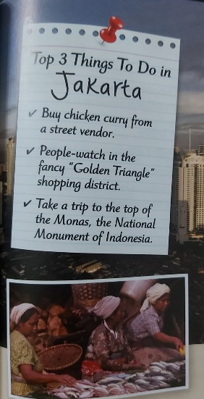

After watching the ships come and go, check out the Pasar Ikan fish market. It is a great place to inspect strange and exotic fish. It is also a great place to watch people as they shop for dinner and haggle over the price of shrimp.

**GETTING AROUND**

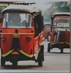Indonesia is famous for its rickshaws. These were small, one-passenger carriages that were pulled by a bicycle. Now, they are banned in Jakarta. They were too slow and held up traffic. They have been replaced by the bajaj, which is a motorized rickshaw. A bajaj is a big seat on wheels pulled around by a moped, a motorized bicycle. Hire a bajaj easily to take you around the city.

**MODERN CULTURE**

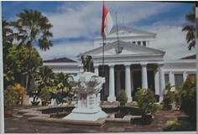Do you want to learn more about the culture of the Indonesian people? Then check out the National Museum. Located in the heart of town, the National Museum is packed with art, historical items, and great displays of Indonesian culture.

You should also head to the Jalan Surabaya antiques market. This is a great spot to pick up souvenirs. You'll find such things as handmade drums, batik-dyed clothing, and jewelry.

1. Which city has more people Jakarta or New York?

__________________________________________________________________

1. What makes Jakarta feel like a city from the future?

__________________________________________________________________________________________________________________________________________

1. How is Kota different from other parts of Jakarta?

__________________________________________________________________________________________________________________________________________

1. What can you do at the Pasar Ikan fish market?

__________________________________________________________________________________________________________________________________________

1. Why is the bajaj better than rickshaw?

__________________________________________________________________________________________________________________________________________

1. The text you read is a non- chronological report. Tick two features of non- chronological reports.

Impersonal

Personal

Written in formal style

Written in an informal style

1. The word “vendor” in the following sentence means:

**“Buy chicken curry from a street vendor.”**

1. A person who sells something.
2. A person who drives a carriage.
3. A person who is begging for money.
4. Which word in the following paragraph means “**something made in an earlier period that is collected and considered valuable**”.

“You should also head to Jalan Surabaya antique market. This is a great spot to pick up souvenirs. You will find such things as handmade drums and jewelry.”

________________

1. Find a modal verb in the last paragraph. _______________________

**Part 2: Grammar**

1. Underline the **main clause** in each of the following sentences:
   1. When you first arrive, it feels like you just stepped off a spaceship.
   2. You are allowed to go as long as you let us know when you arrive.
2. Underline the **subordinate clause** in each of the following sentences:
   1. After watching the ships come and go, check out the Pasar Ikan market.
   2. He went to work even though he was unwell.
3. Join each pair of the following clauses to make a **complex sentence** using a suitable connective**.**
4. You want to pick up souvenirs. You have to visit the Jalan Surabaya antiques market. __________________________________________________________________________________________________________________________________________
5. Jakarta is a busy port city. It has a population of over 10 million people. __________________________________________________________________________________________________________________________________________
6. Rewrite the following sentences, putting the clause in brackets **into the middle** of the sentence.
7. My chemistry book has some really great topics. (which weighs about 100 pounds)

__________________________________________________________________________________________________________________________________

1. Chocolate always makes me feel better after a bad day. (my favorite treat)

__________________________________________________________________________________________________________________________________

1. **Add the missing commas.**
2. If you ever need a ride just let me know.
3. We wanted to go to Spain for our holiday but the hotels are too expensive in summer.
4. Apples which are my favorite fruit are the main ingredient in this recipe.
5. Last Sunday evening classes were cancelled
6. **Choose the correct modal verb to fill in the blanks.**
7. When you get in the car, you ____________ put your seatbelt on.

(must, might, shouldn’t)

1. You ___________ hurt people or steal things.

(must, might, shouldn’t)

1. I _____________ ride my bike home because it has a flat tyre.

(will, can’t, could)

1. We ____________ go to the zoo at the weekend.

(might, ought not, shouldn’t)

1. The question is too difficult. I ___________ answer it.

(can’t, couldn’t, could)

1. I ____________ open the door because it didn’t have a key.

(can’t, couldn’t, could)

**8.Identify the figurative language (simile, metaphor, personification, alliteration, onomatopoeia) used in the following sentences.**

1. She sang like an angel.________________
2. She is a walking dictionary. _______________
3. The flowers begged for water. _________________
4. The bee buzzed in my ear. _________________
5. The stars danced playfully in the sky. ___________________
6. Love is a jewel. _____________________
7. Jesse’s jaguar is jumping and jiggling. _____________________
8. Noor is as quick as lightning when she runs. _____________________
9. The wolf howled in the night. _____________________