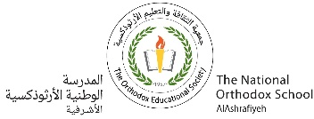

**Our value: Alone we can do so little; together we can do so much.**

**Vocabulary _ Unit 3**

**(The Cavity)**

**Name………………… Grade (5)**

|  |
| --- |
| **Objectives**  **1. Identify the meaning of the new words.**  **2. Identify the synonyms of the new words.**  **3. Practice using the new words in sentences.** |

**Verbs**

|  |  |  |
| --- | --- | --- |
| **Word** | **Meaning /Synonym** | **Example** |
| Scrub | To **clean** by rubbing hard. | Scrub the wood thoroughly with water and a stiff brush. |
| Thrill | To **excite** | If you want to thrill the audience, taking risks is essential. |
| Scurry | To **run** | All the chicks scurry to shelter. |
| Attack | To **beat**. | Brazil began to attack more in the second half of the match. |
| Stray | To **get lost**. | Be careful not to stray from the path. |
| Munch | To **chew**. | He will munch two carrots. |
| Slice | To **cut** something into thin pieces. | I’ll slice it for you as thick as you want. |
| Grip | To **keep hold** of someone or something firmly. | The brake doesn’t grip properly. |
| Crush | To **press** someone or something hard so that he/ she/ it is broken, damaged or injured. | They crushed the olives with a heavy wooden crusher. |

**Adjectives**

|  |  |  |
| --- | --- | --- |
| **Word** | **Meaning /Synonym** | **Example** |
| Nasty | **Awful**. | You can get a nasty sting from a jellyfish. |
| Yummy | **Delicious**. | I think I'll have some more of that yummy chocolate cake. |
| Defective | Having a defect; **imperfect**. | I exchanged the defective tire for a good one. |

**Nouns**

|  |  |  |
| --- | --- | --- |
| **Word** | **Meaning /Synonym** | **Example** |
| Canines | The four **sharp, pointed teeth** towards the front of your mouth. | His canines are very big and sharp. |
| Molars | **The largest teeth** at the back of the mouth. | The horse softens food by chewing the food between his molars. |
| Jaws | The **bones** **of the mouth** forming the framework | The deer could not escape the crocodile’s jaws. |
| Cavity | **A hole in a tooth.** | I’ve got a cavity right inside my tooth. |
| Incisors | The four **front teeth** in each jaw, used for cutting and gnawing. | Toddlers have small incisors. |
| Carnivores | An animal that eats meat only. /  **meat-eater** | Danger in the wild comes from the carnivores. |
| Herbivores | An animal that eat plants only. / **vegetarian** | Sheep, cows and horses are herbivores |
| Omnivores | **An animal or person that eats both plant and meat.** | Humans and birds are omnivores. |
| Prey | An animal that is hunted and killed by another for food./**victim** | The big bird carried its prey in its claws. |
| Treat | A **gift**. | Johnny’ dad gave him a treat because he got high marks. |

1. **Write the synonym of each of these words**:
2. Scrub --------------------------
3. Thrill --------------------------
4. Scurry --------------------------
5. Attack --------------------------
6. Stray --------------------------
7. Munch --------------------------
8. Nasty --------------------------
9. Yummy --------------------------
10. Defective --------------------------
11. Jaws --------------------------
12. Cavity --------------------------
13. Carnivore --------------------------
14. Herbivore --------------------------
15. Omnivore --------------------------
16. Prey --------------------------
17. Treat --------------------------
18. **Write the correct word under each picture.**

|  |
| --- |
| Gum _Crush _ Grip _Slice_ Scrub _Thrill _ Scurry _ Attack _ Stray _Munch _ Nasty ache _ Yummy _ Defective _ Canines _ Molars _ Jaws _ Cavity_ Incisor _ Carnivore _ Herbivore _ Omnivore _ Prey _ Treat. |

 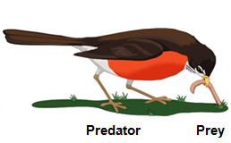 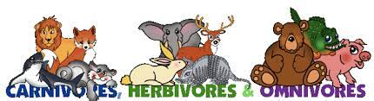 

---------- -------------- ---------------- --------------------

 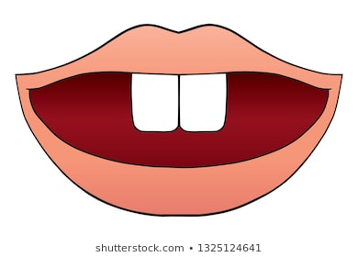 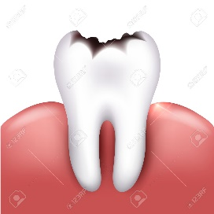 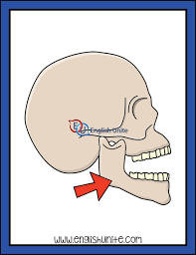

---------------- ------------------ ---------------- --------------

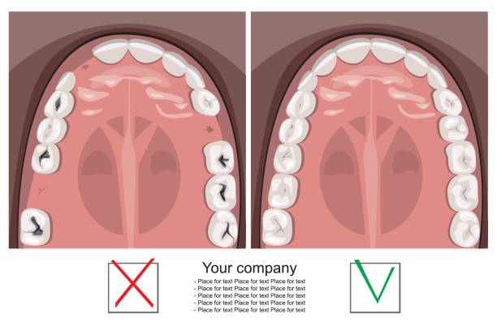 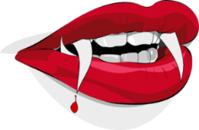 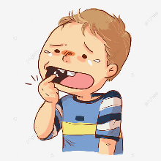 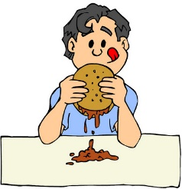 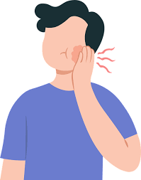

------------------ ------------- ------------ ------------- ------------

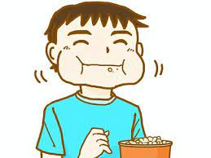  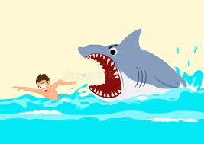 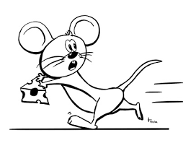

---------------- -------------- ------------------- --------------------

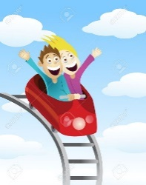 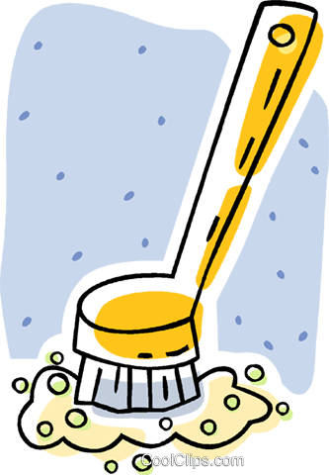 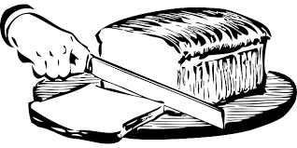 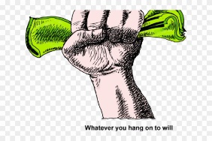 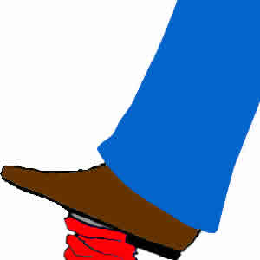

------------ ---------- ------------ ------------ -------------

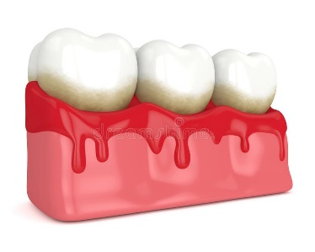

----------------------

1. **Fill in the gaps with the correct words from the box.**

|  |
| --- |
| Omnivores _ Thrill _ Attack _Stray _ Munch _ Nasty _ Yummy _ Canines _ Defective _ Treat _ Jaws _ Cavity_ Scrub _ Incisor _ Carnivores _ Herbivores _ Prey _ Molars |

1. I gave my dog a ----------------- for his good behavior.
2. The lion attacked its ----------------- quickly.
3. Humans are -----------------. They eat all kinds of food.
4. Cows are -----------------. They eat grass.
5. Lions and tigers are ----------------.
6. The first tooth that appeared for the baby is the lower --------------.
7. There’s a -------------- in the boy’s tooth.
8. The fish has strong -------------- and sharp teeth.
9. The elephant grinds its food with its powerful ----------------.
10. Her two --------------- are very large and give her the appearance of a vampire.
11. The building was destroyed when the --------------- boiler exploded.
12. This cake is really---------------
13. He had a -------------- moment when he thought he'd lost his passport.
14. I will ---------- all the food.
15. Tourists often get lost and --------------- into dangerous areas.
16. They decided to --------------their enemy's southern side.
17. His songs continue to --------------the audience.
18. I started to ---------------- off the dirt.
19. **Find the synonyms of the following words in the crossword and write them down.**

|  |  |  |  |  |  |  |  |  |  |  |  |
| --- | --- | --- | --- | --- | --- | --- | --- | --- | --- | --- | --- |
| v | e | c | s | c | l | e | a | n | f | i | n |
| a | w | g | u | a | r | u | n | e | a | r | y |
| b | i | t | e | a | c | t | u | l | b | n | m |
| s | c | h | e | w | c | h | y | o | n | a | d |
| g | a | w | f | u | l | y | p | y | o | r | h |
| r | a | w | d | e | l | i | c | i | o | u | s |
| e | c | g | a | b | o | n | e | s | v | e | c |
| t | v | i | c | t | i | m | t | i | o | n | v |

1. Scrub ------------- 5. Scurry -----------------
2. Munch -------------- 6. Prey ------------------
3. Nasty ----------- 7. Yummy ----------------
4. Jaws -----------

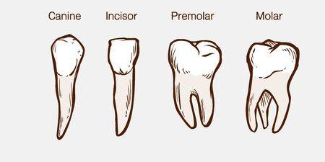

Teacher: Michleen Abyad

Coordinator’s Signature: --------------------------