**Grammar Study Sheet|** Lower Secondary

1st Semester 2023/2024 Stage (6-8)

|  |  |  |
| --- | --- | --- |
| **Name:** | ________________________________ | **Subject: English – Question Tags** |
| **Unit 3: Terrific Technology** |
| **Date:** | **________________________________** | **Class: Grade 7CS – Section: __________** |

**Objective:**

* to use different forms of questions in a way that serves the purpose of writing effectively **­­­**

**Question Tags**

**Question tags** are short questions at the end of statements.

They are mainly **used in speech** when we want to:

* confirm that something is true or not, or
* to encourage a reply from the person we are speaking to

Question tags are formed with ***the auxiliary or modal verb*** from the statement **and the appropriate subject**.

|  |  |  |
| --- | --- | --- |
| A **positive** statement is followed by a **negative** question tag.   * Jack **is** from Spain, **isn't** he? * Mary **can** speak English, **can't** she? |  | A **negative** statement is followed by a **positive** question tag.   * They **aren't** funny, **are** they? * He **shouldn't** say things like that, **should** he? |
|  |  |  |
| When the verb in the main sentence is in the*present simple*we form the question tag with**do /does**   * You *play*the guitar, **don't** you? * Alison *likes*tennis, **doesn't** she? |  | If the verb is in the *past simple* we use **did**.   * They *went* to the cinema, **didn't** they? * She *studied* in New Zealand, **didn't** she? |

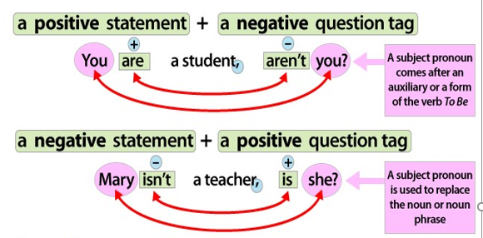

**Positive Question Tags**

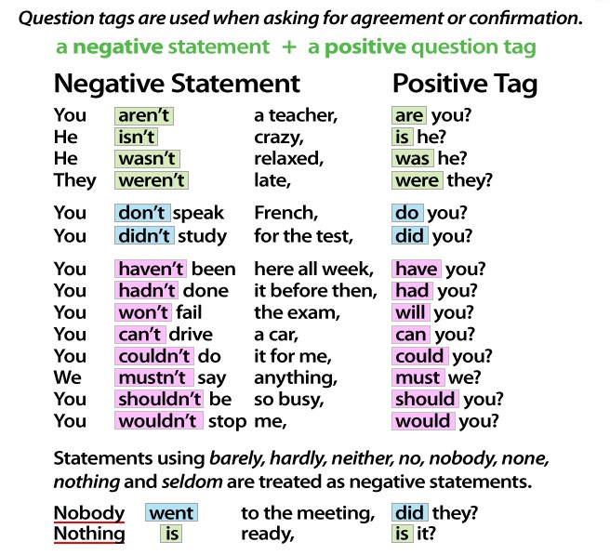

**Negative Question Tags**

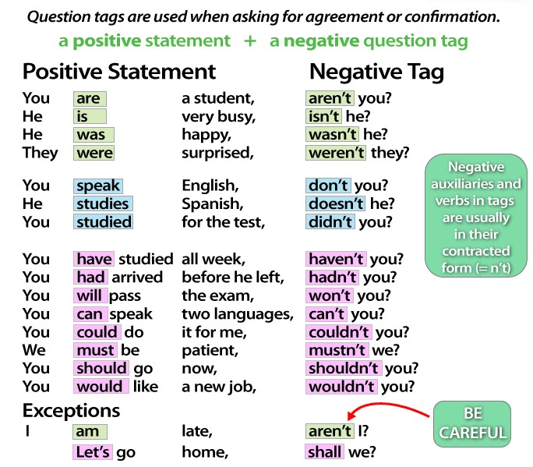

**Practice**

**Complete the following questions using question tags. Don’t forget to complete your questions with a question mark!**

1. The baby is innocent, **______________**
2. Nothing comes out of nothing, **_______________**
3. The glass contains little water, **_______________**
4. In our class everybody knows everybody, **_______________**
5. The mother rose in her, **______________**
6. None can do this, **_________________**
7. I am happy, **___________**
8. The universities have opened recently, **_______________**
9. They have tried but failed, **_________________**
10. Everyone should respect the teachers, **________________**
11. The team is qualified, **________________**
12. He never goes out with his dog, **_______________**
13. She could have been more discreet, **_______________**
14. He locked the papers in the safe, **________________**
15. For the boys the task was easy, **__________________**
16. You broke the machine, **________________**
17. Come and see me tomorrow, **________________**
18. He can go to college by bus, **________________**
19. The girl cried for help, **________________**
20. We didn’t play very well today, **__________________**