**Work Sheet** **|** Lower Secondary

Stage (6-8)

1st Semester | 2023-2024

|  |  |
| --- | --- |
| **Subject:** Biology | **Chapter:** specialized cells  Name:  Grade 6 (all sections) |
| **Objectives:**   * Relate the structure of cells to their functions. | |

………………………………………………………………………………………………………………………………………………………………

Name the specialized plant and animal cells from the box below.

Red blood cell White blood cell Bone cell Ciliated cell Fat cell

Palisade cell Root hair cell Muscle cell Nerve cell

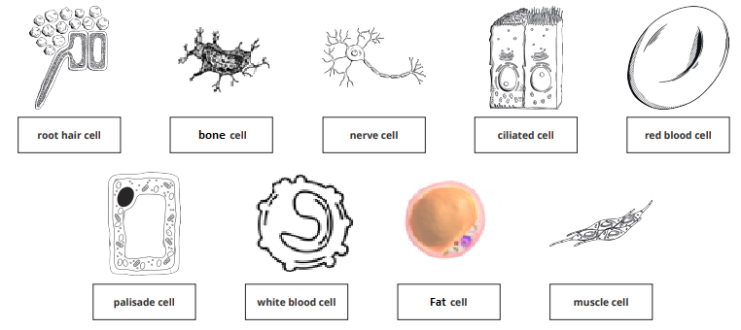

**Question Two:**

Name the cell or function or the adaptation of each cell.

|  |  |  |
| --- | --- | --- |
| **CELL** | **FUNCTION** | **ADAPTATION** |
| Root hair cell | To absorb water from the soil | -long thin extensions to grow easily between soil particles  - provide a large surface area to increase absorption |
| Fat cell | They act as an energy store | -The nucleus and cytoplasm are squeezed to the side to make room |
| Bone cell | -make fibers and excrete them into their surroundings | Produces fibers that attract minerals to make a rigid solid |
| Red blood cell | -to carry oxygen around the body | -thin flexible disc shaped  -biconcave  -no nucleus  To make more room for hemoglobin |
| White blood cell | Involved in protection and fighting diseases | -Irregular shapes  Lymphocyte produces antibodies  Phagocyte engulfs harmful microorganisms |