**Study sheet 3|** Lower Secondary

Stage (6-8)

1st Semester | 2023-2024

|  |  |
| --- | --- |
| **Subject:** ICT | **Chapter:** 3 |
| **Objectives: Introduce If -Else Statement.** | |

|  |
| --- |
| **if test expression:**  **Code to run when test expression is TRUE**  **else:**  **Code to run when test expression is FALSE** |

**Syntax of if … else**

The if...else statement evaluates test expression and will execute the body of if only when the test conditions is **True**.

If the condition is **False**, the body of else is executed.

**Example#1**

**Write a program that:**

a. Input and print your name.

b. Input the three grade G1, G2 and G3 and then calculate and print the average.   
 **Average = (G1 + G2+ G3) / 3**

c. If the Average is greater than or equal to 50 print (“Pass”)   
 else print (“Fail”)

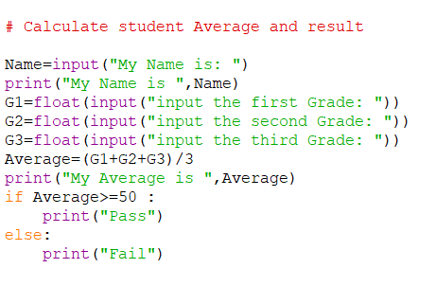

**Example#2**

**Write a program to check if a number is positive or negative.**

(If a number is greater than zero, it is a positive number. If a number is less than zero, it is a negative number.)

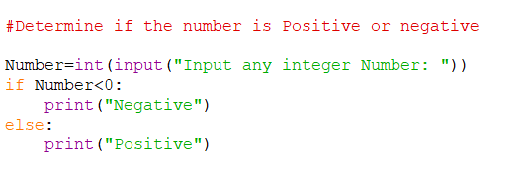

**Example#3**

**Write a program that compare two numbers and print the largest.**

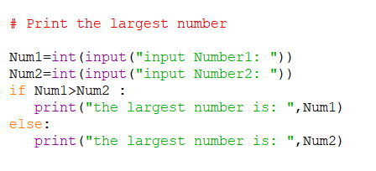

**Example#4**

**Write a program that print whether a number is odd or even**

**You will need to find the remainder (Mod** 🡺 **% in python)**

**Mod finds the remainder of the division**

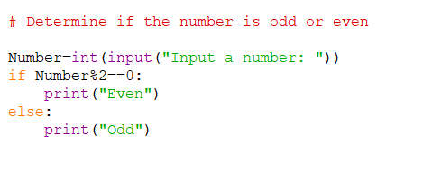

**Example#5**

**Write a program that find and print the square of a number.**

* **Input a number**
* **Find the square of the number: Power=X**2**
* **Print the square of the number**

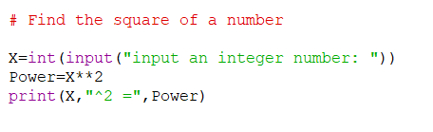

**Example#6**

**Write a program that calculate your age and then: if your age is greater than 18 print (“I’m Adult), else print (I’m child)**

* **Input your name.**
* **Print your name.**
* **Input your birthyear.**
* **Calculate your age.**
* **If your age is greater than 18 print (“I’m Adult)   
  else print (I’m child)**

