

**Worksheet** **|** Lower Secondary

Stage (6-8)

1st Semester | 2023-2024

|  |  |
| --- | --- |
| **Subject:** Biology | **Chapter: Digestive enzymes** |
| **Objectives:**  Recognize the main digestive enzymes. **Name:** | |

1. **Label the organs in the digestive system.**

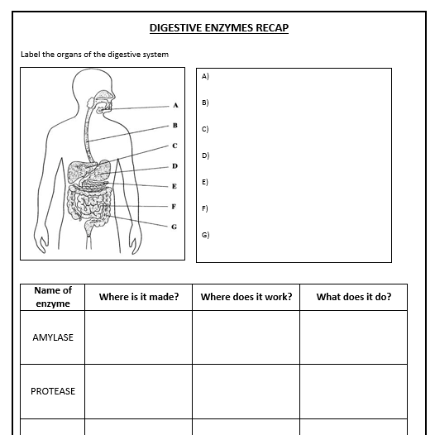

1. **Fill in the table below.**

|  |  |  |  |
| --- | --- | --- | --- |
| **Enzyme** | **Where is it made?** | **What does it to?** | **Where does it work?** |
| **Amylase** |  |  |  |
| **Protease** |  |  |  |
| **Lipase** |  |  |  |