

**Worksheet** **|** Lower Secondary

Stage (6-8)

1st Semester | 2023-2024

|  |  |
| --- | --- |
| **Subject:** Biology | **Chapter: Digestive enzymes** |
| **Objectives:**  Recognize the main digestive enzymes. **Name:** | |

1. **Label the organs in the digestive system.**

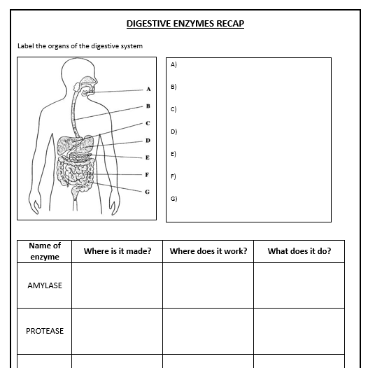

Mouth

Esophagus

Liver

Stomach

Pancreas

Small intestine

Large intestine

1. **Fill in the table below.**

|  |  |  |  |
| --- | --- | --- | --- |
| **Enzyme** | **Where is it made?** | **What does it to?** | **Where does it work?** |
| **Amylase** | Salivary glands  Pancreas  Small intestine | Turns starch into small sugars | Mouth/ small intestine |
| **Protease** | Stomach  Pancreas  Small intestine | Turns proteins into amino acids | Stomach/ small intestine |
| **Lipase** | Pancreas  Small intestine | Turns lipids into fatty acids and glycerol | Small intestine |