**Work Sheet** **|** Lower Secondary

Stage (6-8)

1st Semester | 2023-2024

|  |  |
| --- | --- |
| **Subject:** Biology | **Chapter:** specialized cells  Name:  Grade 6 (all sections) |
| **Objectives:**   * Relate the structure of cells to their functions. | |

**1.Question One:**

Name the specialized plant and animal cells from the box below.

Red blood cell White blood cell Bone cell Ciliated cell Fat cell

Palisade cell Root hair cell Muscle cell Nerve cell

Red blood cell White blood cell Bone cell Ciliated cell Fat cell

Palisade cell Root hair cell Muscle cell Nerve cell

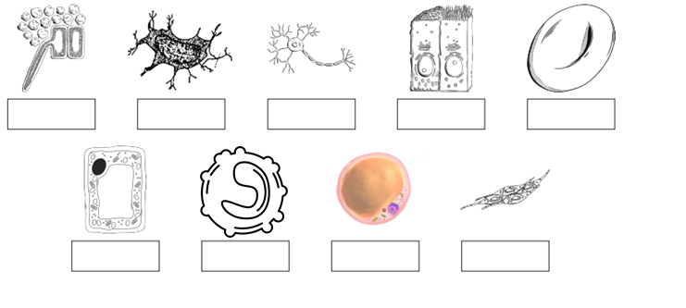

**Question Two:**

Name the cell or function or the adaptation of each cell.

|  |  |  |
| --- | --- | --- |
| **CELL** | **FUNCTION** | **ADAPTATION** |
| Root hair cell |  |  |
|  | They act as an energy store |  |
|  |  | Produces fibers that attract minerals to make a rigid solid |
| Red blood cell |  |  |
|  | Involved in protection and fighting diseases |  |