
Meaning Worksheet ( 3 )
Grade 1
Name: Date: 28 / 11 /2023
- Study the words below:
word | meaning
red | 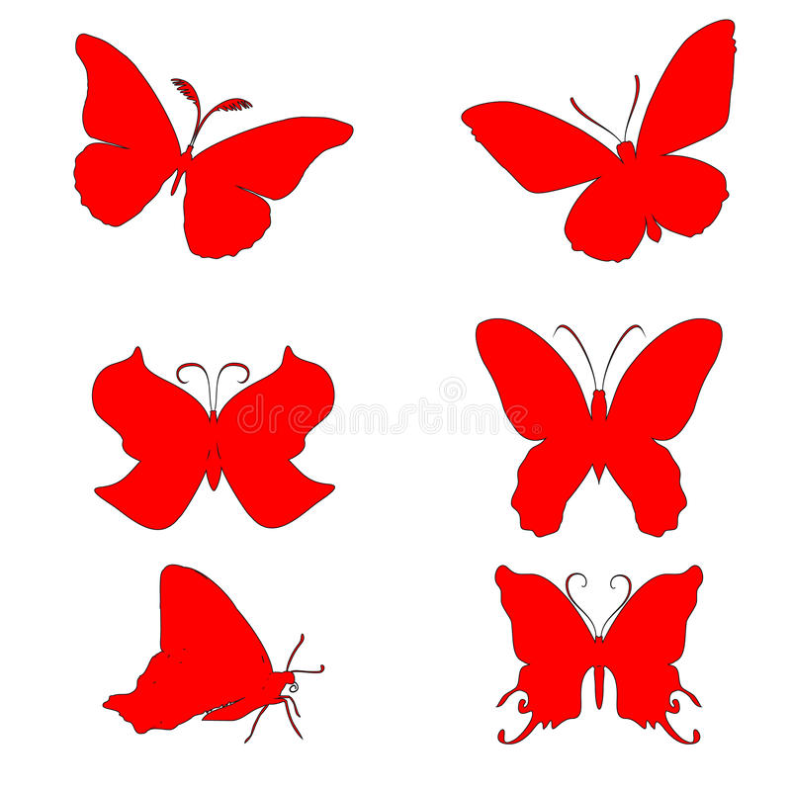
yellow | 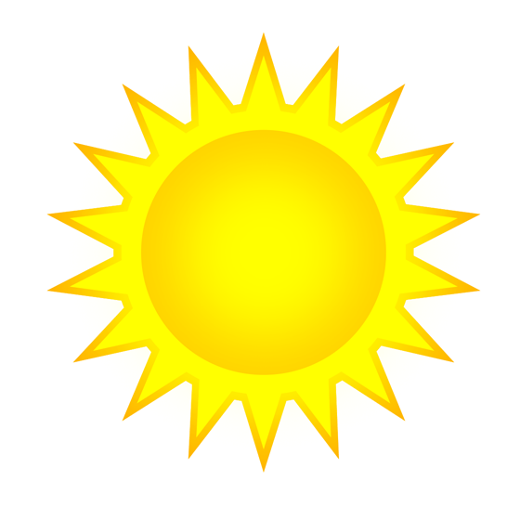
green | 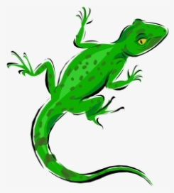
blue | 
white | 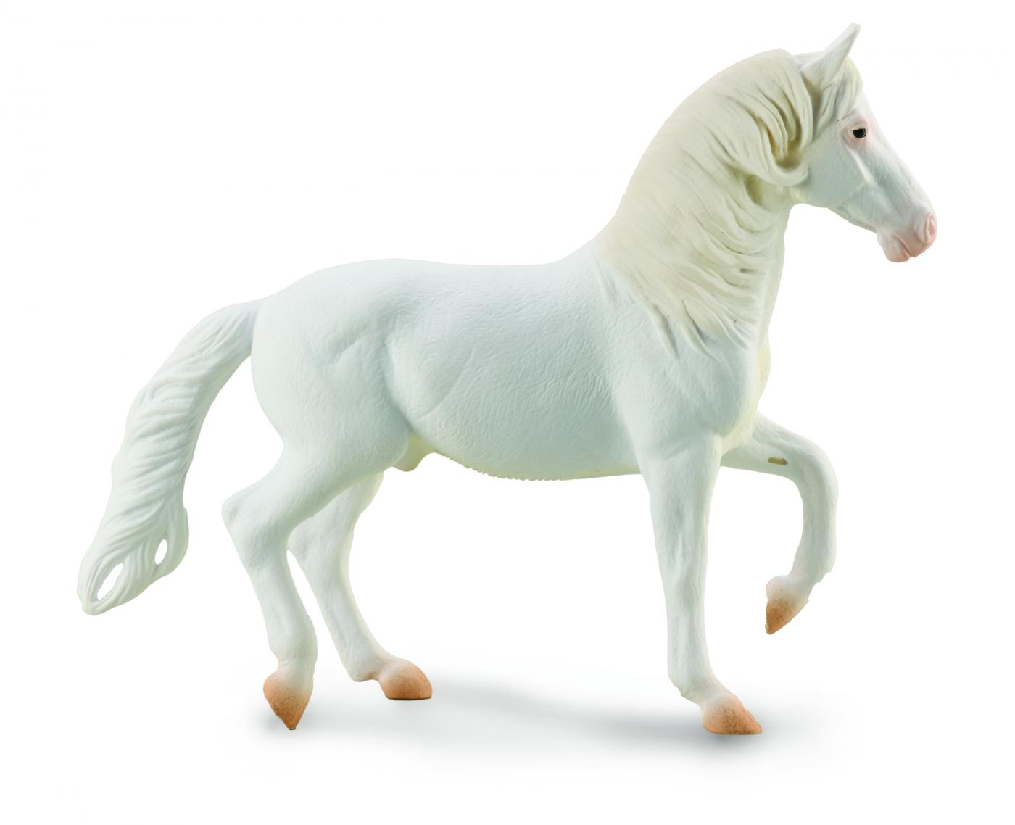
black | 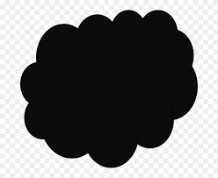
brown | 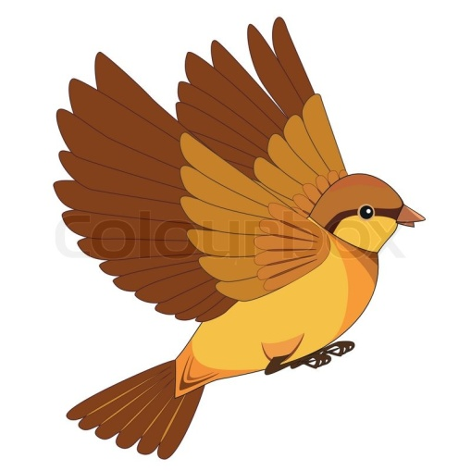
purple | 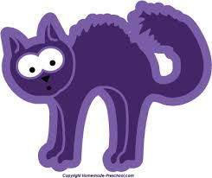
grey | 

2) Circle the correct word:
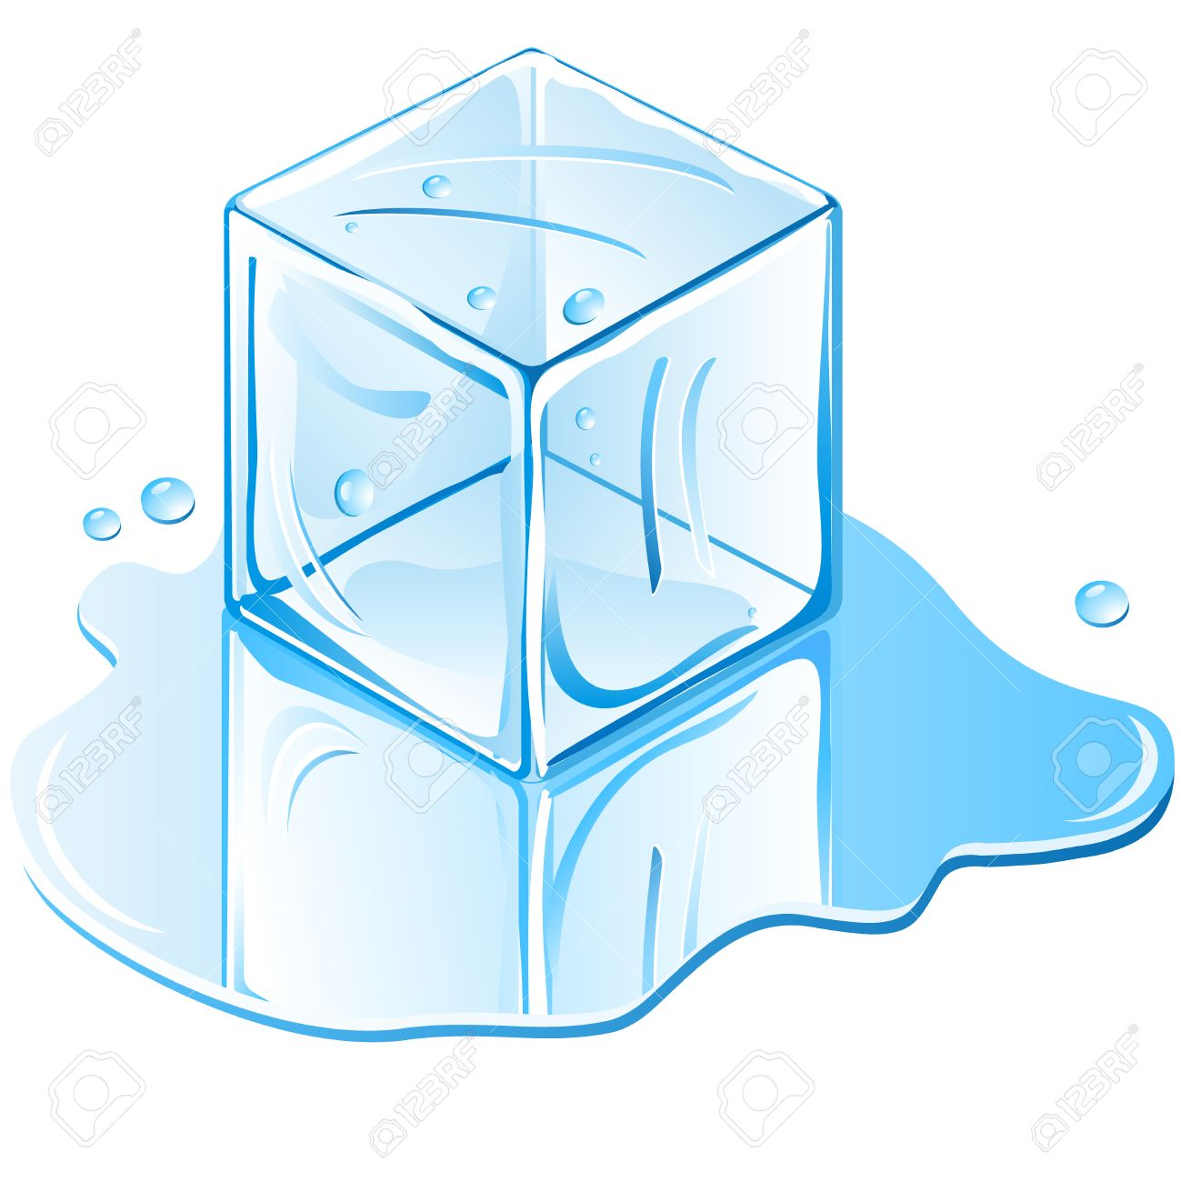
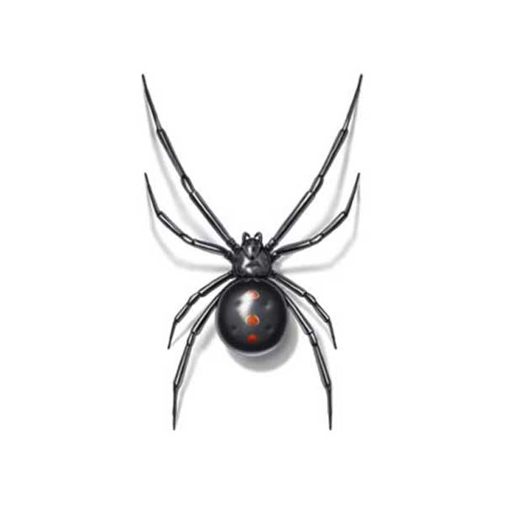 yellow - blue - black

blue – green- red

- Fill in the blanks with the correct word:
yellow green blue white grey red

- Milk is white.
- The sun is yellow.
- We can see two grey elephants.
- Apples can be red-and green.
- Blue is my favourite colour. It is the colour of the sky.

T.Taghreed Alnimri

