

Worksheet ( 13 )
Grade 1
Name: Date: 29 /11 /2023 __________________________________________________
Objective: To use There is and There are in sentences.
There is / There are

There is | a/an | Singular nouns
There are | two,three, four, …… | Plural nouns

1)Look at the picture below then complete the sentences with There is or There are:
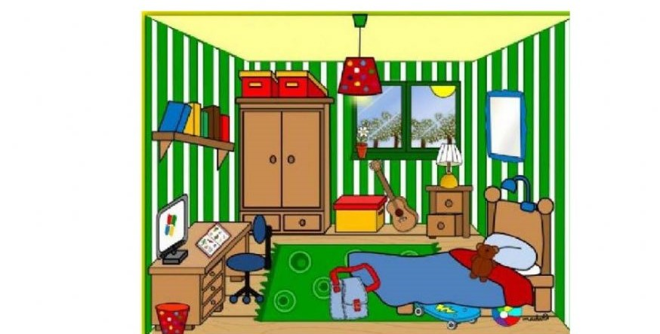

1.There is a chair.
2.There is one computer.
3. There are three lamps.
4. There is a bag on the carpet.
5. There are five books on the shelf.
6. There is a book on the desk.
7. There are toys in the bedroom.

2) Order the words to make meaningful sentences.
frogs./ four / are / green / There

There are four green frogs.

T.Taghreed Alnimri

