**Worksheet |** The Primary Stage of Grades (4-5)

2023-2024

|  |  |
| --- | --- |
| **Name:** ……………………………………… | **Subject: English Language**  Fiction Writing Worksheet # 4 |
| **Date:**  / / | **Class:** Grade 5 (A, B, C, D, E, F, G) |

**Objective/s: Apply the narrative features and create a different version of a folk tale.**

**The Emperor’s New Cloak**

A long, long time ago, there lived an Emperor. He was very rich and he loved new cloaks. He filled many rooms in the palace with huge wardrobes. In every wardrobe he hung beautiful cloaks.

The Emperor loved to dress up in his beautiful cloaks and ride through the streets of the town. He wanted all the people to see his splendid cloaks and how smart he looked in them.

One day, two strangers came to the palace. They said they were excellent tailors and that they wished to speak to the Emperor. Now, the Emperor did not usually see people who were not invited to the palace, but tailors made cloaks so he was willing to see them!

They bowed low to the Emperor, and one of the tailors said “We have heard that you love new cloaks. For many years, we have made the most fabulous cloaks. We wish to make one for you with shining gold thread.”

The second tailor said, “We weave our own amazing cloth and it is as light as air, but only the wisest of people can see it. We know that you will be able to see it because you are very wise. Look at this beautiful cloth!”

The Emperor stared at the tailors who seemed to be holding up the beautiful and amazing cloth. He didn’t want to admit that he couldn’t see anything so he gave the tailors a large, pleasant room in the palace to begin work immediately. The tailors were very pleased because the Emperor had agreed to pay them a lot of gold for the wonderful cloak.

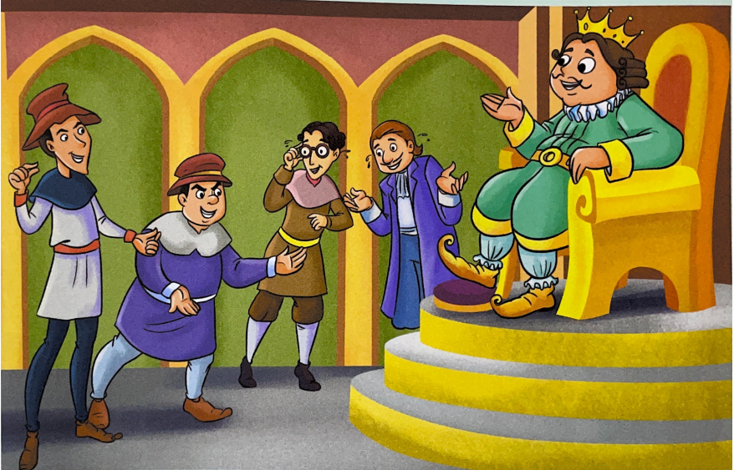

After a few days, the Emperor sent three of his ministers to see how the tailors were getting on. They went to the room where the tailors were weaving the amazing cloth, but they could see no cloth! None of them wanted to admit they were foolish, so they all agreed how beautiful the cloth was. They went back to the Emperor and told him the cloth was the most beautiful in the world.

Very soon, the tailors said they had finished the cloth and made it into a beautiful cloak. They brought the cloak to the Emperor. “You should wear it today as you ride through the crowded streets,” said one of the tailors. “Everyone will see how splendid you look!”

“Yes, yes,” said the Emperor. “That is a wonderful idea.” The Emperor looked but could see nothing! He did not want to admit that he was foolish so he let them put the cloak on his shoulders. He could not see it, but paid the tailors the gold. All the ministers said how wonderful the Emperor looked. None of them could see the cloak, but none of them would admit it.

The Emperor and his ministers rode out into the town. People had gathered in the streets. They wanted to see the Emperor’s new cloak. They knew that only wise people could see the cloak, so they pretended they could see it. They clapped and cheered. No one wanted to admin that they were foolish.

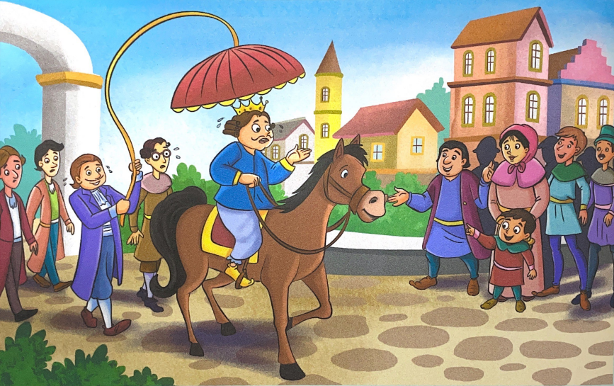

There was one little boy called Tom in the crowd, who always told the truth. When he saw the Emperor he shouted, “He isn’t wearing a cloak!”.

The people around told the little boy to be quiet. “The cloak is beautiful,” they told him crossly. “No!” shouted the little boy. “He’s not wearing a cloak!”

The people began to look at each other. They asked quietly if anyone could see the cloak. No one could. They all felt ashamed. Soon, everyone was telling the truth. The Emperor was not wearing a cloak. The people began to laugh. The Emperor and his ministers felt very foolish! They rode quickly back to the palace. As they were entering the palace gates, the tailors were leaving. The ministers stopped the tailors and took their bags. The Emperor got his gold back, but it was a long time before he rode through the streets again, showing off his wonderful cloaks.

You have read the story of the *Emperor’s new cloak* some of the characters lied about what they saw. Tom told the truth about what he saw.

You are now going to write a different version of the story.

Here’s a summary of the different version:

|  |
| --- |
| * The Emperor loves music. * Two musicians come to the palace * They say they are wonderful musicians but that only wise people can hear how good they are * They play for the Emperor. * They sound awful but the Emperor says they are wonderful. * He gives them a lot of gold. * He invites lots of people to hear the musicians play |

Remember to:

* Write 4 paragraphs four to six sentences in each.
* Describe the characters and setting using strong adjectives and adverbs.
* Use the past tense and third person pronouns.
* Use figurative language to describe what can be seen, heard, smelled and felt.
* Write the ending so it teaches a lesson.

**Planning**

1. 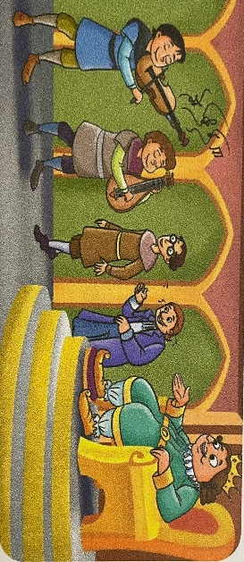Look at the pictures
2. Create a well-constructed paragraph under each picture describing the events.

----------------------------------------------------------------------------------------------------------------------------------------------------------------------------------------------------

--------------------------------------------------------------------------------------------------

--------------------------------------------------------------------------------------------------

------------------------------------------------------------------------------------------------------------------------------------------------------------------------------------------------------------------------------------------------------------------------------------------------------

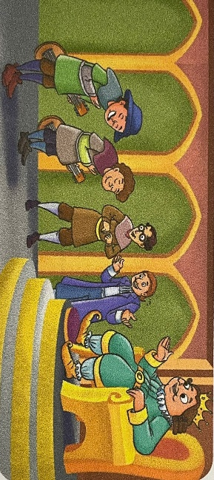--------------------------------------------------------------------------------------------------

--------------------------------------------------------------------------------------------------

--------------------------------------------------------------------------------------------------

--------------------------------------------------------------------------------------------------

--------------------------------------------------------------------------------------------------

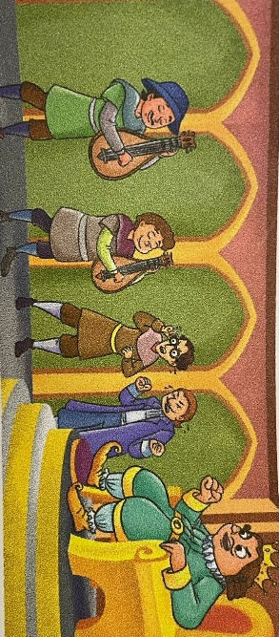----------------------------------------------------------------------------------------------------------------------------------------------------------------------------------------------------

--------------------------------------------------------------------------------------------------

--------------------------------------------------------------------------------------------------

--------------------------------------------------------------------------------------------------

--------------------------------------------------------------------------------------------------

------------------------------------------------------------------------------------------------------------------------------------------------------------------------------------------------------------------------------------------------------------------------------------------------------

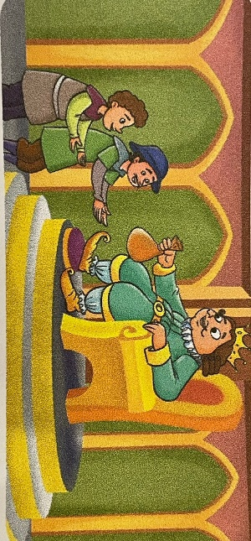

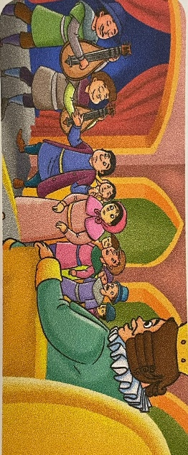----------------------------------------------------------------------------------------------------------------------------------------------------------------------------------------------------------------------------------------------------------------------------------------------------------------------------------------------------------------------------------------------------------------------------------------------------------------------------------------------------------

-------------------------------------------------------------------------------------------------

--------------------------------------------------------------------------------------------------

-------------------------------------------------------------------------------------------------

-------------------------------------------------------------------------------------------------

--------------------------------------------------------------------------------------------------

--------------------------------------------------------------------------------------------------

------------------------------------------------------------------------------------------------------------------------------------------------------------------------------------------------------------------------------------------------------------------------------------------------------

--------------------------------------------------------------------------------------------------------------------------------------------------------------------------------------------------------------------------------------------------------------------------------------------------------------------------------------------------------------------------------------------------------

**Fables and Folktales Rubric:**

|  |  |
| --- | --- |
| 1. **Creation of Text:** | **/4** |
| Writing is developed so that the features of the text type are clearly established. Simple plot, simple language and a lesson to be learned. |  |
| Consistent view point well presented. |  |
| 1. **Vocabulary and Language:** | **/2** |
| The setting and characters are well-described (using powerful adjectives and adverbs to add interest and effect). |  |
| Figurative language is used to vividly describe what can be seen, heard, smelled or felt. |  |
| 1. **Grammar and Punctuation:** | **/6** |
| Overall grammar and use of English are appropriate for the text type. (Past tense and third person pronouns)  A mixture of short and long sentences is used to build up tension towards an exciting climax |  |
| Accurate use of punctuation: full stops, capital letters, commas, questions marks…  Punctuation is used for effect, like an ellipsis for a dramatic pause |  |
| 1. **Structure of text:** | **/6** |
| The chosen point of view is consistent throughout and the action is all in the past tense. |  |
| Well-organised ideas in paragraphs and/or sections support overall cohesion and shaping of a narrative. |  |
| Cohesion within and between paragraphs is achieved by using devices such as connectives, e.g., time connectives used to support content. |  |
| 1. **Word Structure (Spelling)** | **/2** |
| Correct spelling of high frequency words and pollysllabic words including compound words |  |