**Persuasive Writing Study Sheet** **|** Lower Secondary

Stage (6-8)

1st Semester | 2023-2024

|  |  |
| --- | --- |
| **Subject:** English | **Unit:** 4 |
| **Objectives:**   * To realize the features of writing a persuasive article.   **Name: ___________________________________**  **Grade 6CS: All Sections** | |

* **What is a persuasive text?**

The term “persuasive” is an [adjective](https://literarydevices.net/adjective/) derived from [verb](https://literarydevices.net/verb/) “persuade,” which means “to convince somebody.” A persuasive [essay](https://literarydevices.net/essay/) is full of all the convincing techniques a writer can employ. It presents a situation, and takes a stand – either in its favor, or against it – to prove to readers whether it is beneficial or harmful for them.

* **Features of persuasive text:**
* The purpose is to persuade the reader to do or believe something.
* Uses biased or emotive language.
* Usually written in the present tense.
* A thesis is written at the end of the 1st paragraph.
* Repetition of keywords.
* Adjectives and phrases – descriptive, emphatic, feeling words that appeal to the emotions: *Wonderful, beneficial, amazing, excellent, terrible, horrible, cruel, unjust, endangered, unwise, attractive, frightening, perfect, highly recommended, practical, sensible, the best way, useful, the only path, the obvious solution* …
* Personal voice with action verbs: I *like, I think, I believe, I do not believe, I urge you, you should, shouldn’t, we should, could, must, must not, we need to…*
* Alliteration or rhyme, especially in the title or the last statement or sentence to make better images in the reader’s head.

*Exercise is exhilarating Plastic will never ever go away.*

* Conclude with a summary and repeat the case you want your reader to consider.
* Use formal language away from being sarcastic or unreal.
* Use Figurative language, metaphor to enhance your argument

*… is driving me up the wall, Littering is a sickness, eating junk food is like jumping off a cliff.*

* Use Connectives at the beginning of each paragraph and to link ideas in a paragraph.
* 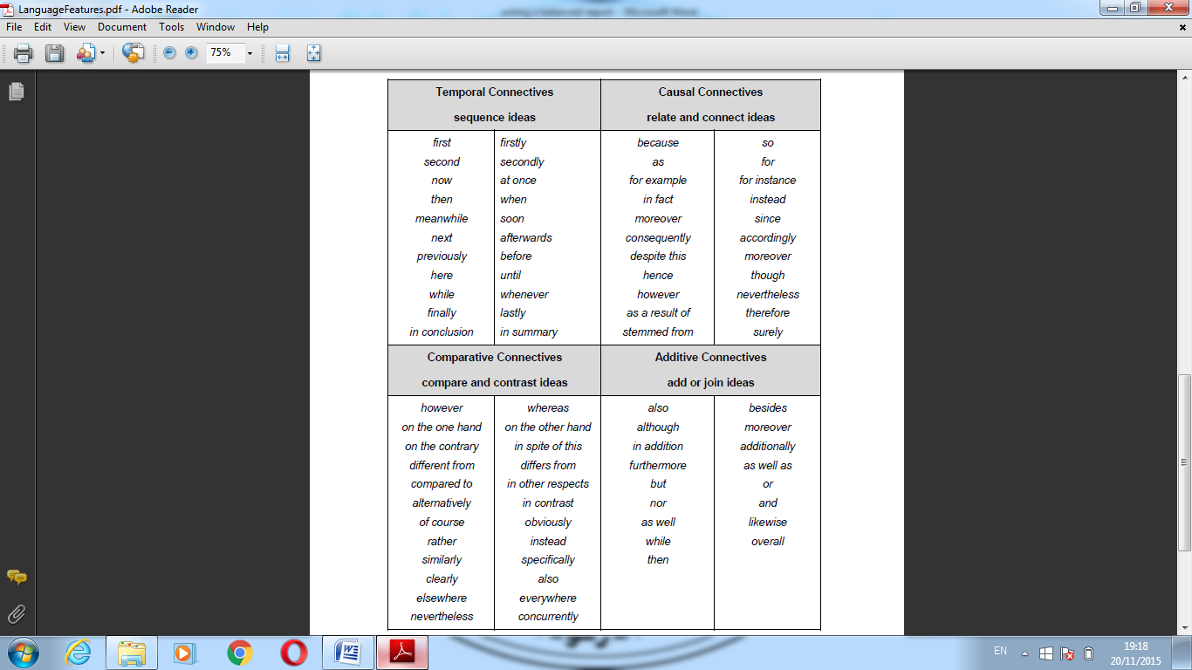Use Connectives to link ideas.

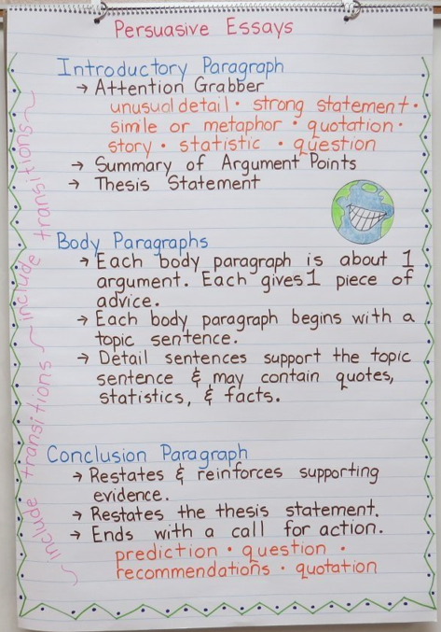

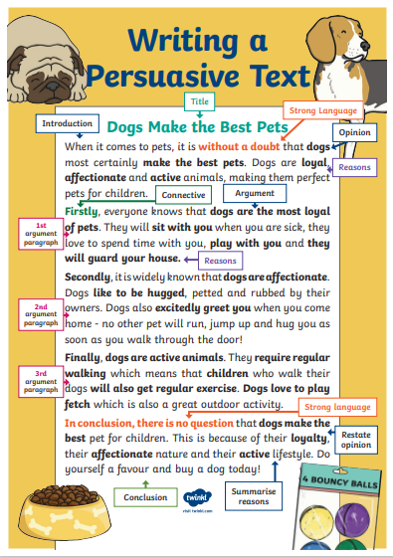

* **Writing practice:**
* **Write a persuasive article on the following subject:**
* **“Are dress codes a good idea for schools?”**

**__________________________________________________________________________________**

**__________________________________________________________________________________**

**__________________________________________________________________________________**

**__________________________________________________________________________________**

**__________________________________________________________________________________**

**__________________________________________________________________________________**

**__________________________________________________________________________________**

**__________________________________________________________________________________**

**__________________________________________________________________________________**

**__________________________________________________________________________________**

**__________________________________________________________________________________**

**__________________________________________________________________________________**

**__________________________________________________________________________________**

**__________________________________________________________________________________**

**__________________________________________________________________________________**

**__________________________________________________________________________________**

**__________________________________________________________________________________**

**__________________________________________________________________________________**

**__________________________________________________________________________________**

**__________________________________________________________________________________**

**__________________________________________________________________________________**

**__________________________________________________________________________________**

**__________________________________________________________________________________**

**__________________________________________________________________________________**

**__________________________________________________________________________________**

**__________________________________________________________________________________**

**__________________________________________________________________________________**

**__________________________________________________________________________________**

**__________________________________________________________________________________**

**__________________________________________________________________________________**

**__________________________________________________________________________________**

**__________________________________________________________________________________**

**__________________________________________________________________________________**

**__________________________________________________________________________________**

**__________________________________________________________________________________**

**__________________________________________________________________________________**

**__________________________________________________________________________________**

**__________________________________________________________________________________**

**__________________________________________________________________________________**

**__________________________________________________________________________________**

**__________________________________________________________________________________**

**__________________________________________________________________________________**

**__________________________________________________________________________________**

**__________________________________________________________________________________**

**__________________________________________________________________________________**

**__________________________________________________________________________________**

**__________________________________________________________________________________**

**__________________________________________________________________________________**

**__________________________________________________________________________________**

**__________________________________________________________________________________**

**__________________________________________________________________________________**

**__________________________________________________________________________________**

**__________________________________________________________________________________**

**__________________________________________________________________________________**

**__________________________________________________________________________________**

**__________________________________________________________________________________**

**__________________________________________________________________________________**

**__________________________________________________________________________________**

**__________________________________________________________________________________**

**__________________________________________________________________________________**

**__________________________________________________________________________________**

**__________________________________________________________________________________**

**__________________________________________________________________________________**

**__________________________________________________________________________________**

**__________________________________________________________________________________**

**__________________________________________________________________________________**

**__________________________________________________________________________________**

**__________________________________________________________________________________**

**__________________________________________________________________________________**

**__________________________________________________________________________________**

**__________________________________________________________________________________**

**__________________________________________________________________________________**

**__________________________________________________________________________________**