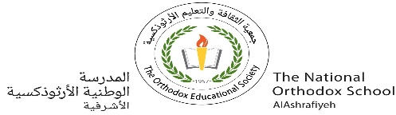

The National Orthodox School

Science Worksheet/**Plants**

Name : Grade: 1

Date: /11/2023

**Question:1**

**Label the parts of the plant.**

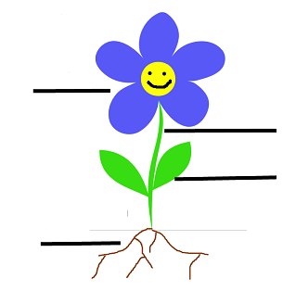

**Question:2**

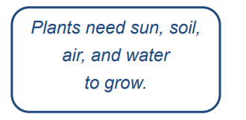In each box write what the plants need.

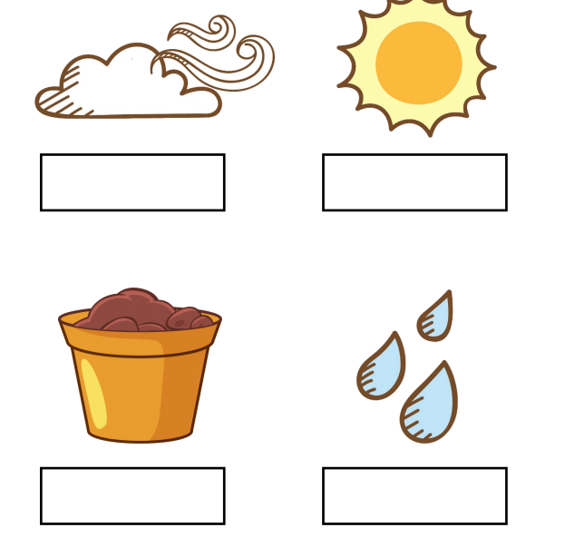

**animal that eat only grass and plants.**



**Animals that eat eating other animal.**



**.**



