

The National Orthodox School

**Science Worksheet / Parts of a plant**

**Grade: 2**

Name : Date:

**Question:1**

Label the parts of the following plant.

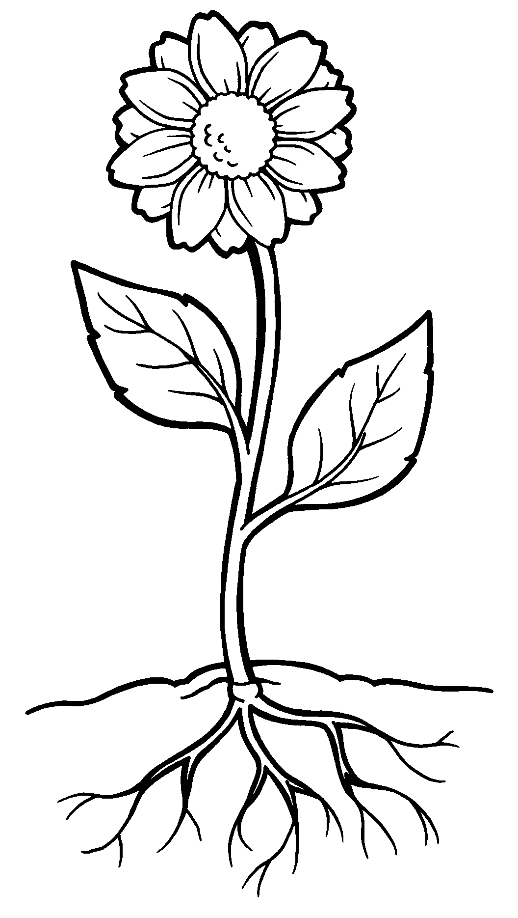

**Question:2**

Complete the paragraph about plants.

absorb water and nutrients for the plant from the soil.

***roots***

***stem***

***leaves***

***flower***

The ____________supports

the plant and takes water to the roots. The green _________ make food for the plant.

The___________creates seeds for new plants to grow from.

**Question 3:**

