**Classwork#2**  **|** Lower Secondary

Stage (6-8)

1st Semester | 2023-2024

|  |  |
| --- | --- |
| **Subject:** ICT | **Chapter:** 5 |
| **Objectives:** Survey Analysis – create charts. | |

**The school send a survey to the student to collect information about students interests, the responses file was given to you so you can analyze the data and create charts.**

Open the file **Students Interests_2023.xlsx** using MS-Excel and then apply the steps below:

* 1. Change the row height for Row#1 to 50 points.
  2. Set the width of column E, F to 25 points.
  3. In the range [A1:F1], align the text: **center** and **middle**, and **wrap** the text over many lines.

**Task 1**

* 1. Create a new sheet and rename to **[Task 1]**.
  2. 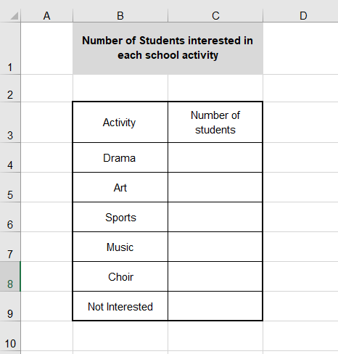In the sheet **[Task 1]** create the following table.
     + - Merge the cells B1&C1
       - Align the text in the merged cells to center and Middle, and **wrap** the text over many lines.
       - Set the height of row#1 to 45 and row#3 to 35.
       - Set the width of the columns B&C to 15
       - Align the text in the table to center and Middle.
       - Add a border to the range [B3:C9].
  3. Select the **[Form Responses] Sheet.**

Use the data in the **[Form Responses] Sheet and the filter feature** to fill the created table with data.

**Select the range [A1:F1] and then select Data 🡪 Filter.**

* 1. Create a pie chart to show the percentage of students interested in different types of activities.
     1. Add a chart title "Students Interest Distribution"
     2. Display the percentage.
     3. Show the legend

**[Task2]**

* 1. Create a new sheet and rename to **[Task 2].**
  2. In the sheet [Task 2] create the following table.

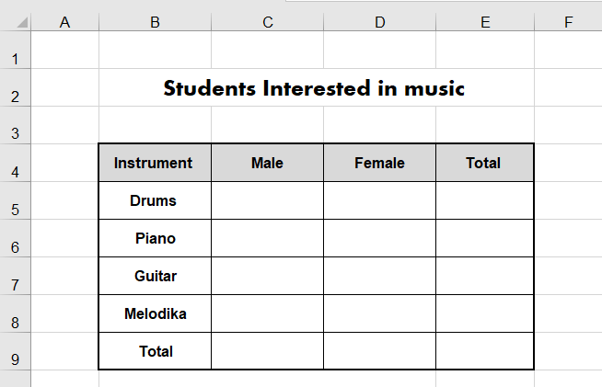

* 1. Use the same alignments as appear in the image.
  2. Select the **[Form Responses] Sheet.**

Use the data in the **[Form Responses] Sheet and the filter feature** to fill the created table with data.

**Select the range [A1:F1] and then select Data 🡪 Filter.**

* 1. In cell E5 insert a function to calculate the total number of students interested in playing Drums.

Replicate this function over the cells [E6:E8].

* 1. In the cell C9 insert a function to calculate the total number of Male interested in Music.
  2. In the cell D9 insert a function to calculate the total number of Female interested in Music.
  3. Use suitable row height and column width.
  4. Create a pie chart to show the percentage of students interested in playing different types of instruments.
     1. Add a chart title “Musical instrument performers”.
     2. Show the Legend.
     3. Display the percentage.
  5. Create a pie chart to show the percentage of Male/Female interested in Music.
     1. Add a chart title “Male/Female interested in Music”.
     2. Show the Legend.
     3. Display the percentage.

**[Task3]**

* 1. Select the sheet **[Task 3].**
  2. Merge the cells [B1:E1].
  3. Set the height of row#1 to 30.
  4. In the merged cells type the text: **Students Interested in Sports.**
  5. Align the text in the merged cells to center and Middle.
  6. Sort the data in the table using the student name from A🡪 Z.

**[Task4]**

* 1. Select the sheet [Task 4].
  2. Create a vertical bar chart to compare the number of students participate in each activity.
     + - Add a chart title “Students Interested in different types of sports”.
       - Add a vertical axis title “Number of Students”.
       - Add a horizontal axis title “Sport”.
  3. Save your file.