**Plan a Survey ­­**

**Survey Goal**

Before you can plan a survey, you must decide what you want to find out. This is called **Survey Goal**.

**Survey Goal:** Study the Sleeping hours per day for students in grade 6

**Survey Method**

**Questionnaire:** prepare a questionnaire using google form.

* **Create a google form**

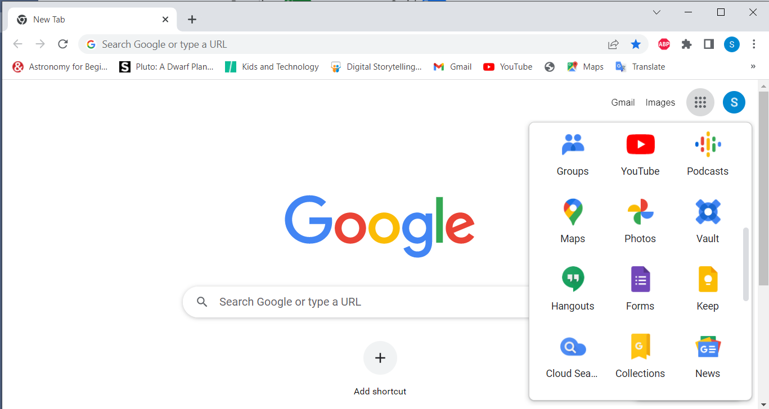

* **Create a new blank form**

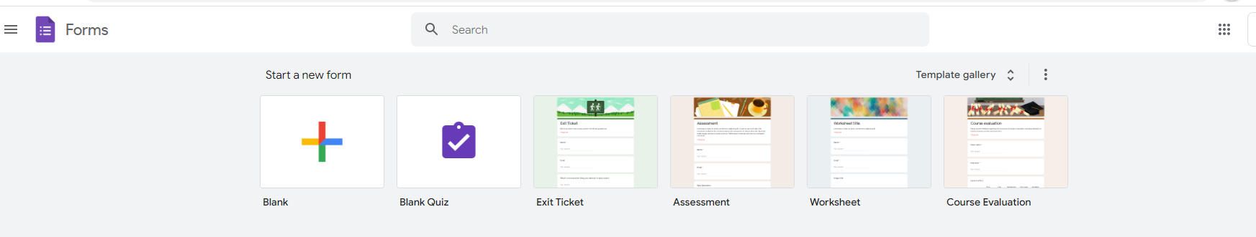

* **This screen will appear**

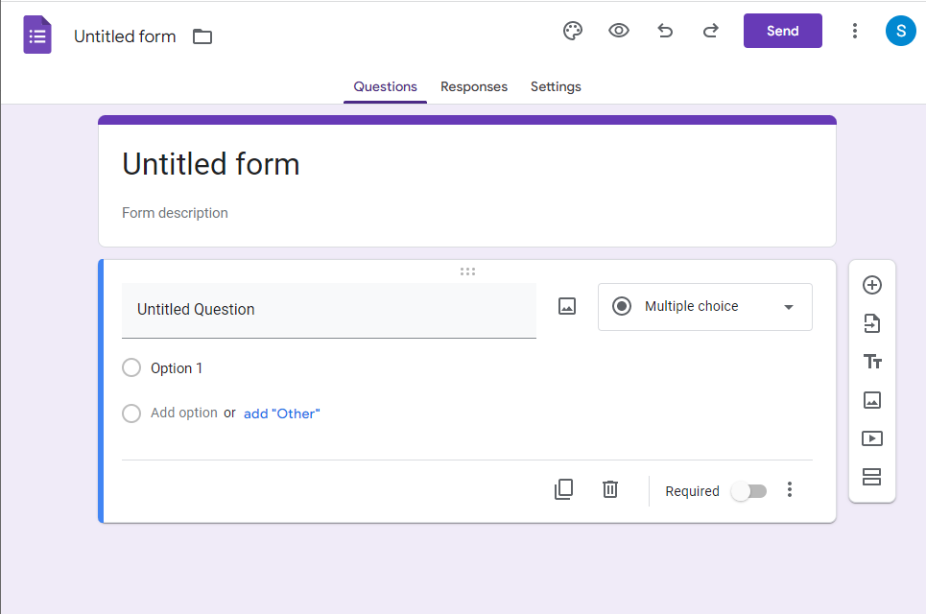

In the screen above an online survey can be designed taking into consideration the following points:

* Add a title to the form to be used for saving.

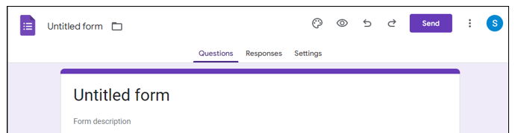

* Add the form description, to explain the objectives of create the form.
* Add new question by clicking the to add a new question.
* The most practical type of questions for surveys are: Multiple choice and check boxes, so that the user can answer easily and fast.
* If the question is required (must be answered) activate the required feature.

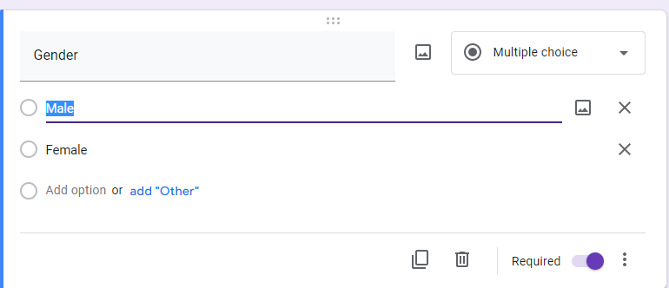

* **Send the google form**

**Click the  button to copy the form link, so that you can send it to the target group.**

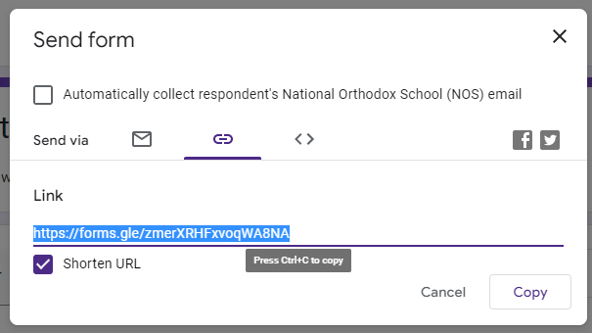

* **Form Responses**
* Click the **Responses** so you can display all the responses for a form. The responses can be displayed in a google sheet.

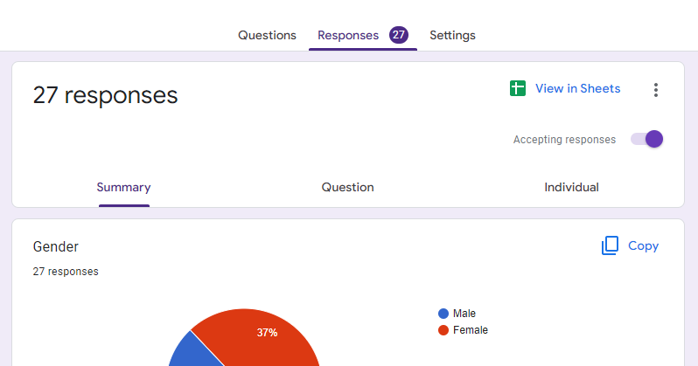

* Click on [View in Sheets] to display the results of the survey in a google sheet that can be downloaded as excel file.

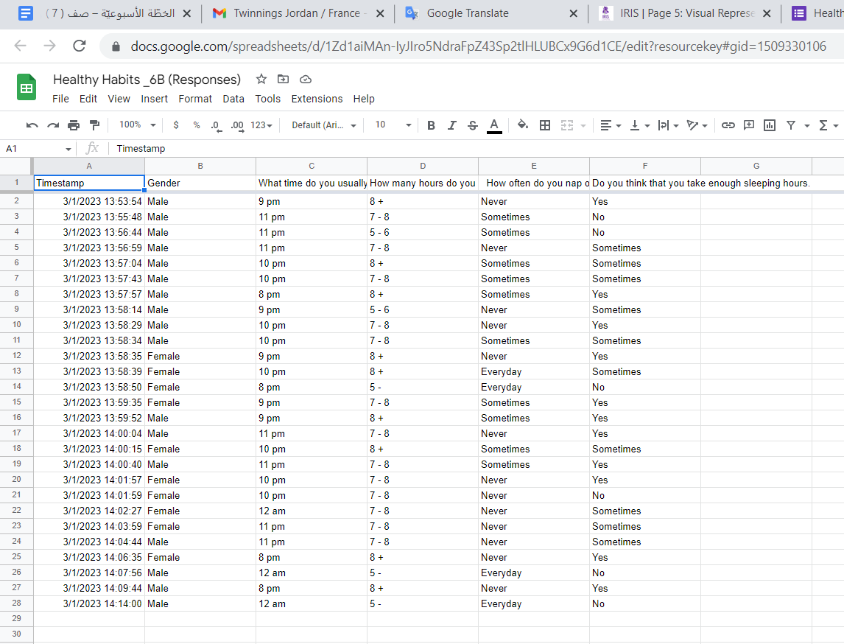

* Download the sheet as excel file as follows:



**Analyze collected data in the spreadsheet:**

* Open the Excel Table that includes the responses.

Row Height (50)

Wrap Text

Center - Middle

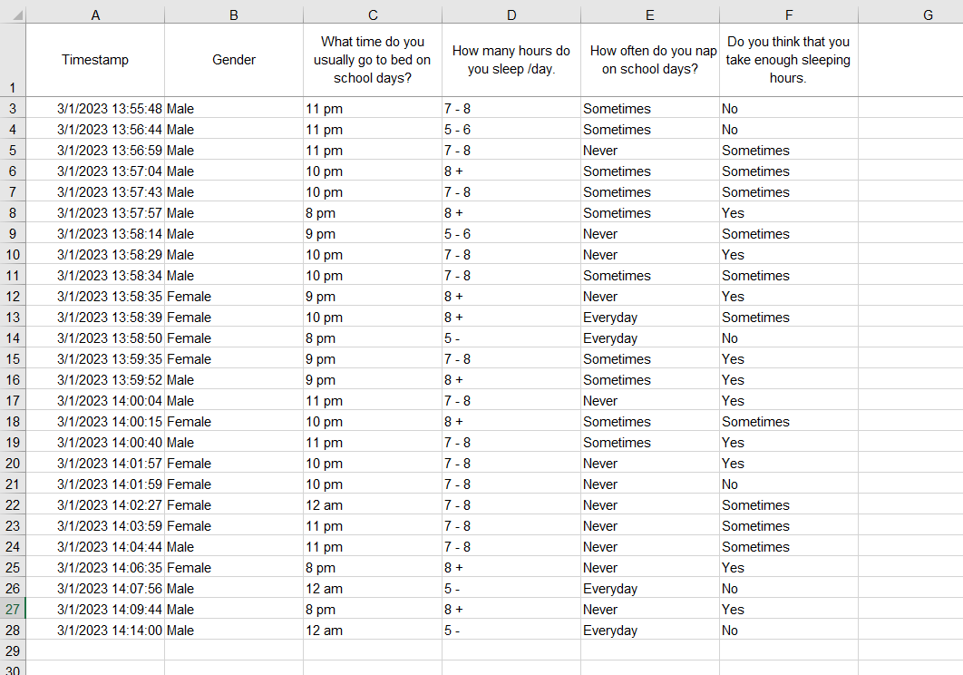

* Select the range [A1:F28] and then select [Data] 🡪 [Filter].
* Add new sheet and then prepare the following table

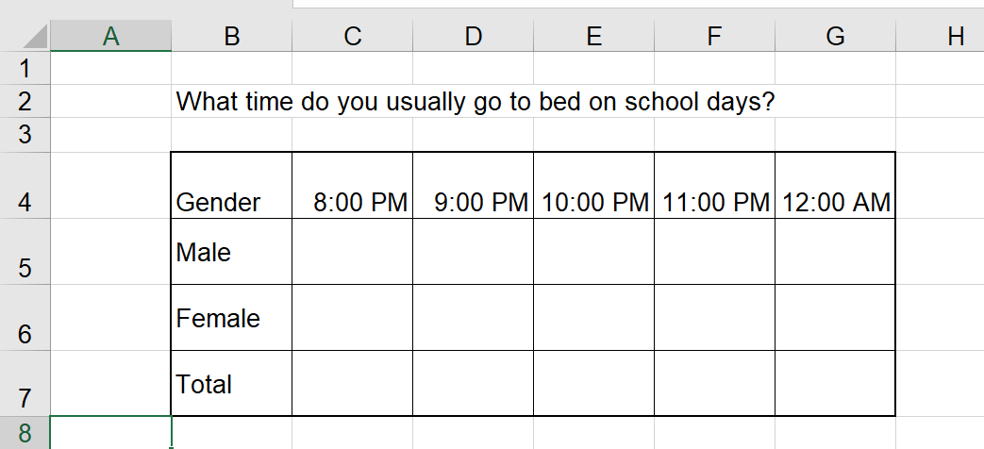

Use the first sheet to fill in the table above (filtering data will make your work easier)

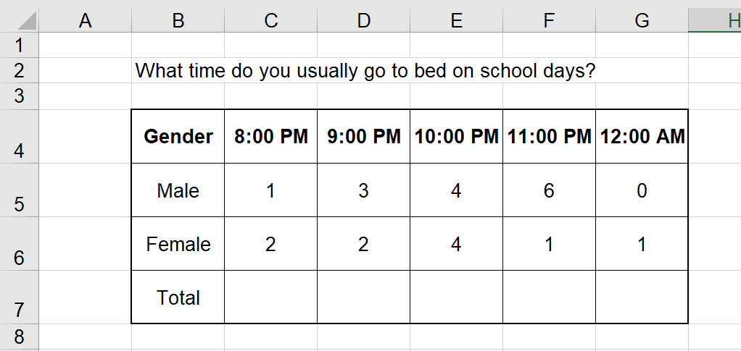

* In the cell C7 use a function to calculate the total number of male and female who go to bed at 8.

Replicate the functions over the cells [ D7: G7]

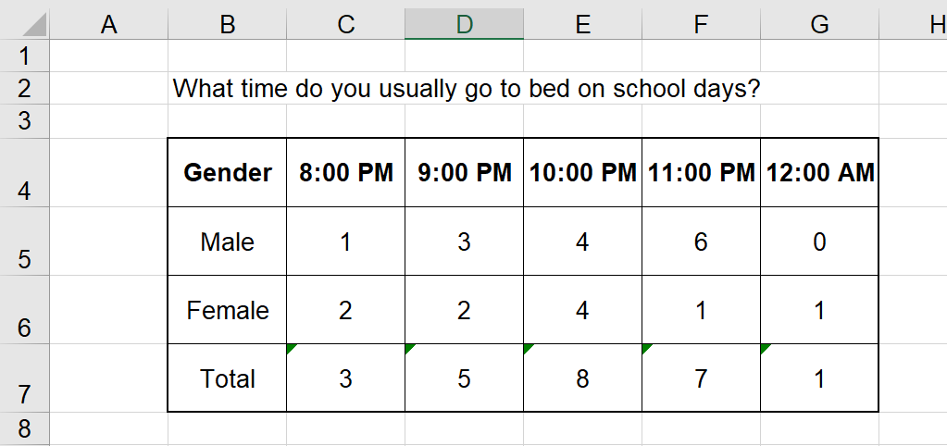



* Create a Pie chart to show the percentage of Male that go to bed at each hour starting from 8pm to 12am.

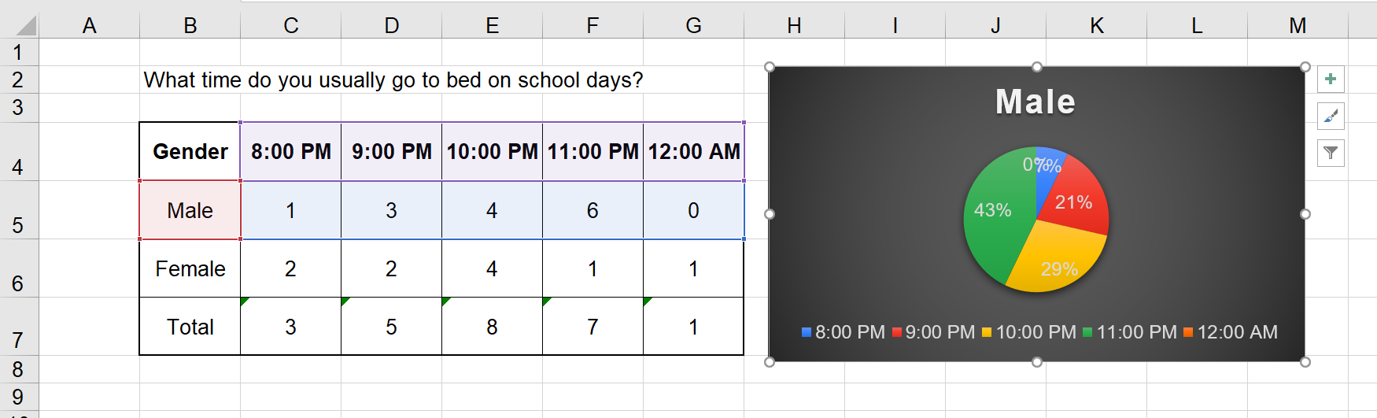

* Create a Pie chart to show the percentage of Female that go to bed at each hour starting from 8pm to 12am.

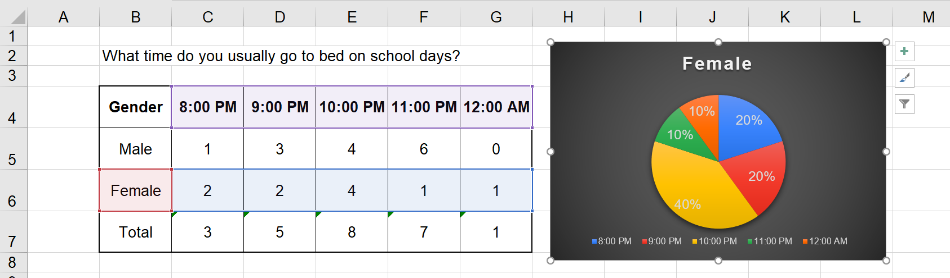

**Use the CTRL key to highlight two separate rows or columns.**

* Create a Pie chart to show the percentage of participants (total) that go to bed at each hour starting from 8pm to 12am.

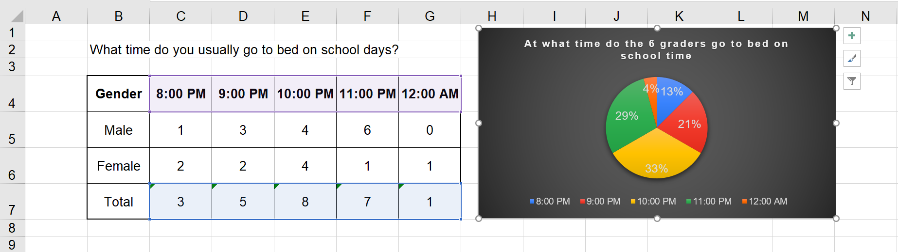

* Add new sheet and then prepare the following table.

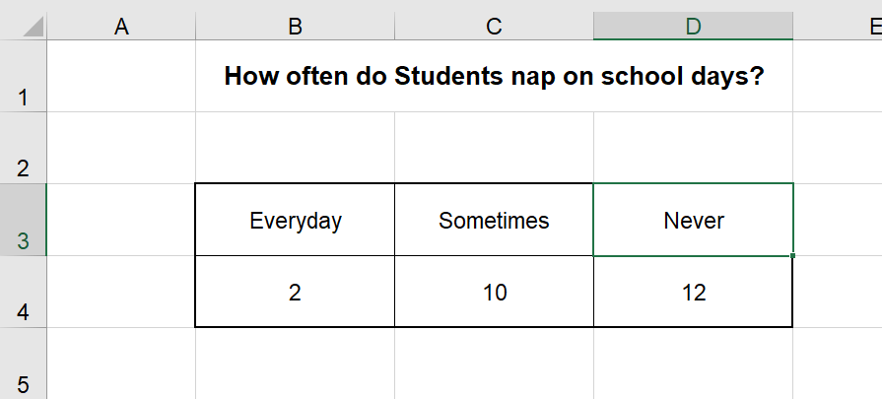

* Create a Pie chart to show how repetitive do participants nap on school day.