

**Our value: Alone we can do so little; together we can do so much.**

**Homonyms**

**Name………………… Grade (6)**

|  |
| --- |
| **Objectives**  **To identify what a homonym is and study many examples.**  **To practise guessing the meaning of a word in a sentence.** |

**Homonyms** are two words that are spelled the same and sound the same but have different meanings.

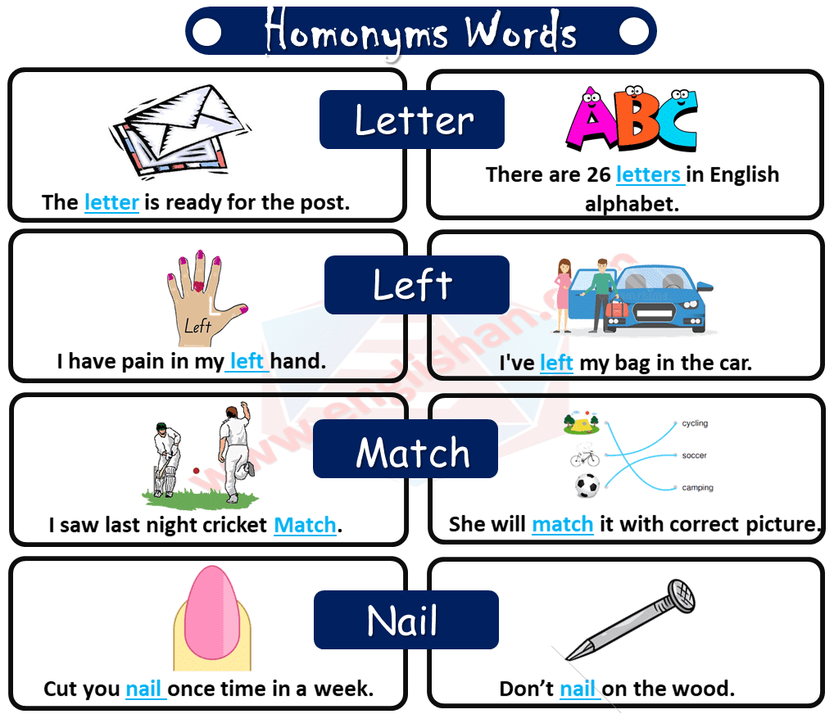A simple example of a homonym is the word "**pen**." This can mean both "a holding area for animals" and "a writing instrument." Another example is "**book**," which can mean "something to read" or "the act of making a reservation." In both cases, the sound and spelling are the same, and only the definition changes. Examples:

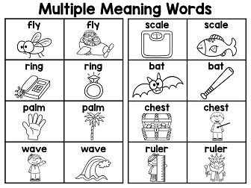

|  |  |  |  |
| --- | --- | --- | --- |
| **Homonym** | **Part of Speech** | **Meaning** | **Sentence Example** |
| Bear | Noun | A large, wild animal | They saw a black **bear.** |
| Verb | Being able to accept and deal with something | You will have to **bear** the pain. |
| Right | Adjective | Correct or true | You are **right.** |
| Noun | The right side | Meena sat on the **right.** |
| Adverb | Correctly or exactly | Everything that you told us was **right.** |
| Tear | Noun | A drop that comes from your eye when you cry | She had **tears**in her eyes at the end of the movie. |
| Verb | To pull something apart in pieces and damage it | The little girl will **tear** up everything she gets. |
| Match | Noun | A game | Do you know which team won the **match?** |
| Noun | A small stick used to start a fire | I used a **match**to light up the stove. |
| Verb | To find something that is suitable | My mom was looking for a lining material that **matches** the pastel-coloured saree she bought recently. |
| Ring | Noun | A jewel that you wear on your finger | My father bought me a diamond **ring** |
| Noun | A round object | I used a **ring**to make a dreamcatcher. |
| Verb | To call someone | Manu will **ring**you in some time. |
| Verb | To cause something to sound like a bell | Did you hear the bell **ring?** |
| Kind | Noun | A group of people with similar characteristics | We are one of a **kind.** |
| Adjective | Being good, generous, helpful | Beena is very **kind.** |
| Lie | Noun | Something untrue | I think she is telling a **lie.** |
| Verb | To quote something untrue | My mom does not **lie.** |
| Verb | To rest | He is **lying**on the bed. |
| Bright | Adjective | Strong, full of light | The sun is very **bright** today. |
| Adjective | Intelligent, clever, learning quickly | Aarathi is a **bright** student. |
| Address | Noun | The name and number of a building, the location of a building | Sherly gave her **address** so that we would not lose our way. |
| Verb | To write or speak to someone | Today, Susan will be **addressing**the first-year students. |
| Watch | Noun | A device to check the time of the day | I bought a new **watch.** |
| Verb | To see or look at something | Can you please **watch**the baby for an hour? |

1. **Look at the pictures, and write the words.**

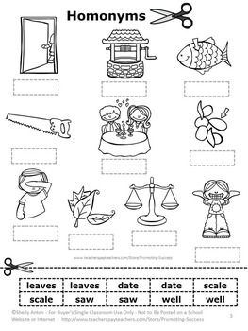

leaves

scale

well

date

date

saw

saw

scale

well

leaves

|  |  |  |  |  |
| --- | --- | --- | --- | --- |
| leaves | leaves | date | date | Scale |
| scale | saw | saw | well | well |

**B) What does the underline word mean.**

1. Put the shoe on the right foot. The right side

2. Two wrongs don’t make a right. Correct or true

3. A kind word is never lost. Good

4. What kind of house do you live in? A group of things with similar characteristics

5. I cannot find my watch; I must have lost it. A device to check the time of the day.

6. Come round tonight and we'll watch a video. To see or look at something.

**C) Circle the correct answer:**

1. Can you ring the doorbell? The underlined word means:
2. **A jewel that you wear on your finger.**
3. **To cause something to sound like a bell.**
4. The sun is bright. The underlined word means:
5. **Strong, full of light.**
6. **Intelligent, clever, learning quickly.**
7. I used a match to light the fire. The underlined word means:
8. **A small stick used to start a fire.**
9. **A game.**
10. I cannot bear noisy people. The underlined word means:
11. **A large, wild animal.**
12. **Being able to accept and deal with something.**
13. The president addressed the council. The underlined word means:
14. **The name and number of a building, the location of a building.**
15. **To write or speak to someone.**

**Coordinator’s signature: ---------------------**