

**Work Sheet** **|** Lower Secondary

Stage (6-8)

1st Semester | 2023-2024

**Subject: Biology**

**Name: Worksheet: Digestive System**

**Date: Grade-Section: 7CS- all sections**

**Objective*:*** *1. Recognize each part of the alimentary canal and explain its role in digestion.*

*2. Understand the function of enzymes.*

**Inside your gut:**

Everything you eat goes into your gut, or alimentary canal. This long tube winds its way from your mouth to your rectum. Food can spend more than a day inside it, but most of your food doesn't get to the end. 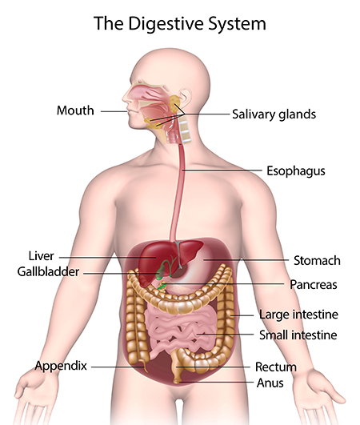

**What happens to it?**

The starch, fats, and proteins in your food are made of big complex molecules. Your cells can't use them as they are. Inside your gut, these big food molecules are broken down to make small molecules your body can use, such as glucose. These molecules pass into your blood, which carries them to every cell.

**Mouth to stomach**

Your teeth *break up solid lumps of food to make smaller pieces* you can swallow. This is **mechanical digestion**. It makes the large molecules in the food easier to break down later.

Your mouth fills with saliva as you chew. Saliva contains an enzyme. Enzymes help *large molecules break down to form smaller ones*. This is **chemical digestion.**

*Saliva:*

* *The enzyme in saliva helps starch to break down.*
* *Saliva is also very slippery. It makes food easy to swallow.*

Then the walls of your gullet squeeze it down to your stomach. This **squeezing action of the gut walls is called peristalsis.**

*Types of Digestion:*

* *Mechanical (physical) - your teeth rip, break and crush food particles.*
* *Chemical – saliva contains enzymes that break down food molecules and makes it slippery mass of food that will slide down easier.*

**Inside your stomach:**

Your stomach blends each meal with acid and another enzyme.

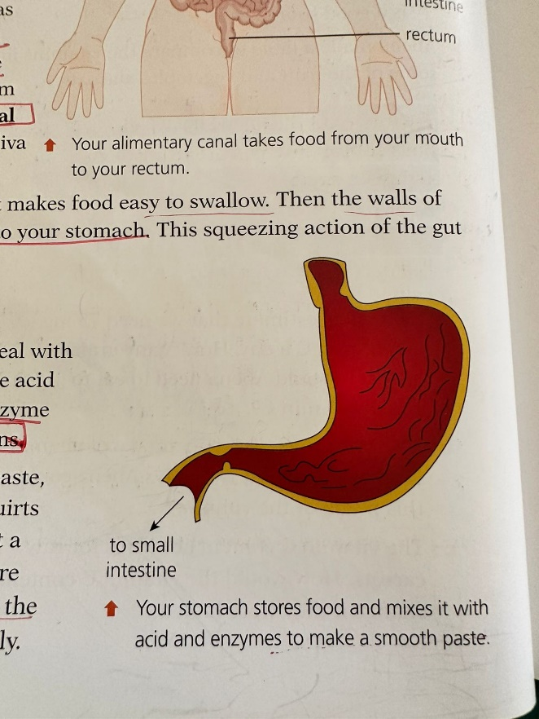**The acid** destroys microbes and the **enzyme** begins the digestion of proteins.

Once your meal is a smooth paste, your stomach lets it out. It squirts into the small intestine a bit at a time. Now the pieces of food are smaller, enzymes can mix with the large food molecules more easily.

**In the small intestine**

Your small intestine is the longest part of your gut. This is where most large molecules get broken down. Its walls squeeze food along and mix it with more enzymes. A lot of these enzymes come from another organ - the pancreas.

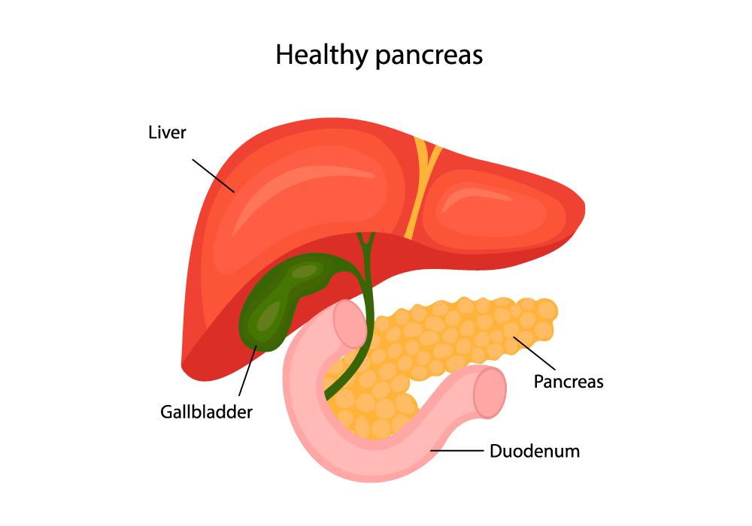

(Produces bile)

(Produces enzymes)

(Bile is stored)

As food leaves the stomach, enzymes from the pancreas pour onto it. Carbohydrate and protein continue to break down and fat digestion starts. The small intestine makes more enzymes to help finish the job.

As food is digested, small molecules are produced. They pass through the small intestine's walls and into your bloodstream. Now you can use them.

**Beyond the small intestine**

When a meal gets to the large intestine there is nothing left but fiber. This part of the gut is full of bacteria. They live off the fiber and make important vitamins that we can absorb.

The walls of the large intestine absorb water into the bloodstream. This turns the mixture of fiber and bacteria into solid waste called **faces**. It is stored in your **rectum** until you are ready to go to the toilet. Then it squeezes out through your **anus**.

**Enzymes**

**Catalysts**

Life could not exist without enzymes. They **control the chemical reactions in your body.** Without enzymes, most of these chemical reactions would be too slow to keep you alive.

Chemicals that **speed up chemical reactions** are **catalysts** so enzymes are biological catalysts -catalysts made by living things.

Enzymes can speed up chemical reactions **without being changed or used up**. The enzymes in your gut **make large food molecules break down to form smaller ones.**

**Different enzymes for different jobs**

scissors can cut anything, but enzymes are specialised. Each of the enzymes in your gut can only make one type of molecule break down.

* The enzyme in saliva is called **amylase**. It's a type of **carbohydrase** because it breaks down **starch** - a carbohydrate.
* The enzyme produced in the stomach is a **protease** - it makes **proteins** split to smaller molecules.
* 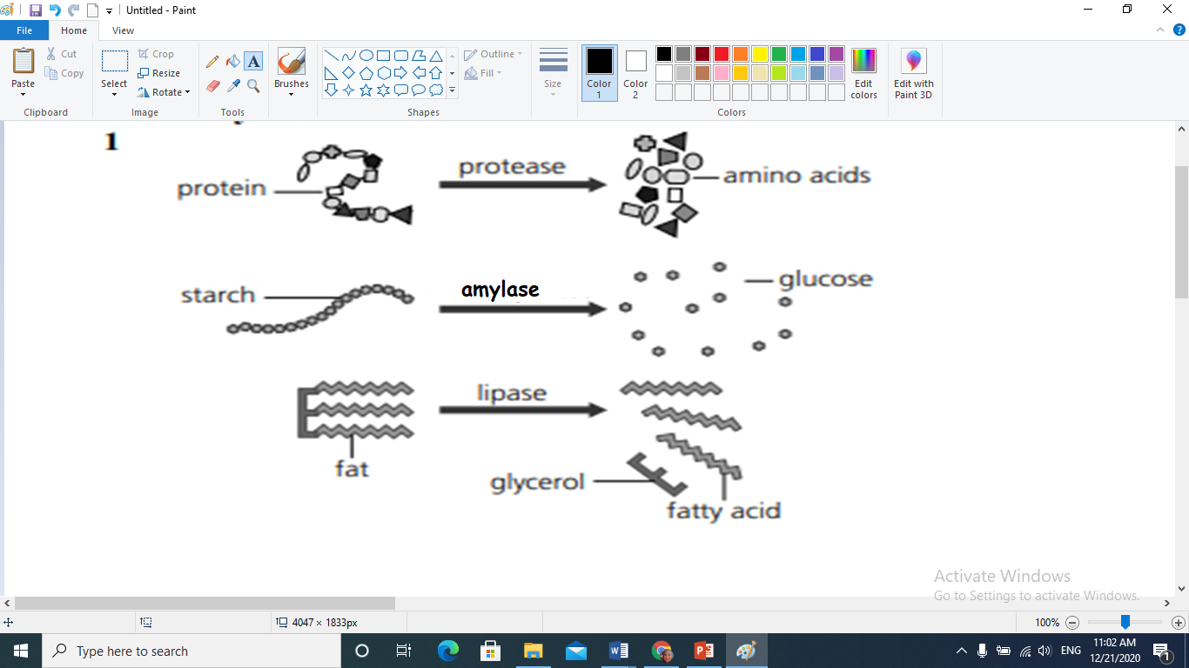other enzymes from the pancreas and small intestine complete **starch** and **protein** digestion. The pancreas also makes a **lipase** enzyme to make fat molecules break down.

**Providing the right conditions for enzymes**

Enzymes are giant molecules made from protein.

They have to be just the right shape to do their job. Each chemical reaction needs a different enzyme.

1. If the **pH** around an enzyme changes, its **shape can change**. The enzyme becomes **denatured** and stops working. Each enzyme has an **optimum pH** at which the acidity of its surroundings lets it work as fast as it can.
2. High **temperatures** can also **denature** enzymes. The enzymes in our bodies work best at 37 °C, but the enzymes in other living things can be very different.

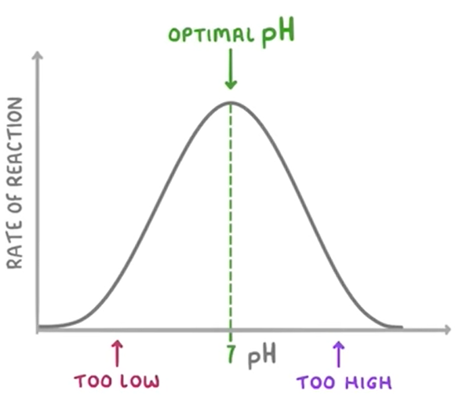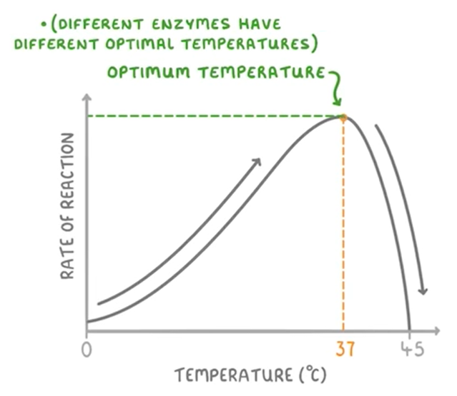

**Helping our enzymes**

The process of lipid digestion begins in the small intestine. The liver produces bile, a greenish-yellow fluid stored in the gallbladder and released into the small intestine when needed. Bile is essential for lipid digestion because it emulsifies fats, breaking them down into smaller droplets.

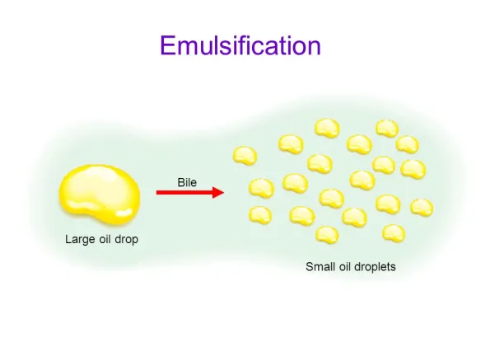

After bile has emulsified the fats, pancreatic lipase, an enzyme secreted by the pancreas, acts upon the emulsified fat droplets, breaking them down further. These smaller components are more easily absorbed by the intestinal lining.

**Digestive enzymes**

