Study sheet | Lower Secondary
Stage (6-8)
1st Semester | 2023-2024
Subject: Biology | Chapter: Specialized Cells
Name:
Objectives: Relate the structure of cells to their functions.
-----------------------------------------------------------------------------------------------------------------------
Cells with different functions have different structures. The cell is adapted to carry out its function really well.
- Some specialized plant cells

Cell | Function | Adaptation
- Root hair cells | They absorb water from the soil.  The root hairs provide a large surface area for substances to enter the root. | The cells have long, thin extensions that allow them to grow easily between the soil particles.
- Palisade cells (leaf cell) | They have chloroplasts that contain chlorophyll to trap light energy for photosynthesis. | They have a shape that allows them to pack closely together in the upper part of a leaf.

- Some specialized animal cells
Cell | Function | Adaptation
- Red blood cells | They carry oxygen around the body.  Their cytoplasm contains a red substance called hemoglobin, which carries oxygen. | 1. They are disc-shaped but their centers dip inward.  2. They don’t have a nucleus (this makes more room for hemoglobin.)
- White blood cells | They are cells of the immune system that are involved in protection and fighting diseases. | Irregular shapes.  for example:  1. Lymphocyte: produces antibodies, which attack harmful microorganisms in the blood.  2. Phagocyte: engulfs harmful microorganisms.
- Muscle cells | The function varies according to which organ it is found in. | These cells are long and thin.  Each muscle cell is completely full of fibers. The fibers allow muscle cells to contract and produce movement.

Cell | Function | Adaptation
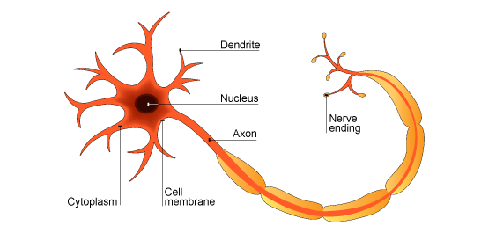  - Nerve cells | They transfer messages from one part of the body to another.  (Carry signals around the body.) | Neurons have long thread-like extensions, so that they communicate with distant parts of the body.
- Fat cells  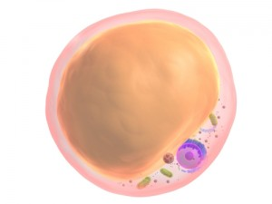 | They act as an energy store for times when you can’t eat enough.  Helps to keep you warm. | The nucleus and cytoplasm are squeezed to the side to make room.
- Ciliated cells  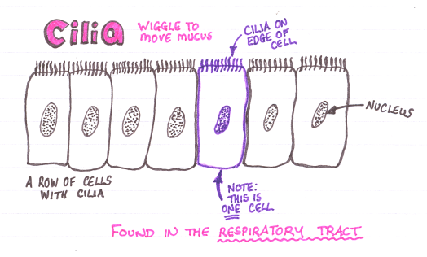 | The cilia move in a wave-like motion to carry the dust trapped in the mucus away from the lungs.  They are found in structures like the nasal cavities, bronchial tubes and trachea. | Cilia are microscopic hair like-extensions.  They need a lot of energy, so they always contain lots of mitochondria.
8. Bone cells  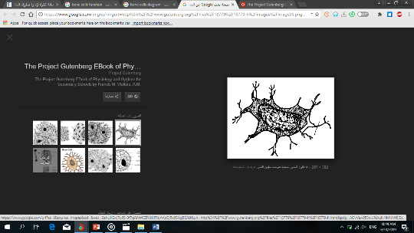 | Bone cells make fibers and excrete them into their surroundings | Produces fibers that attract minerals to make a rigid solid.

