**Writing Study Sheet|** Lower Secondary

1st Semester 2023/2024 Stage (6-8)

|  |  |  |
| --- | --- | --- |
| **Name:** | ________________________________ | **Subject: English – Speech Writing** |
| **Unit 3: Terrific Technology** |
| **Date:** | **________________________________** | **Class: Grade 7CS – Section: __________** |

**Objective:**

* to recognize the features of writing a speech **­­­**

**‘I have fought against white domination, and I have fought against black domination.’**

**Nelson Mandela**



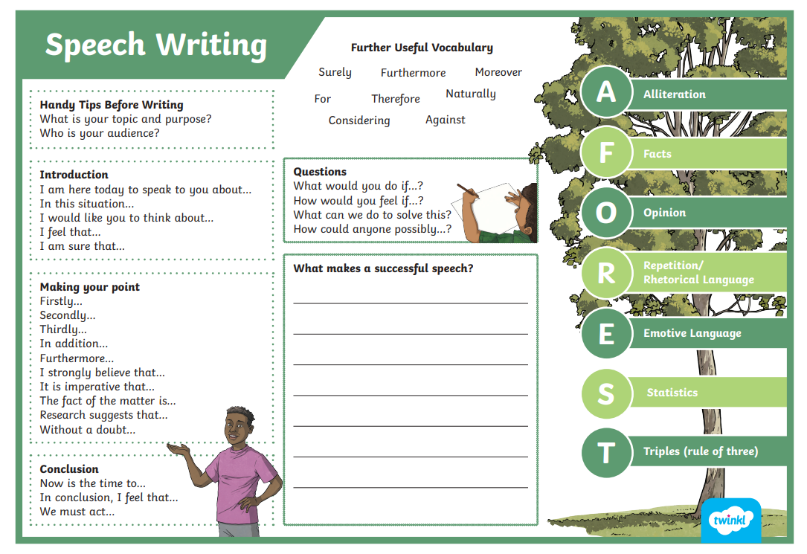

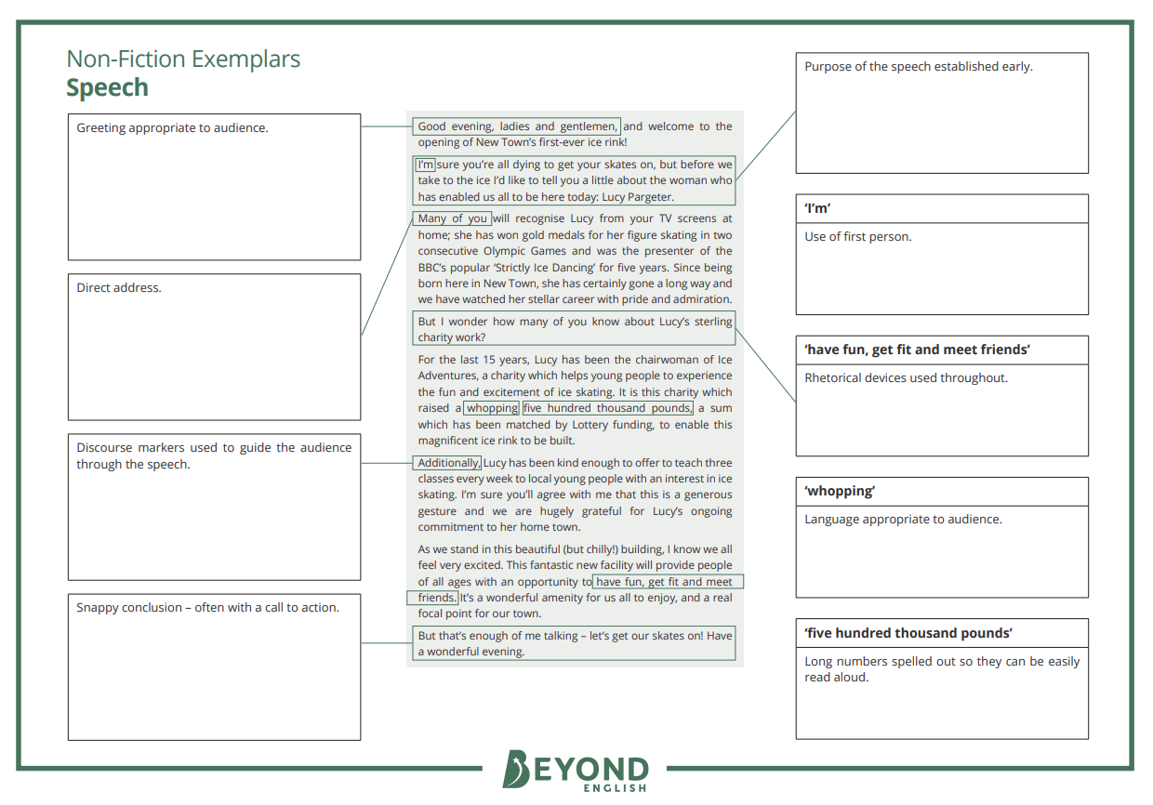

Persuasive Speech

**Follow the below format for your speech:**

|  |
| --- |
| **Paragraph 1: Introduction** |
| ***Why are you writing this speech? What do you want the outcome to be?***   |  | | --- | |  | |  | |  | |
| ↓ |
| **Paragraph 2 (Body paragraph 1): 1st Point** |
| ***Make your first point strong, following your introduction.***   |  | | --- | |  | |  | |  | |
| ↓ |
| **Paragraph 3 (Body paragraph 2): 2nd Point** |
| ***Make links with your last point and move into another one.***   |  | | --- | |  | |  | |  | |
| ↓ |
| **Paragraph 4 (Body paragraph 3): 3rd Point** |
| ***Make your final point your strongest one.***   |  | | --- | |  | |  | |  | |
| ↓ |
| **Paragraph 5: Conclusion** |
| ***Summarise your main points in a final bid to convince or persuade your audience.***   |  | | --- | |  | |  | |  | |

**Speech Writing Checklist**

Use some of the tricks from the writer’s tool box. Tick each one that you have used. Try not to use the same one too many times.

|  |  |
| --- | --- |
|  | metaphor |
|  |  |
|  | simile |
|  |  |
|  | statistics |
|  |  |
|  | repeated phrase |
|  |  |
|  | 3 adjectives |
|  |  |
|  | rhetorical question |
|  |  |
|  | emotions |
|  |  |
|  | personal story |