1. Rhyme scheme



Blue a



Morn b

Two a



Corn b



1. Alliteration



Sing



Silent



1. To add to the rhythm of the poem. (to make the poem musical)



1. To link dissimilar (different) words.

*Soared*



*sank*



*A Green Cornfield*

*Christina Rossetti*

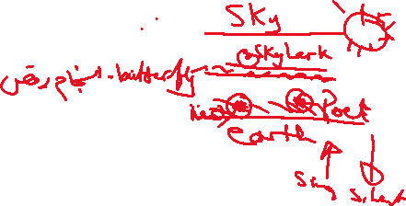

The earth was green, the sky was blue:



I saw and heard one sunny morn



A skylark hang between the two,



A singing ***speck*** above the corn;



1)Is a speck something big or small?

2)What does the word “**two**” refer to?

3) Find a name of a bird from the previous stanza?

4)Two colours are mentioned in the above stanza.

5)What does the pronoun” I” in the second line refer to?

6)When did the poet see the bird?

7)Does the third line imply that the poet talks about a bird, how?



8) How is the bird described in terms of **size** in the above stanza?

9)Which word gives us information that the bird is small?



1,

A stage below, in gay ***accord***,



White butterflies danced on the wing,



And still the singing skylark soared,



And silent sank and soared to sing.



10) Find a line which includes the rhetorical device poetic technique (alliteration) in the previous stanza?

11)If something is in “**accord**” is it in agreement or disagreement?

12) Does the bird come down singing or silent?



13)Does the bird soar (rise, go up) singing or silent?



14)Mention the name of animals/creatures in the previous stanza.

15) Which word shows the bird is happy?



16) Which word shows that the butterflies are happy?



17)What is the rhetorical device used by the poet to link dissimilar words such as “soared and sank”//” sing and silent”?



18) Which word tells us that butterflies are in agreement?



19)Write down the line which tells us that the butterflies moved quickly.



20) What does the colour white stand for /symbolizes?



The cornfield stretched a ***tender*** green



To right and left beside my walks;



I knew he had a ***nest*** unseen



Somewhere among the million ***stalks***.



21) What is the type of field which is mentioned in the previous stanza?



22)Does “tender” suggest something “fresh and young” or “old and strong”?

23)What does a bird do in a nest?



24)What part of a plant is the stalk?



25)Find a word that means the nest is hidden in the cornfield?



26) Two directions are mentioned in the text, write them down. (right, left)

27) What does the underlined pronoun “he” refer to? (personification)

28)Which word tells us that the field is fresh?



And as I paused to hear his song

While ***swift*** the sunny moments slid,

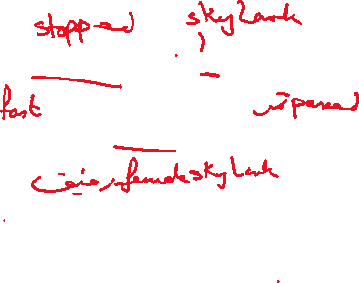

Perhaps **his** mate sat listening long,



And listened longer than I did



29)Does the word “**swift**” means slow or fast?



30)What does the word swift means?

31)How did time pass as described in the above stanza?



32)What is the reason behind the poet stopping in the cornfield?



33)The poet says that (**And as I paused to hear his** **song**), do you think pausing to hear a song shows that the listener is happy?



34)What does the underlined pronoun “his “refer to?



35)Find two references to another listener apart from the poet? Who or what is this listener?



I knew……

Perhaps…………

36)The poet uses many examples of the rhetorical device” alliteration Find an example. What effect(function) is the poet trying to achieve with this technique?

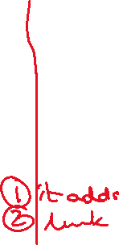

37)How do we know that the poet leaves the cornfield before the skylark has stopped singing?



38)What do you think the colour green symbolizes?



39)Rhyming words occur at the end of lines and in a particular pattern (rhyme scheme) Describe the rhyme scheme in the poem? abab

