

Grammar worksheet (2)

Present Continuous

Grade (4)

Name: Date: / /2023

|  |
| --- |
| **Objectives:**  1. To identify the present continuous tense.  2. To practice using the present continuous to talk about the actions that are happening at the moment of speaking. |

**Key Words :**

Now, at the moment , right now , today, Listen! , Look!, Be careful!, Be quiet .

**Present Continuous Form:**

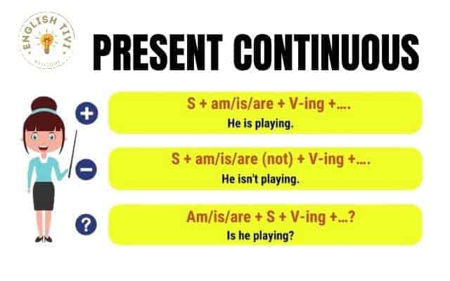

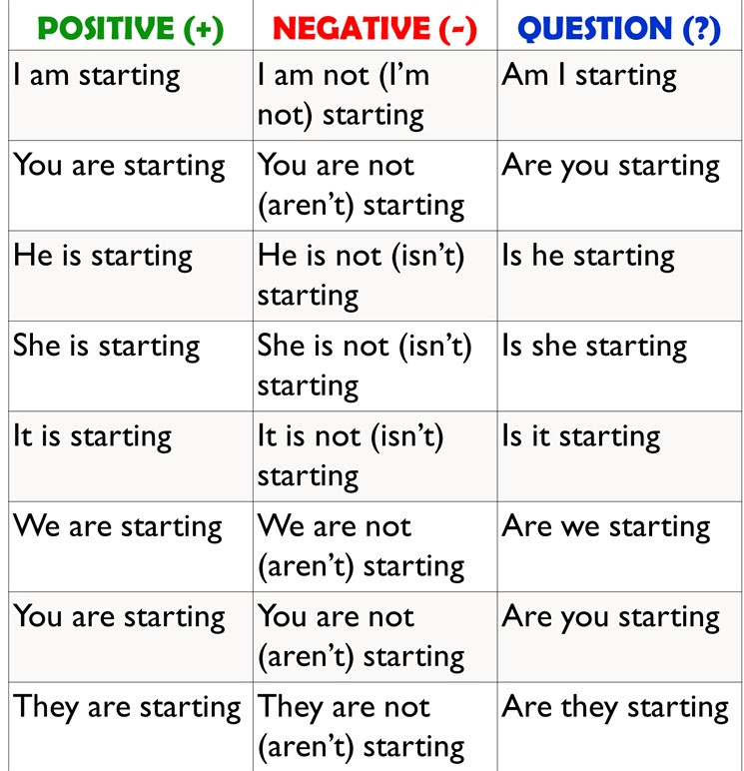

Spelling Rules :

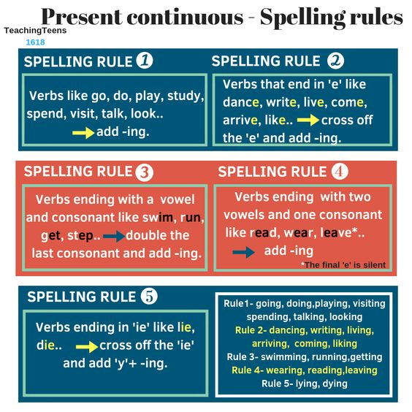

**Q1) Complete the sentences with the verbs in brackets. Use present continuous tense.**

1. Julia_____________ making her homework at home**.(do)**
2. Jad ______________ in the lake with his father.**(sail)**
3. My grandmother________________ some cakes. **(bake)**
4. Basil and Zina __________________ table tennis**.(play)**
5. I _______________ a letter to my best friend**.(write)**
6. The teacher ____________________ some tests**.(correct)**
7. William and Anna______________ some orange juice.**(drink)**
8. They ____________________ the bus.**(wait)**



**Q2) Rewrite these sentences in the present continuous tense.**

1. I eat my favorite meal.

--------------------------------------------------------------------------

1. Be quiet! We learn English.

--------------------------------------------------------------------------

1. He watches TV in the living room .

---------------------------------------------------------------------------

**Q3) Change these sentences into question and negative sentence .**

**Ex**: We are visiting my friend today.

**Negative** : We aren’t visiting my friend today .

**Question** :Are they visiting my friend today ?

**1.She is going to the mall now .**

Negative :------------------------------------------------------------------

Question:------------------------------------------------------------------

**2.I am writing a story at this moment .**

Negative:----------------------------------------------------------------------

Question:----------------------------------------------------------------------

**3.Look! The cat is dancing .**

Negative:----------------------------------------------------------------------

Question:----------------------------------------------------------------------

**4.Listen! Somebody is playing the violin.**

Negative:---------------------------------------------------------------------

Question:---------------------------------------------------------------------

**Q4) Answer these questions, use present continuous tense.**

1. Are you wearing something red today?

__________________________________________________

1. Is your teacher writing on the board now?

__________________________________________________

1. Are your friends eating their breakfast?

___________________________________________________

1. What are you doing at the moment?

___________________________________________________

Teacher: Raneem Haddad

Coordinator’s Signature: _________________.