

Meaning worksheet (2)

Unit 4

Grade (3)

Name: Date: / /2023

|  |
| --- |
| **Objectives:**  1. To identify the meaning of the new words.  2. To identify the synonym of the new words.  3. To use the new words in meaningful sentences. |

|  |  |  |
| --- | --- | --- |
| **Verb** | **Meaning** | **Synonym** |
| **Experience** | To feel or know.  **Example**:  They had the opportunity to **experience** life at sea. | To know |

|  |  |  |
| --- | --- | --- |
| **Adjectives** | **Meaning** | **Synonym** |
| **Rural** | Countryside.  **Example:**  We live in a **rural area** of the San Francisco Bay Area. | Countryside |
| **Urban** | Related to a city.  **Example**:  Most people have moved to live in an **urban area**. |  |
| **Nouns** | **Meaning** | **Synonym** |
| **Immigrant** | A person who moves to another country from his country to another country to work.  **Example**:  They were **immigrants** to the United States from Brazil. | Foreigner |
| **Factory** | A building where products are made by machines.  **Example**:  This **factory** produces millions of ketchups bottles every year. | Buildings / workshop |
| **Suburb** | An area that is outside a city or town.  **Example**:  Many people who live in a **suburb** go to work in the city. |  |
| **Service** | Help.  **Example:**  He provides many **services** as a coach. | Help |

|  |  |  |
| --- | --- | --- |
| **Adverbs** | **Meaning** | **Synonym** |

|  |  |  |
| --- | --- | --- |
| **Perhaps** | Maybe.  **Example:**  **Perhaps** the weather will change this evening. | Maybe |
| **Abroad** | Outside one’s country.  **Example:**  I've never lived **abroad** before. | Far away |
| **Wide** | Vast.  **Example:**  They live in a quiet and a **wide** street. | vast |

**Q1) Put these sentences into the correct order.**

1. many / has / factories / China .

1. street/ The / wide / was / very .

**Q2) Match each word with its synonym.**

1. Wide a. vast
2. Perhaps b. far away
3. Factory c. maybe
4. Experience d. building
5. Abroad e. to know

|  |
| --- |
| 1.---------2.-----------3.-----------4.-----------5.----------- |

**Q3) Write the correct word under each picture.**

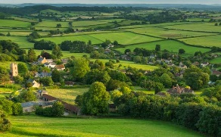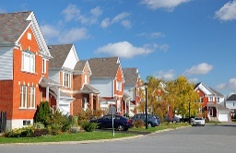

1. 2. 3.

__________ ____________ __________



1. 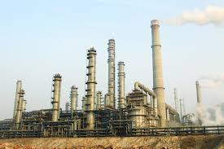 5. 6.

__________ __________ __________

**Q4) Complete the sentences using the words in the box.**

|  |
| --- |
| Perhaps, factories, experiences, suburb, Immigrants, abroad |

1.He lives in the -------------- of Beijing and works in the city**.**

2.People often travel to find new ------------------.

3.---------------- moved from Syria to Europe to find jobs.

4.These **-------------** are releasing toxic gases into the atmosphere.

5.**-----------** we should invite them to dinner.

Teacher: Raneem Haddad.

Coordinator’s Signature:________________