

**Our value: Alone we can do so little; together we can do so much.**

**Will Vs Be going to**

Grade 6 ( A + B )

Name: ___________________ Date : / /

Objectives: To identify the future simple (will + be going to)

To practise using will and be going to.

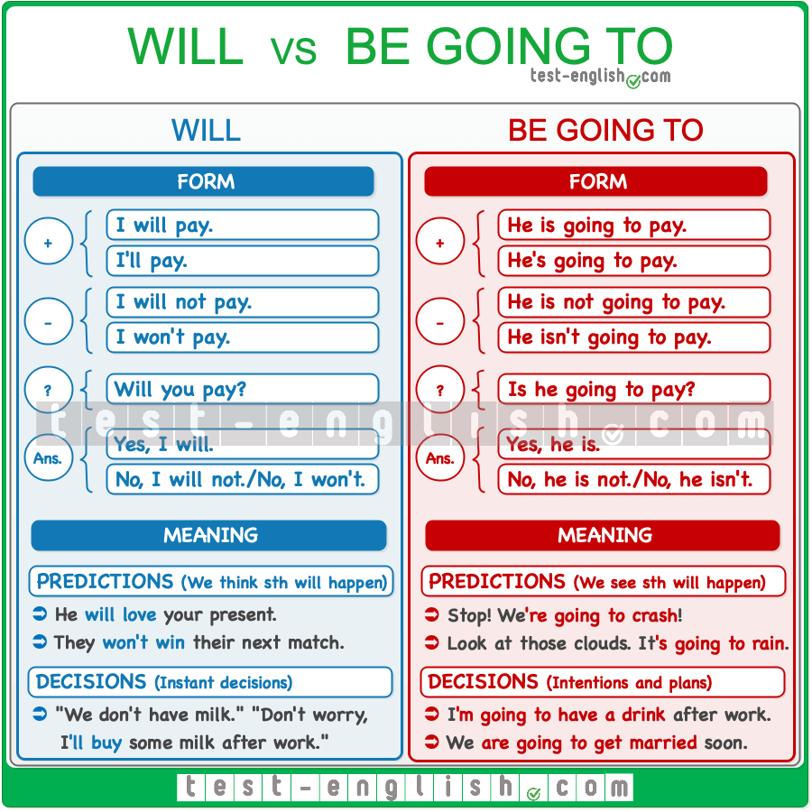

**When to use GOING TO?**

**1. When we have already decided or we intended to do something in the future. (Prior Plan)**

The decision has been made before the moment of speaking.

* They**'re going to** retire to the beach - in fact they have already bought a little beach house.
* I**'m going to** accept the job offer.

**2. When there are definite signs that something is going to happen. (prediction with evidence)**

Something is likely to happen based on the evidence or experience you have.

* Look at the clouds! It **is going to** rain.
* I don't feel well. I think I**'m going to** throw up. (throw up = vomit)

**When to use WILL?**

In other cases, where there is no implicit or explicit connection to the present, use **WILL**:

**1. For things that we decide to do now. (on_ spot Decisions) rapid**

This is when you make a decision at that moment, in a spontaneous way.

* Do you like it? I'll buy one for you too.
* It’s hot. I will open the window. (I just decided this right now)

**2. When we think or believe something about the future. (Prediction) without evidence**

* **Perhaps** my team will not win the league this season.
* I **think** it will rain later so take an umbrella with you.

Note: (to express prediction especially with: probably, I expect,

I hope, I believe, I think, I’m afraid, I’m sure, I know….)

**3. To make an offer, a promise or a threat.**

* **I'll give** you a discount if you buy it right now. (offer)
* I **promise** I will behave next time. (promise)
* If you don’t stop, I will tell your mother. (threat)

**4. You use WON'T when someone refuses to do something.refusal**

* I told him to take out the trash but he **won't** do it.
* My kids **won't** listen to anything I say.
* My car **won't** start.

**Time expressions:**

Tomorrow / tonight / next week , month , year / in two days / the day after tomorrow / soon / in a week , month …. etc.

**Practice**

A)Put the verbs in brackets into the correct future form. (**will-** or **be** **going to)**

Top of Form

1. Doris is always late. She  late tomorrow, too. ***(be)***
2. Would you like tea or coffee? I  coffee.

***(have)***

1. Watch out! You  yourself. ***(hurt)***
2. My friends  at home tonight. They are grounded.***(stay in)***
3. It's starting to rain. I  the umbrella.

***(put up)***

1. Look! They  the car. ***(wash)***
2. I don't think they  their holidays by the sea again. ***(spend)***
3. If you don’t stop bullying her, I  the teacher. ***(tell)***
4. It’s 5 o'clock already. We  the bus.

***(miss)***

B) **Circle the correct future tense phrase in the following sentences then write the function under each one**.

1. I am feeling energetic. So, I **(will / am going to)** wash my car.

On spot decision

2. It has been decided that we **(will / are going to)** to climb Mount Everest tomorrow.

Prior plan

3. Who wants to come with me to the movie tonight? -Oh that sounds fun. I **(will / am going to)** come with you.

On spot decision

4. We have already made plans for the vacation. We have decided that we **(will / are going to)** go to the Bahamas.

Prior plan

5. Tonight seems like a nice night to be outside. I **(will / am going to)** go for a walk after dinner.

Prior plan

6. -Have you thought about what you want to do after college? -Yes, I have decided that I **(will / am going to)** become an engineer.

Prior plan

7. I guess I **(will / am going to)** help you clean the kitchen if no one else will.

Offer

8. My car tires look low on air. I **(will / am going to)** fill them up at the next gas station.

Prediction with evidence

9.The weather man said that it **(will / is going to)** rain tomorrow.

Prediction without evidence

10. Okay, I have an idea. After we play the game, we

**(will / are going to)** get some ice cream!

Prior plan

C)**Use the following time expressions in meaningful sentences to match the functions given:**

* 1. Tomorrow / prediction without evidence:

I will pass the exam tomorrow.

* 1. Tonight / plan:

They are going to have a party tonight.

* 1. Next month / plan:

They are going to spend their holiday on the beach next month.

* 1. In two days / promise:

I promise, I will finish my project in two days.

* 1. Soon / offer:

They will make discounts soon.

Coordinator’s Signature: --------------------------