
With awareness come responsibility and choice

Worksheet ( 10 )
Grade One
Name: Date: 8 /11 /2023 _______________________________________________________________
Objectives:1- To understand the terms of singular and plural.
2-To change the singular nouns to plural.
Singular and plural

We can write nouns in the singular or the plural form.
Singular means just one.
Plural means more than one.
To make regular nouns plural, add -s at the end of the nouns.

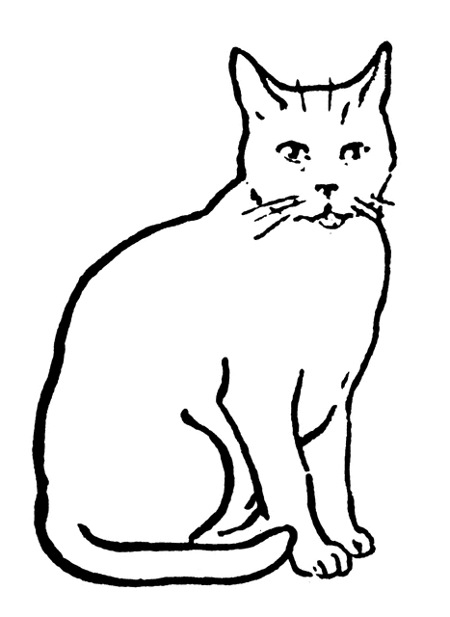
One cat two cats
Singular noun plural noun

- Make the singular noun plural.
Singular | Plural
hat | hats
bird | birds
ant | ants
book | books
dog | dogs

- Answer the questions below:
- What are these? 2. What is this?
 _These are balls. 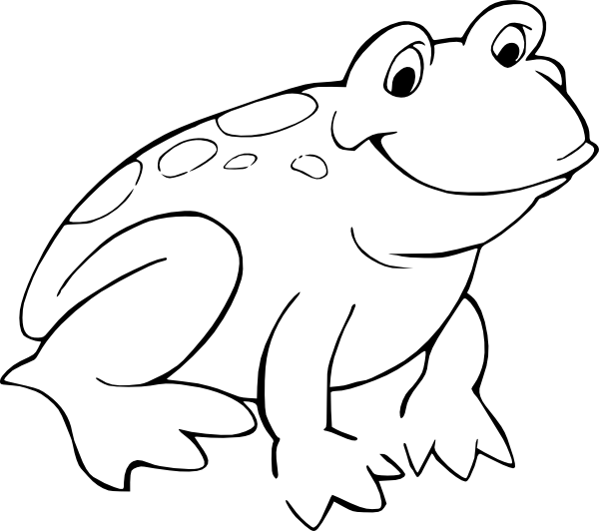This is a frog.

3-Draw
Three (3) eggs | One (1) apple

T.Taghreed Alnimri Coordinator’s Signature:

