

Worksheet (11)

Grade ( 1)

Name: Date: /11 /2023

Objective: To be able to use “This, That, These and those”.

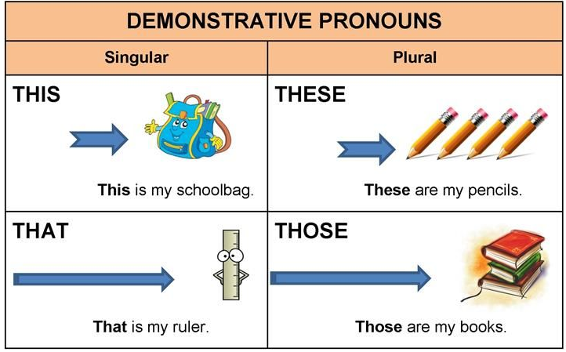

* **Choose the correct word**.

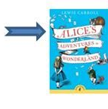1-______is my favourite book.

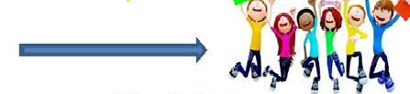These This That

2- __________ students are happy.

Those These This

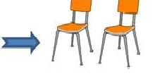

3- ________ are chairs.

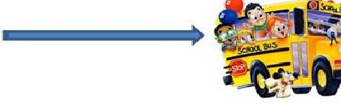This Those These

4- __________ is the school bus.

This That These

*Complete with This, That, These or those”.

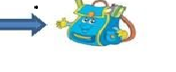1-This is a bag .

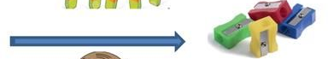2-Those are sharpeners.

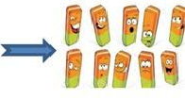

3-These are sharpener.

4- This is a pen.

T.Taghreed Alnimri Coordinator’s signature