

**Our value: Self – belief and hard work will always earn you success**

**Vocabulary _ Unit 2**

**(Save Our Tigers)**

**Name………………… Grade (5)**

|  |
| --- |
| **Objectives**  **1. Identify the meaning of the new words.**  **2. Identify the synonyms of the new words.**  **3. Practice using the new words in sentences.** |

**Verbs**

|  |  |  |
| --- | --- | --- |
| **Word** | **Meaning /Synonym** | **Example** |
| Terrify | To **scare**. | Don’t **terrify** the children with your scary stories. |
| Identify | To **recognize.** | She was able to **identify** the thief. |
| Protect | To **save** | It’s important to **protect** your skin from the harmful effects of the sun. |
| Inspire | To **influence.** | The nature **inspires** artist to paint beautiful pictures. |
| Fascinate | To **attract** | The sky was sparkly enough to **fascinate** her. |

**Adjectives**

|  |  |  |
| --- | --- | --- |
| **Word** | **Meaning /Synonym** | **Example** |
| Diverse | **Many kinds** /**various** | The wild life is **diverse**. |
| Starving | extremely **hungry** | There are lots of homeless people who are **starving**. |
| Damaged | **Destroyed**. | The house was **damaged** by the storm. |

**Nouns**

|  |  |  |
| --- | --- | --- |
| **Word** | **Meaning /Synonym** | **Example** |
| Foothills | low **hills** at the base of a mountain range. | We marched 5 km across the **foothills**. |
| Tracker | A person who is trained to find animals or people. / **tracer** | Police and **trackers** were searching for the lost boy. |
| Naturalist | A person who studies living  things. /**zoologist** | Jim Corbett was a great **naturalist**. |
| Injury | **Harm** or damage that is done in the body of a person or animal. | He is recovering from a knee **injury**. |
| Wound | A **cut**. | Blood was pouring from the **wound**. |
| Poaching | **Catching or Killing animals illegally** | The reason for **poaching** tigers is to sell their skins and bones. |
| Conservation | **Protection** of the natural world**.** | The lake was recently designated a **conservation** area. |
| Preservation | **Keeping** something in the same or good condition. | The **preservation** of the mummy was great**.** |
| Population | The total **number of** **people or animals** living in an area. | The country has a total **population** of 65 million. |
| Reserve | A **sanctuary**. | The land is to be left undisturbed as a nature **reserve**. |

1. **Write the synonym of each of these words**:
2. Terrify
3. Identify
4. Protect
5. Inspire
6. Diverse
7. Starving
8. Fascinate
9. Damaged
10. Foothills
11. Tracker
12. Naturalist
13. Injury
14. Wound
15. Poaching
16. Conservation
17. Preservation
18. Population
19. Reserve
20. **Write the correct word under each picture.**

|  |
| --- |
| Terrify _ Identify _ Protect _ Inspire _ Fascinate _ Damaged _ Diverse Starving _ Foothills _ Tracker_ Naturalist _ Injury _ Wound _ Poaching Conservation _ Preservation_ Population _ Reserve. |

  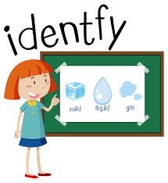

-------------- --------------- -------------------- ------------

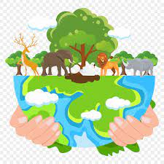  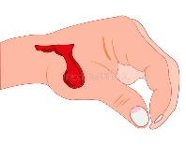 

------------- ---------------- --------------- ---------------

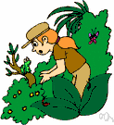  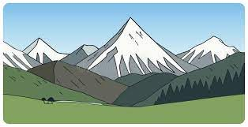  

-------------- --------------- ---------------- -------------- --------------

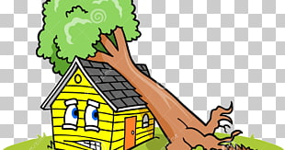   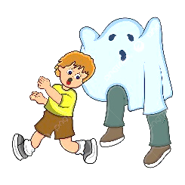

------------------------ ----------------------- ----------------------- -------------------------- ------------

1. **Fill in the gaps with the correct words from the box.**

|  |
| --- |
| terrify _ identify _ protect _ inspire _ fascinate _ damaged _ diverse_ starving _ foothills _ tracker_ naturalist _ injury _ wound _ poaching conservation _ preservation_ population _ reserve. |

1. There is a ------------- in the forest that has lots of animals.
2. The ---------------- of the pandas in the world is going down.
3. There are chemicals in the food ---------------.
4. There is a need for the -------------- of trees, or there will soon be no forests.
5. --------------- animals is illegal.
6. The surgeon sewed the -------------.
7. She survived the accident without any -------------.
8. Uncle Sam is a ------------. He studies living things.
9. The ------------ found footprints of a bear.
10. The --------------- of the Himalayas have beautiful nature.
11. A lot of children in Sudan are -------------. They are dying because they don’t have food.
12. The sea world is ------------. You can find different types of sea creatures in it.
13. The earthquake left a lot of -------------- areas.
14. The place continues to -------------- all the people who visit it.
15. We need someone who can ------------- the team.
16. How can you -------------- the environment?
17. I can ------------- the three states of matter.
18. The aim of the terrorists was to -------------- people!
19. **Find the synonyms of the following words in the crossword and write them down.**

|  |  |  |  |  |  |  |  |  |  |  |  |
| --- | --- | --- | --- | --- | --- | --- | --- | --- | --- | --- | --- |
| v | e | c | s | c | a | r | e | g | f | i | n |
| a | w | g | u | a | r | d | p | e | a | r | y |
| a | t | t | r | a | c | t | u | l | b | n | m |
| s | d | e | s | t | r | o | y | o | n | a | d |
| g | h | u | n | g | r | y | p | y | o | r | h |
| r | a | w | c | i | n | j | u | r | y | e | n |
| e | c | g | a | h | u | n | t | r | v | e | c |
| t | p | e | o | p | l | e | t | i | o | n | v |

1. Terrify ----------- 2. Protect --------------
2. Fascinate ------------- 4. Damage ----------------
3. Starving ------------- 6. Wound ----------------
4. Poaching -------------- 8. Population --------------

Teacher: Michleen Abyad

Coordinator’s Signature: --------------------------