****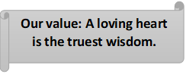

**Present Simple**

Name: _______________ Grade 5

Date: / /

Objectives: To review the present simple tense.

To practise using the present simple tense.

------------------------------------------------------------------------------------------------------------

**Positive**: Subject + **verb** / **verb + s/ es /ies** +…… +.

**Negative**: Subject + **don’t / doesn’t** + **V.1** +…… +.

**Question**: **Do / Does** + subject + **V.1** +…… +?

|  |
| --- |
| ***Positive*** |
| He **walks** |
| She **walks** |
| It **walks** |
| I **walk** |
| You **walk** |
| We **walk** |
| They **walk** |

|  |
| --- |
| ***Negative*** |
| He **doesn’t walk** |
| She **doesn’t walk** |
| It **doesn’t walk** |
| I **don’t walk** |
| You **don’t walk** |
| We **don’t walk** |
| They **don’t walk** |

|  |
| --- |
| ***Question*** |
| **Does** he **walk**? |
| **Does** she **walk**? |
| **Does** it **walk**? |
| **Do** I **walk**? |
| **Do** you **walk**? |
| **Do** we **walk**? |
| **Do** they **walk**? |

|  |
| --- |
| ***Short answers*** |
| Yes, he **does**. / No, he **doesn’t**. |
| Yes, she **does**. / No, she **doesn’t**. |
| Yes, it **does**. / No, it **doesn’t**. |
| Yes, you **do**. / No, you **don’t**. |
| Yes, I /we **do**. / No, I / we **don’t**. |
| Yes, we **do**. / No, we **don’t**. |
| Yes, they **do**. / No, they **don’t**. |

**Spelling rules (3rd person singular affirmative)**

**Only with He / She / It**

* Most verbs take –s in the third person singular.

I work

He work**s**

* Verbs ending in –ss, -sh, -ch, -x or –o take –es .

I mi**ss** I wa**sh** I wat**ch**

He miss**es** He wash**es** He watch**es**

I fi**x** I g**o**

He fix**es** He go**es**

* Verbs ending in consonant + y drop they –y and take –ies.

I cr**y**

He cr**ies**

* But verbs ending in vowels +y take –s.

I pl**ay**

He play**s**

**Uses**

We use the present simple for:

1. Permanent states.

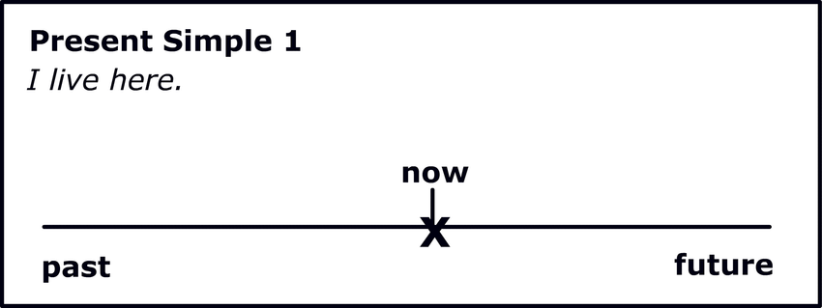

We **live** in Jordan.

Tom **works** in a school. He **is** a teacher.

1. Daily routine.

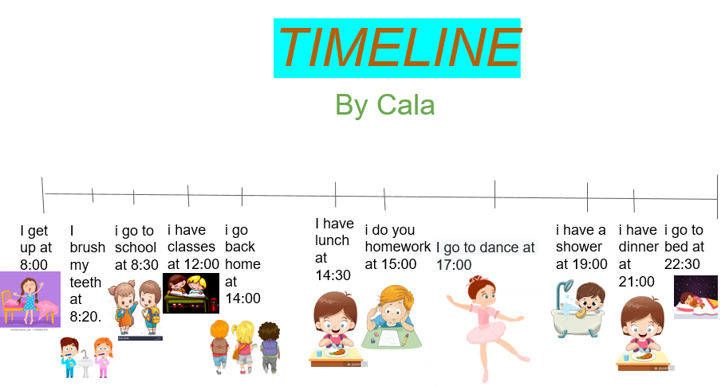

I **leave** work at 5 o’clock.

I usually **wake** up at 7:30.

1. Repeated habits.

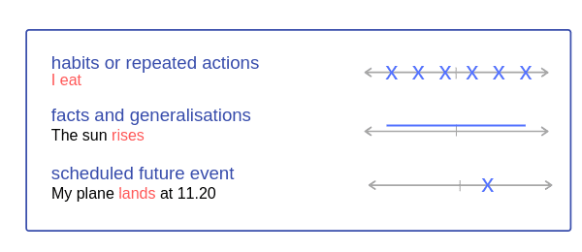

She **goes** to the gym every evening.

He usually **swims** on Sundays.

1. General truths and laws of nature. (Facts)



The sun **sets** in the west.

Water **freezes** at 0 C.

1. Time tables which we can’t change.



The first flight to London **leaves** at 9 am.

The match **finishes** at 7:45.

Time expressions used with the present simple (**Keywords**):

Every hour /day / week / month / summer / year.

On Sundays / On Mondays

Once a week / twice a month / daily

Adverbs of frequency: always / usually / often / sometimes /often / rarely / never

* Adverbs of frequency are used before **main verbs** but after **verb to be**.

He **always** goes to school.

He is **always** late.

---------------------------------------------------------------------

Note: Verb (be): am / is / are

Verb (have): have / has

Q1) Form sentences in the **positive**, **negative**, **question and short answer**. Use the **present simple** and write the **use** of each sentence in the brackets.

1. She / play / basketball on Saturdays. ( )

Positive: ------------------------------------------------------

Negative: -----------------------------------------------------

Question: -----------------------------------------------------

Short Answer: ------------------------------------------------

2. My parents / work / in a big company. ( )

Positive: ------------------------------------------------------

Negative: -----------------------------------------------------

Question: -----------------------------------------------------

Short Answer: ------------------------------------------------

3. The plane / leave / at 8 am. ( )

Positive: ------------------------------------------------------

Negative: -----------------------------------------------------

Question: -----------------------------------------------------

Short Answer: ------------------------------------------------

1. The sun / rise / in the east. ( )

Positive: ------------------------------------------------------

Negative: -----------------------------------------------------

Question: -----------------------------------------------------

Short Answer: ------------------------------------------------

1. I / go / to sleep at 9 pm. ( )

Positive: ------------------------------------------------------

Negative: -----------------------------------------------------

Question: -----------------------------------------------------

Short Answer: ------------------------------------------------

**Q2) Write the verbs in the correct form of simple present.**

1. She -------------- to a different country every year. **(travel)**
2. My friends ------------- always good to me. **(be)**
3. The girl -------------- often late. (**not**/**be**)
4. ----------- they sometimes --------------- in the park? (**play**)
5. ------------ he usually-------------- his homework alone? (**do**)
6. The teacher --------------- a test every day. (**not** / **give**)
7. The children sometimes --------------- mistakes. **(make)**
8. Jack --------------- early every day. (**not**/ **sleep**)
9. The baby ----------------- a lot every night. (**cry)**
10. Water -------------------- at 100 C. (**boil)**
11. He always -------------------- TV after lunch. (**watch)**
12. My dad often -------------------- to work by bus. (**go)**
13. They -------------------- the newspaper daily. (**read)**
14. She never -------------------- home late. (**come)**

Coordinator’s Signature: _________________

Teacher: Michleen Abyad