 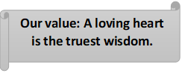

**Present Continuous**

Grade 5 (A + B)

Name: Date: / /

Objectives: To review the present continuous tense.

To practice forming and using the present continuous tense.

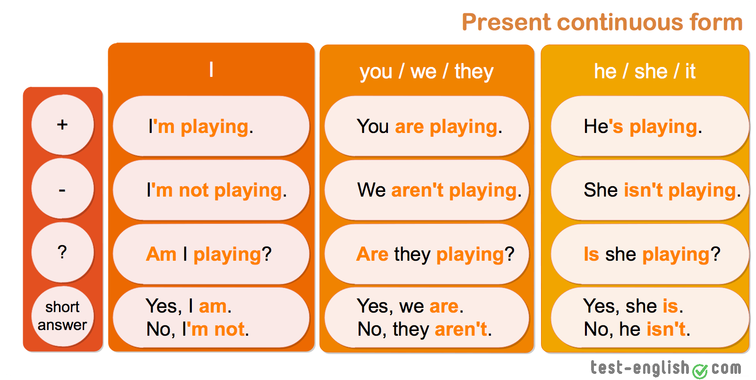

Uses…

* 1. **Now, at the time of speaking.**

http://www.englishpage.com/image/verbs/presentcontinuousnow.gif

* We **are studying** English now.
* You **are not swimming** now.
* **Are** you **sleeping**?
* They **are reading** their books right now.
* They **are not watching** television at the moment.
* What **are** you **doing now**?
  1. **Around the time of speaking.**

http://www.englishpage.com/image/verbs/presentcontinuouslongnow.gif

* I **am studying** to become a doctor.
* He **is not studying** to become a dentist.
* I **am reading** the book *Tom Sawyer these days.*
* They **are** still **working** on the project.
* We **are** currently **looking** for a new house.
  1. **Near future plan (personal arrangement)**

http://www.englishpage.com/image/verbs/simplefuture.gif

* I **am meeting** some friends after work.
* I **am not going** to the party tonight.
* **Is** he **visiting** his parents next weekend?
* **Is** he **coming** with us tonight?
  1. **To express annoyance (always)**

You **are always talking** in class.

**Key words**

My brother **is always using** my things without permission.

**now, right now, nowadays, at present, at the moment, currently, still,**

**tonight, today, tomorrow, Listen! Look! Be careful!**

**always (to express annoyance)**

**next + time (next week, year, Monday),**

**this + time (This week, this Tuesday, this evening**)Bottom of Form

Top of Form

Bottom of Form

* 1. **Fill in the blanks with the correct form of present continuous.**

1. My son -------------------------- (talk) on the phone right now.

2. -------------------------- (Sara / sleep) now?

3. Jason -------------------------- (do) his homework at the moment.

4. Tom -------------------------- (work) on a project nowadays.

5. My kids -------------------------- (play) in the garden now.

6. Look! Some people -------------------------- (wait) to talk to you.

7. My wife -------------------------- (not cook) today.

8. -------------------------- (Lucas / study) for his exam right now?

9. -------------------------- (Ryan / play) the piano this week?

10. Lea and I -------------------------- (paint) the fences today.

11. Andrea -------------------------- (help) me at present.

12. My children -------------------------- (not listen) to the radio now.

13. Selena -------------------------- (not drink) tea now.

14. My father -------------------------- (watch) TV now.

15. What -------------------------- (she / eat) right now?

16. What book -------------------------- (you / read) nowadays?

17. Thomas -------------------------- (drive) me home now.

18. I -------------------------- (wash) my face at the moment.

* 1. **Write the use of the present continuous in the following sentences.**

1. I’m taking a ballet class this Tuesday.

----------------------------------------------------------------------

1. The child is always crying for no reason.

----------------------------------------------------------------------

1. Jim is watching TV at the moment.

----------------------------------------------------------------------

1. My friend is staying at my house these days.

----------------------------------------------------------------------

* 1. **Circle the mistake and correct it in the following sentences.**

1. I not reading the newspaper now. ( )
2. We is practicing for the play at the moment. ( )
3. Is she play in the garden right now? ( )
4. Are she going to the dentist tomorrow? ( )
5. The students are have a test next week. ( )
   1. **Circle the correct answer. Present simple or present continuous?**
      1. We usually **(go / is going)** to the beach at the weekend.
      2. She **(plays/ are playing)** the piano every day.
      3. He **(dance / is dancing)** at the moment.
      4. John **(doesn’t help / isn’t helping)** his mom now.
      5. I **(wake up / am waking up)** at 6 o’clock.
      6. They **(write / are writing)** a letter every week.
      7. **(Do you drink / Are you drinking)** cola now?
      8. **(Does she brush / Is she brushing)** her teeth twice a day?

Coordinator’s Signature: _________________

Teachers: Michleen Abyad.