**Worksheet|** Lower Secondary Stage (6-8)

1st Semester | 2023-2024

|  |  |
| --- | --- |
| **Subject:** Science/ Chemistry | **Chapter:** Ions, Ionic Compounds and Ionic Bonds |
| **Objectives:**   * Draw a cross and dot diagram for ionic compounds | |

**1 Each of the following dot and cross diagrams below are incomplete. Find the missing feature to complete each one.**

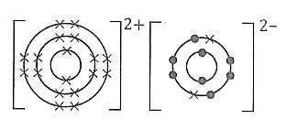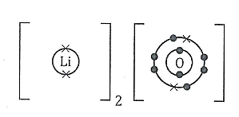

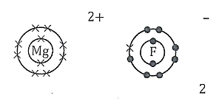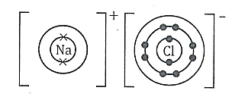

**2 Use the outlines below to draw the dot and cross diagrams for the following ionic compounds.**

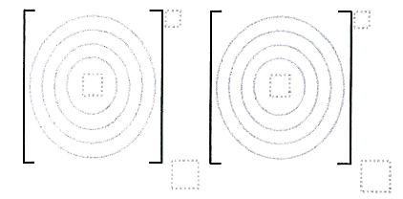

Magnesium oxide

Calcium fluoride

Potassium nitride