**Revision Sheet #1** **|** Lower Secondary

Stage (6-8)

1st Semester | 2023-2024

|  |  |
| --- | --- |
| **Subject:** Chemistry | **Chapter 1:** The Particle Model |
| **Objectives:**   * Define evaporation, boiling, condensation, melting, freezing and sublimation. * Describe how the arrangement, separation and movement of particles change when a substance changes its state. * Make conclusions from data | |

**1 – Use the words and phrases to copy and complete the sentences below. You may use each word or phrase once, more than once, or not at all.**

*a little close together far apart gas liquid much solid vibrate on the spot move around from place to place*

*move around and slide over each other*

Copper exists in three states – solid, liquid and .......................... In the solid state, its particles …………………........................... . The particles are ..................... . When copper melts, it changes state from ..................... to ..................... . Its particles start to ..................... ............................................................... . They get ..................... further apart. If copper is heated to 1084°C, it changes from the liquid to the ..................... state. Its particles get ..................... further apart and the start to .......................................... .

**2- Choose the correct answer.**

* Which of the following choices is not an example of a change of state?

1. A puddle of water drying out
2. Table salt dissolving in a pot of warm water
3. Ice melting in a glass of soda

* In a research lab a technician placed a pot with water on a gas stove. The technician notices bubbles forming throughout the water. What process caused the bubbles to form?

1. Sublimation
2. Boiling
3. Evaporation

* 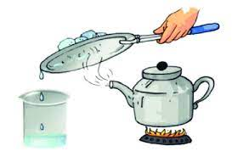A handful of ice cubes were placed on a pan held over a tea pot that was filled with water and set over high heat. Eventually the water comes to a boil and you notice water droplets forming on the pan. What is the correct order of the changes of state involved in this scenario?

1. Liquid----> sublimation----> gas ---->deposition----> liquid
2. Liquid----> evaporation----> gas----> deposition----> liquid
3. Liquid----> evaporation----> gas----> condensation----> liquid

* What happens to the movement of the particles in a substance when the energy is increased?

1. Speed Up
2. Slow Down
3. Stay the same

* When energy is decreased in a gas, what change in state is happening?

1. Boiling
2. melting
3. Condensation

**3- Describe the arrangement, movement and separation of particles before and after sublimation.**

|  |
| --- |
|  |
|  |
|  |

**4- Choose the correct term to complete the following statements.**

* A space with no particles in it is called ..................... .
* The temperature at which a substance boils is known as its...................................., while the temperature at which the substance melts is called ...................................
* The change of state from liquid to solid is ..................... ., and the opposite change of state will be ..................... .

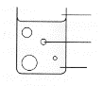**5- Write the letter of each label next to the correct line in the diagram.**

**A** Water in the liquid state

**B** Water in the gas state (steam or vapour)

**C** Mixture of air and steam

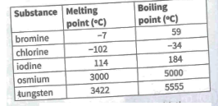**6- The table gives the melting points and boiling points of five substances.**

1. Which substance has the highest melting point?

...................................

b- Which substance has the lowest boiling point?

...................................

c- Name a substance from the table that is in the gas state at 20°C. ...................................

d- Name all the substances that are in the solid state at 20°C. ...............................................

e- What is the state of bromine at 20°C? ................................

f- Explain what happens when bromine is heated from 20°C to 100°C?

.......................................................................................................................................... ..........................................................................................................................................

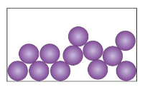**7- The diagram shows the particle of a substance in its liquid state.**

a-What can you do to make the particles in the liquid move faster?

..........................................................................................................................................

b-Draw a diagram to explain what happens to the liquid when it evaporates.

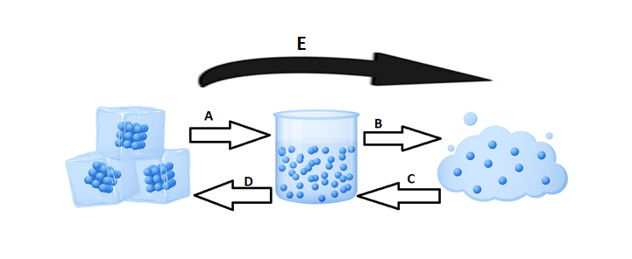**7- In the diagram below, each arrow represents a change of state.**

* Write the letter that shows the following:

Freezing Sublimation Condensing

* Give the letters that show a decrease in energy.
* Give the letters that show an increase in energy.

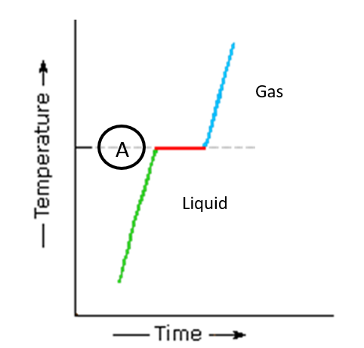

**8- The graph shows changes of state of a substance.**

* The liquid turns into a gas when it reaches point (A). What is point (A) called?

..........................................................................................................................................

* Explain why the temperature stops rising at point (A).

..........................................................................................................................................

* Explain the process in which liquids turn into gases using the particle theory.

..........................................................................................................................................

..........................................................................................................................................