**Revision worksheet (1)|** The Primary Stage of Grades (4-5)

2023-2024

|  |  |
| --- | --- |
| **Name:** ……………………………………… | **Subject:** Math |
| **Date:**  / 11 / 2023 | **Class:** Grade 4 (C, D, E, F &G) |

|  |  |
| --- | --- |
| 1. The **product** of 294 and 7 | 1. The **product** of 705 and 4 |
| 1. The **product** of 86 and 9 | 1. The **product** of 35 and 8 |
| 1. The **difference** between 459 and 793 | 1. The **sum** of 8999 and 805 |

1. Find the following.
2. Answer the following.

1. 16 x 10 = g) 289 + = 1007
2. x 200 = 26000 h) 45000 ÷ 90 =

1. - 308 = 2007 i) ÷ 700 = 6000
2. 951 - = 488 j) 704 + 9540 =
3. 630 ÷ 9 = k) 855000 ÷ 100 =

l) 807 is 100 more than

m) is 1000 less than 3697

n) is 100 more than 999

1. 7325 is 1000 less than
2. is 100 less than 1030
3. 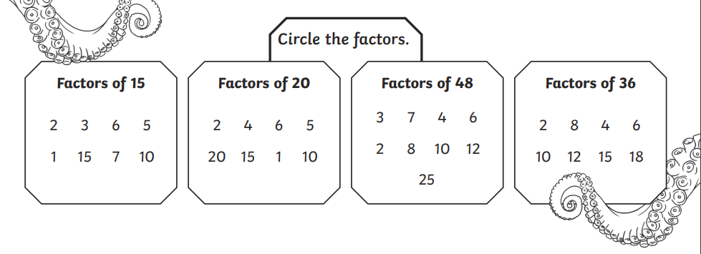Circle the factors of the following numbers.

1. Continue the sequences in the following.
2. 27, 36, 45, , , , .
3. 2371, 2271, , , 1971 , .
4. 851, , 1453, 1754, .
5. Write the multiples of 8 that are greater than 20 but less than 60.
6. Write the multiples of 3 that are greater than 14 but less than 35.
7. Write the multiples of 4 that are greater than 10 but less than 41.
8. Answer the following problems.
9. A greengrocer has a box of apples. In the morning he sells 17 apples. In the afternoon he sells 60 apples. At the end of the day there are 41 apples left in the box. How many apples were there at the start of the day?

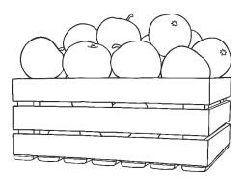

1. In a pastry, the cook has 216 pie trays. She makes meat pies and vegetarian pies. The cook uses 85 trays for the meat pies and 97 for the vegetarian pies. How many trays are not used?

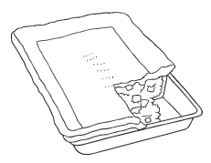

1. Lilian has 30 packets of biscuits. There are 12 biscuits in each packet.
2. How many biscuits does she have in all?
3. If she gives 189 of the biscuits to some friends, how many are left with her?
4. She buys another 10 packets biscuits. How many biscuits does she have now?

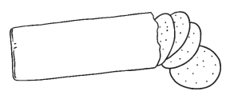

1. A photographer takes 354 photographs in a day. How many photographs does she take in 8 days?



1. Elena has to run for 298 minutes everyday for 7 days to enter a competition. How many minutes she will run after 7 days?
2. Alex went shopping and bought small fish for $205, large fish for $391, crabs for $142.
3. How much he paid in all?
4. If he had $900, how much he has left?

Round your answer to the nearest dollar.

1. If the cost of one kilogram of shrimps is $9, can he buy 32 Kilograms from what he has left?
2. Flora wants to drive to see her family which is 535 km away. She drives 249 km and stops for a cup pf coffee. How many more km does she have to drive to reach her family?
3. Find the product of the following.
4. 48 and 8 b) 65 and 4 c) 9 and 72

1. 5 and 28 e) 83 and 3 f) 6 and 64
2. 492 and 5 h) 309 and 4 i) 917 and 7

1. 8 and 824 k) 9 and 258 l) 4 and 256