

**Our value: Alone we can do so little; together we can do so much.**

**Vocabulary _ Unit 3**

**(Inside Our Planet)**

**Name ………………… Grade (6)**

|  |
| --- |
| **Objectives**  **1. Identify the meaning of the new words.**  **2. Identify the synonyms of the words.**  **3. Practice using the new words in sentences.** |

**Verbs**

|  |  |  |
| --- | --- | --- |
| **Word** | **Synonym** | **Meaning** |
| Comprise | Include | To be made up of.  **Example**: Italian students **comprise** 60% of the class. |
| Collide | Strike | To hit with force.  **Example**: The two boats were going to **collide** but one of them moved away at the last second. |
| Erode | Decay | To decay or wear away.  **Example**: The wooden door was **eroded** by the rain. |

**Adverbs**

|  |  |  |
| --- | --- | --- |
| **Word** | **Synonym** | **Meaning** |
| Gradually | Slowly | By small degrees or little by little / slowly.  **Example**: We are **gradually** changing the whole plan. |
| Chemically |  | In a way that relates to or is caused by chemicals.  **Example**: This water is **chemically** treated. |

**Nouns**

|  |  |  |
| --- | --- | --- |
| **Word** | **Synonym** | **Meaning** |
| Mass | Quantity | A large quantity of matter with irregular shape.  **Example**: The **mass** of ice blocked the stream and stopped the flow of water. |
| Crust | Covering | **Example**: Earthquakes leave scars in the Earth’s **crust**. |
| Sphere | Ball | A round figure like a ball.  **Example**: The Earth is not a perfect **sphere**. |
| Chamber | Room | An enclosed space or room.  **Example**: The climbers discovered a large **chamber** in the mountain. |
| Chunk | Piece | A thick solid piece of something.  **Example**: A **chunk** of the wall had cracked off in the storm. |
| Geologist |  | A person who studies the development of Earth’s crust.  **Example**: The **geologist** found many uncovered fossils. |
| Pressure | Physical force | A physical force against an object by something in contact with it.  **Example**: Let me check your blood **pressure**. |
| Element | Component | **Example**: Carbon is an **element**, while carbon dioxide is a compound. |

1. **Write the synonym of each of these words**:
2. gradually slowly
3. collide strike
4. comprise include
5. mass quantity
6. erode decay
7. crust covering
8. element component
9. chunk piece
10. Pressure Physical force
11. sphere ball
12. chamber room

1. **Write the correct word under each picture.**

|  |
| --- |
| collide_ crust _ erode _ element _ geologist _ mass _ chamber _ sphere pressure _ chunks |

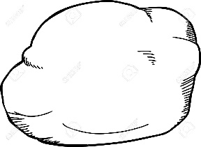 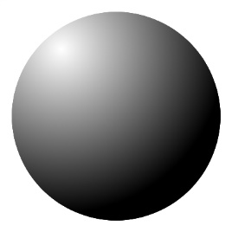 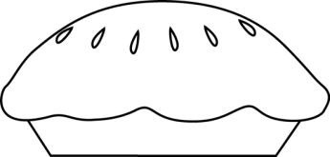 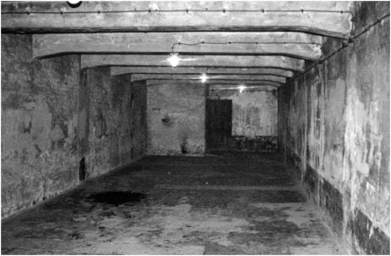

Mass sphere crust chamber

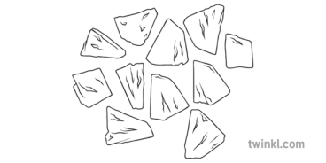 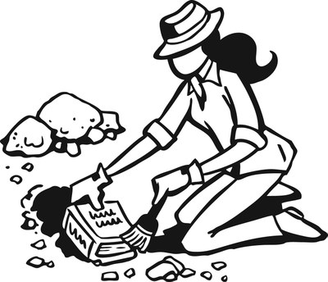 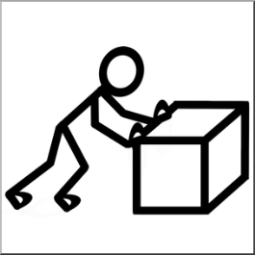 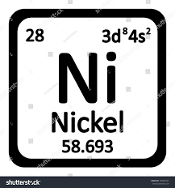

Chunks geologist pressure element

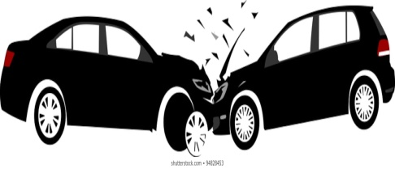 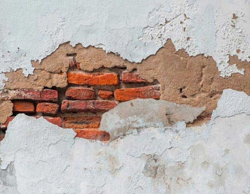

Collide erode

1. **Fill in the gaps with the correct words from the box.**

|  |
| --- |
| collided_ gradually _ crust _ eroded _ chemically _element _ geologist _ mass _ chamber _ sphere _ pressure _ chunk _ comprises |

1. He turned the mass of clay into a perfect vase.
2. The crust of the bread is burnt.
3. My uncle is a famous geologist.
4. He bit a large chunk of the apple.
5. The policeman took him to a near chamber to ask him some questions.
6. Hydrogen is chemically combined with oxygen to form water.
7. She gradually got used to the new diet.
8. Water comprises 70% of the Earth’s surface.
9. The two cars collided but there were no injuries.

10.Apply some pressure on your nose to stop the bleeding.

11. The flood eroded the soil that was covering that land.

12.Gold is an expensive element.

13.He rounded the clay into a sphere.

**D) Circle the correct answer from a or b.**

1. Land is found on the ------------ surface of the Earth’s crust.

**a. oceanic b. continental**

2. Wind and rain ------------ rock over time.

**a. erode b. collide**

3. Volcanoes ------------- when molten rock builds up pressure under the crust.

**a. erupt b. explode**

4. Tectonic plates are different -------------- of the Earth’s crust.

**a. sections b. layers**

5. The Earth -------------- four layers: the inner core, the outer core, the mantle, and the crust.

**a. comprises b. collides**

6. This rock looks like a solid-------------, but it is made up of several layers.

**a. element b. mass**

7. Rock can change ------------- in a process known as the rock cycle.

**a. constantly b. chemically**

8. Erosion is a process that happens ------------.

**a. quickly b. gradually**

1. **Find the synonyms of the following words in the crossword and write them down.**

|  |  |  |  |  |  |  |  |  |  |  |  |  |  |
| --- | --- | --- | --- | --- | --- | --- | --- | --- | --- | --- | --- | --- | --- |
| m | e | r | g | c | o | l | l | i | d | e | g | j | k |
| a | r | t | y | u | g | h | j | a | s | d | r | t | j |
| s | j | p | c | h | u | n | k | y | m | b | a | b | c |
| s | p | r | e | s | s | u | r | e | m | m | d | h | o |
| q | w | d | r | f | t | g | y | h | j | h | u | f | m |
| f | h | t | f | y | u | i | j | k | f | s | a | d | p |
| c | h | e | m | i | c | a | l | l | y | e | l | r | r |
| c | t | e | t | y | u | i | g | h | j | w | l | e | i |
| r | e | r | f | e | l | e | m | e | n | t | y | a | s |
| u | w | o | x | c | d | f | g | s | p | h | e | r | e |
| s | e | d | r | f | t | g | y | h | u | s | c | e | x |
| t | x | e | c | h | a | m | b | e | r | e | v | y | y |

body _________________ component ___________

covering__________________ include ___________

ball _______________ strike__________

room _________________ decay _________

piece ________________ slowly _________

physical force _______________ In a chemical way ___________