**Worksheet** **|** Lower Secondary

Stage (6-8)

1st Semester | 2023-2024

|  |  |
| --- | --- |
| **Subject:** Biology | **Chapter:** The carbon cycle |
| **Objectives:** Describe the carbon cycle in nature  **Name:** | |

**Question One:**

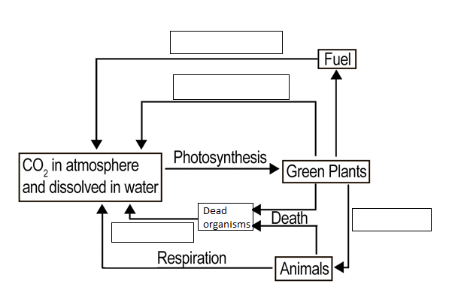The diagram below shows the carbon cycle. Label the empty boxes with the correct process:

**Question Two:**

Use the words below to fill in the blanks.

Each word may be used more than once.

Organisms dioxide carbon fungi decomposers respiration

The carbon cycle involves the cycling of __________ between the environment and ______________. photosynthesis and _______________ are the key processes involved in the cycle. Also decomposition which involves microorganisms called _____________ is important to digest waste and dead organisms. These microorganisms are bacteria and __________. These decomposers carry out respiration, which converts __________ compounds in dead and waste material back to carbon ___________ in the air.