

**Worksheet |** The Primary Stage of Grades (4-5)

2023-2024

|  |  |
| --- | --- |
| **Name:** ……………………………………… | **Subject:** English Language  **Revision Sheet #1** |
| **Date:** / / | **Class:** Grade 4 (All Sections) |

**­­­**

**Objectives:**

* To read a text and answer comprehension questions.
* To practise some grammatical concepts covered.

**Read the following text then answer the questions**

**Living Things**

Living things are classified as a living thing if they move or grow. They are also called organisms. All organisms need some things to help them to stay alive. The essential things are air, water and food. You can tell the difference between living things and non-living things by the way they behave.

4

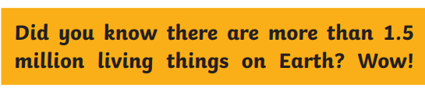

**How do you know if something is a living thing?**

All living things move. We know that animals move in many varied ways: kangaroos jump, kookaburras fly, sharks swim and emus run, but plants move too.

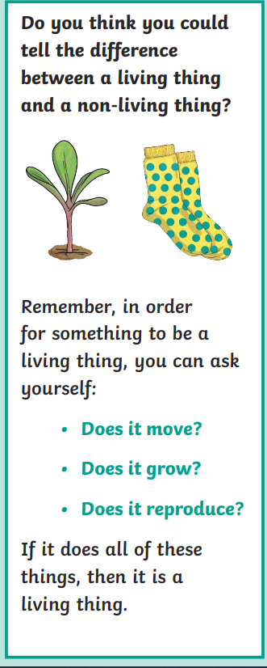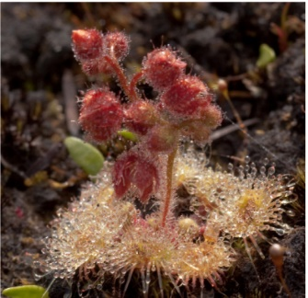**Have you ever heard of a Catapulting Flypaper Trap?**

10

This is a carnivorous plant with sticky leaves that snap shut quickly when something lands on it. They only live in Australia. When the prey lands on the part of the leaves, plant cells break and send the object catapulting towards the middle of the plant, where finally it’s eaten. How cool is that!

15

**How do you classify living things?**

Living things are divided into classification groups by scientists. These groups are made up of living things that are similar to each other. The classifications begin very generally and get more and more specific the more similarities are found between organisms. Would a koala be classified with a gum tree?

20

**What can living things do?**

All living things can move and are sensitive or able to feel. Even the smallest and simplest living things can feel when they are touched or know when something is hot or cold.

25

Living things can all take in and put out chemicals, but these are different between each organism. Animals breathe in oxygen and breathe out carbon dioxide just like humans do. Green plants **absorb** carbon dioxide and release oxygen; they also make their own food through photosynthesis. Animals then eat these green plants and get their energy.

30

All organisms also produce their own waste. Similar to when we put the wrapper from our chocolate bar in the rubbish bin, we get rid of the part that isn’t needed anymore. The same is true of living things. When they have finished taking the nutrients from something, they get rid of the part that is no longer needed.

35

Through these processes, all living things reproduce. Plants make new shoots or produce seeds that can grow into new plants, and animals produce babies.

1. **What is another term for ‘living things’?** ________________________________________________________________________________________________________________________________
2. **Identify the 3 essential things that are needed for living things.**
3. ______________________
4. ______________________
5. ______________________
6. **Identify 3 Australian animals and the different ways they move.** 
   1. __________________________________________________________
   2. __________________________________________________________
   3. __________________________________________________________
7. **How does the Catapulting Trap eat?**

________________________________________________________________________________________________________________________________

1. **Explain the difference between how plants and animals ‘breathe’.**

________________________________________________________________________________________________________________________________

________________________________________________________________

1. **What are three questions to remember when looking for living things?**

1. ____________________________
2. ____________________________
3. ____________________________
4. **The underlined verb “absorb” means:**
5. give out
6. take in
7. release
8. **Find a word between lines (1-4) that means “important”_________________**
9. **The text you read is a non- chronological report. Mention two features of non- chronological reports.**
10. ________________________________________________
11. ________________________________________________
12. **What is the purpose of the subheadings?**

________________________________________________________________________________________________________________________________

1. **Read the following paragraph:**

This is a carnivorous plant with sticky leaves that snap shut quickly when something lands on it. They only live in Australia. When the prey lands on the part of the leaves, plant cells break and send the object catapulting towards the middle of the plant, where finally it’s eaten. How cool is that!

**Find the following:**

1. **An adverb of manner: ________________**
2. **An adverb of time:** ___________________
3. **An adverb of place:** __________________

**Part two: Grammar and Spelling**

1. Complete the sentences by adding a contrast that would not be expected from the first clause using “**but**” correctly.
2. **Mary ran fast**______________________________________________  
   __________________________________________________________
3. **I would have passed the exam**________________________________ __________________________________________________________
4. **Joey hates carrots**___________________________________________

__________________________________________________________

1. **Jenny wanted to go to the garden**______________________________

__________________________________________________________

1. Underline the **main clause** in the following sentence:
2. Unless the bus arrives, I will have to start walking.
3. While the rain poured down, the puddles grew bigger.
4. Enjoy being a child before it’s too late.
5. I can’t help you because I don’t know the answer.
6. Before the party started, the guests were getting ready.
7. Underline the **subordinate clause** in the following sentence:
8. Having a party is a bad idea because the neighbors will complain.
9. After having a long nap, the dog chased the ball.
10. When my alarm sounded, I got out of bed.
11. He goes abroad on holiday although he doesn’t like flying.
12. My dad has fixed my bike so that I can take it to the park.
13. Join the two clauses using a suitable connective to make a **complex sentence**.
14. You can’t leave school. The bell rings.

______________________________________________________________________________________________________________________

1. My brother is grumpy. He has got to do his homework.

______________________________________________________________________________________________________________________

1. I will always support my local team. They always lose!

______________________________________________________________________________________________________________________

1. He was chosen to represent the school. He was the most talented swimmer.

______________________________________________________________________________________________________________________

1. **Change the following adjectives into adverbs:**
2. happy: ________________
3. rude: ________________
4. slow: _________________
5. **Add – ful to the following words.**
6. duty: ________________
7. peace: ________________
8. thank: ________________
9. **Add – al to the following words.**
10. survive: _______________ b) approve: ______________