**Worksheet 1|** Lower Secondary

Stage (6-8)

1st Semester | 2023-2024

|  |  |
| --- | --- |
| **Subject:** ICT | **Chapter:** 3 |
| **Objectives: Identify inputs-outputs-process, write a python program, complete the code in a flowchart.** | |

**Python-Program #1**

1. Write a python program to input the length and width of a rectangle and then calculate and print the **Area and Perimeter** of the rectangle.

**[L: Length – W: Width - A: Area – P: Perimeter]**

**A = L*W P = 2*(L+W)**

**Start**

**Input L, W**

**End**

1. Identify each of the following:

**Inputs:**

**Process:**

**Output:**

**A = L*W**

**P = 2*(L+W)**

**# Calculate the area and the perimeter of a rectangle**

**Print “Perimeter =”, P**

**Print “Area = “, A**

**Python**

**Flowchart**

**Python-Program #2**

1. 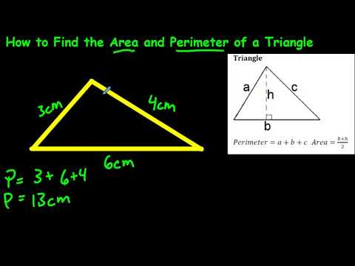Write a python program to input the **base and height** of a triangle, and then calculate and print the **area of triangle**.

**Area=1/2*B*H [ B: Base – H:** Height**]**

1. Complete the flowchart
2. Identify each of the following:

Inputs:

**Start**

**Print “Area =”, Area**

**Area=1/2*B*H**

**End**

Process:

Output:

**# Calculate the area of triangle**

**Python**

**Flowchart**

**Python-Program #3**

1. Write a python program to input Weight and Height and then calculate and print the **BMI (Body Mass Index).**

BMI=W/(H*H)  **[W: Weight – H: Height]**

1. Complete the flowchart

**Input**

**Print “BMI =”**

**BMI =**

1. Identify each of the following:

**Inputs:**

**Process:**

**Output:**

1. # Calculate the BMI (Body Mass Index).

**Teacher: Samar Isead**