**Worksheet 1|** Lower Secondary

Stage (6-8)

1st Semester | 2023-2024

|  |  |
| --- | --- |
| **Subject:** ICT | **Chapter:** 3 |
| **Objectives: Identify inputs-outputs-process, write a python program, complete the code in a flowchart.** | |

**Python-Program #1**

1. Write a python program to input the length and width of a rectangle and then calculate and print the **Area and Perimeter** of the rectangle.

**[L: Length – W: Width - A: Area – P: Perimeter]**

**A = L*W P = 2*(L+W)**

**Start**

**Input L, W**

**End**

1. Identify each of the following:

Inputs: **L and W**

Process: **A = L*W P = 2*(L+W)**

Output: **A(area) P(Perimeter)**

**A = L*W**

**P = 2*(L+W)**

**# Calculate the area and the perimeter of a rectangle**

**L=int(input("input the Length”))**

**W=int(input("input the Width”))**

**A=L*W**

**P=2*(L+W)**

**print("Area = ",A)**

**print("Perimeter = ",P)**

**Print “Perimeter =”, P**

**Print “Area = “, A**

**Python**

**Flowchart**

**Python-Program #2**

1. 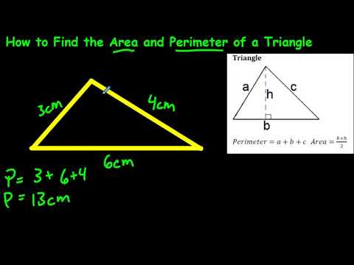Write a python program to input the **base and height** of a triangle, and then calculate and print the **area of triangle**.

**Area=1/2*B*H [ B: Base – H:** Height**]**

1. Complete the flowchart
2. Identify each of the following:

Inputs**: B, H**

**Start**

**Input B,H**

**Print “Area =”, Area**

**Area=1/2*B*H**

**End**

Process: **Area=1/2*B*H**

Output: **A (area)**

**# calculate and print the area of triangle**

**B=int(input("Input the base of the triangle"))**

**H=int(input("Input the Height of the triangle"))**

**A=1/2*B*H**

**print("Area = ",A)**

**Python**

**Flowchart**

**Python-Program #3**

1. Write a python program to input Weight and Height and then calculate and print the **BMI (Body Mass Index).**

BMI=W/(H*H)  **[W: Weight – H: Height]**

1. Complete the flowchart

**Start**

**Input W,H**

**Print “BMI =”,BMI**

**BMI = W/(H*H)**

**End**

1. Identify each of the following:

**Inputs: W and H**

**Process:** BMI=W/(H*H)

**Output: BMI**

**L=int(input("Input the Weight"))**

**W=int(input("Input the Height "))**

**BMI=W/(H*H)**

**print(“BMI = “,BMI)**

1. # Calculate the BMI (Body Mass Index).