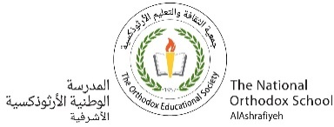

My cousin Rachel ch.4

(I Meet Rainaldi)

Grade 7 ( A + B )

Name: Date : / /

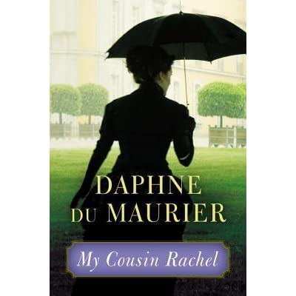Enjoy reading the chapter and answer the following questions.

1. Who gave Rainaldi’s address to Philip?

The servant in the villa.

1. Describe Rainaldi.

He was a thin man, about 40 years old, with a proud hard face.

1. What did Philip show Rainaldi?

He showed him Ambrose’s letters.

1. What did the doctors say to Rachel about Ambrose?

That he had a tumor in his brain.

1. What did Rainaldi send to Philip and Nick Kendall?

He sent them a copy of Ambrose’s death certificate.

1. What did Ambrose’s will say?

That Nick Kendall is now the guardian of Philip.

1. Why would Philip punish Rachel?

Because he thinks that she is the one who killed Ambrose.

Teacher: Mirna Nawaf Al-Sahawneh.

Coordinator’s Signature: -------------------