Non Renewable Energy

Grade 8 ( A + B )

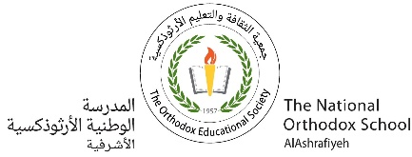 Name: Date : / /2023

**\*Non-Renewable Energy** :are sources of energy that cannot be reformed in a short period of time .

* Non -renewable energy include :1- fossil fuels 2- nuclear energy

* Fossil fuels are fuels that were formed by buried remains of organisms that lived millions of years ago .

*Fossil fuels include :1- Coal 2- Petroleum(oil) 3- Natural gas .

**Compare between** **Coal, gas and Petroleum :**

|  |  |  |  |
| --- | --- | --- | --- |
|  | **Coal** | **Petroleum** | **Gas** |
| **State of matter & color** | Solid( brown-black) | Liquid(black) | Gas( colorless) |
| **Origin(kind of organisms)** | Plants(swamps) | marine organisms | Marine organisms |
| **Place of origin** | swamps | Marine(water) | marine |
| **uses** | -generating electricity  -some industries like paper and steel | -heat our homes  -some industries (plastics ,paints & medicines )  -transportation | -generating electricity  -heating and cooking  -some industries like paints , plastics. |

*Heat and pressure from the top layers of mud help the remains of living things to turn into fossil fuels.

*Natural gas is the cleanest source of fossil fuels .

*Methane is the main ingredient in natural gas .

*Nuclear energy is not a fossil fuel .

*Types of nuclear energy : 1- Nuclear fission 2-Nuclear fusion.

* Nuclear fusion : energy is released when atoms are fused ( united or combined ) together to form a large atom (ex: energy in sun)

* Nuclear fission : energy is released when atoms are split ( break) apart to form smaller atoms .

* Nuclear energy : is a clean source of energy and it can be used to generate electricity .

**Amal Juha +Sahar Silkawi**