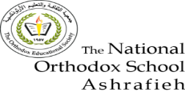The National Orthodox School

Science Worksheet #2

Grade: 4 Name:

A Balanced Diet

|  |  |  |
| --- | --- | --- |
| **Type of Food Group** | **Function** | **Examples** |
| Carbohydrates | **Give us energy.** | **Potato,wheat (bread)**  **Rice, fruits.** |
| Protein | **To grow and mend cells** | **Fish,meat, egg**  **Beans, lentil, peas** |
| Vitamins & Minerals | **To keep our body healthy** | **Fruits and vegetables** |
| Fats and Oils | **Give us energy** | **Olive oil, avocado, nuts, milk, yoghurt,**  **Meat, egg** |
| Fibre | **Clean our digestive system.** | **Friuts and vegetables, grains** |
| Water | **Help the blood to carry substances to the body.** | **Clean water** |