

**Grade:4**

**Science Worksheet /Unit 2**

Name: Date: / /2023

***Animals***

1. **Animals with backbones can be divided into five classes. Mention the**m.

a- Fish b- Birds c- Amphibians d- Mammals

e- reptiles

**2.** **Choose the correct answer.**

1- What group of vertebrates are snakes and lizards?

**a- amphibians b- reptiles c- mammals**

2-What group of vertebrates is an elephant?

**a- birds b- reptiles c- mammals**

3- Which of the following groups of vertebrates can fly?

**a- amphibians b- reptiles c- birds**

4- Which of the following groups of vertebrates MUST live in the water to survive?

**a- fish b- parrot c- mammals**

5- Which of the following groups of vertebrates usually breathe through gills at birth and then breathe through lungs?

**a- fish b- reptiles c- amphibians**

6- Which of the following groups of vertebrates is covered with feathers?

**a- amphibians b- reptiles c- birds**

3. Compare between fish and amphibians by writing the similarities and differences

- Develop lungs. - Live entire its life under water.

- Have backbone. - Lay eggs.

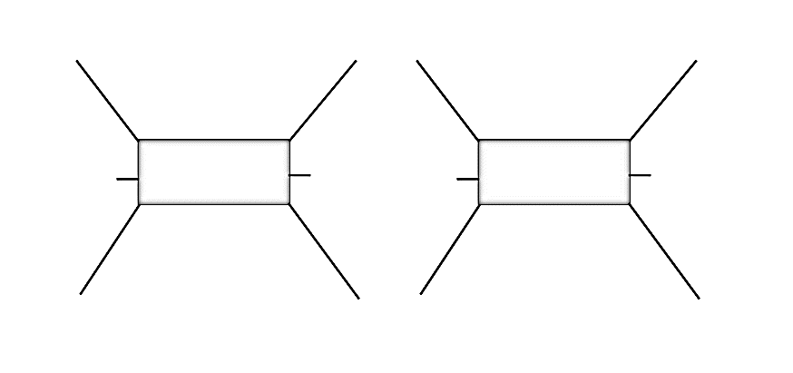 - Have scales. -Have wet skin.

**Have wet skin**

**Have scales**

**Lay eggs**

**Develop lungs**

**Live entire life in water**

**amphibians**

**fish**

**Have backbone**